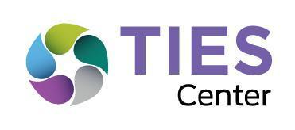

TIES Reflection on Inclusive Systems of Education (RISE)

Facilitator’s Guide

Welcome to the RISE

Introduction

Inclusive Education systems have equity at their center and use evidence-based educational practices that benefit all students, including students with significant cognitive disabilities. As you begin or continue the process of creating inclusive schools for all students, the TIES Reflection on Inclusive Systems of Education (RISE) and the TIES Inclusive Education Roadmap (IER) will assist your system (state, district, or school) in reflecting on your current practices, prioritizing targets for change, creating an action plan, and implementing your that can lead to sustainable change.

The most effective approach for increasing inclusive opportunities for all students, including those with significant cognitive disabilities, is to engage in a systematic process of systems change. This process embeds inclusive education for each and every student within ongoing continuous improvement efforts with a goal of creating a culture of equitable and inclusive school communities. In this way, inclusive education initiatives are not viewed solely as a change in special education service delivery options, but as an equity-driven general education initiative.

The development of the RISE was a two-year process. The features of inclusive education described in the RISE were developed through a comprehensive literature review in combination with a review of existing tools (24) purported to describe indicators of inclusive education and an analysis of the textbooks (7) most frequently used in teacher preparation programs for students with significant cognitive disabilities. A semi-qualitative process was utilized to allow the RISE focus areas and features to emerge from the reviews.

Purposes of the RISE

- To provide an opportunity for self-reflection for states, districts and schools to evaluate the current status of evidence-based best practices for inclusive education for all students, including those with significant cognitive disabilities;
- To initiate discussion among leaders, personnel and stakeholders to identify current strengths and successes as well as priority needs for improvement in the area of inclusive education;
- To identify the priorities that will be used for setting measurable goals in the action plan to increase or improve the use of evidence-based best practices for inclusive education across the targeted system (state, district or school);
- To monitor and report progress toward the implementation of evidence-based best practices for inclusive education within the target system; and
- To analyze data to allocate resources in support of evidence-based best practices for inclusive education across the state, district and/or school.

Intended Outcomes of the RISE

The intended outcomes of the RISE process are best described by the TIES acronym itself. Through use of the RISE a system can increase:
- Time in general education classes, lessons, activities, and routines for all students, including students with significant cognitive disabilities;
- Instructional effectiveness for all students, including those with significant cognitive disabilities;
- Engagement with general education classmates and the general education curriculum; and
- System support for inclusive education

TIES Core Values for Inclusive Education

In addition to its strong research base, the RISE is informed by the TIES Core Values for Inclusive Education and facilitates ongoing continuous improvement efforts for all students.

These values are:

CORE VALUE #1: Each and every student is valued and contributes to their school community and general education classrooms.
CORE VALUE #2: Each and every student deserves meaningful and sustained access to the general education curriculum in general education classrooms.
CORE VALUE #3: Each and every student is a capable learner deserving of instruction that reflects high expectations and assures learning.

CORE VALUE #4: Inclusive education requires ongoing and robust collaboration.

CORE VALUE #5: Leadership at the district level that keeps a sustained and systemic focus on teaching and learning is central to improving the outcomes for each and every student.

CORE VALUE #6: State and district support is needed to sustain a culture of inclusion in schools.

CORE VALUE #7: Effective inclusive environments are maintained through continuous improvement cycles focusing on what works and what needs to be adjusted.

Description of the RISE

The RISE two-part, self-assessment process is completed by the Equitable Inclusive Leadership Team (EILT) composed of a variety of stakeholders and using a consensus-building approach. The process is led by one or two facilitators who are familiar with the content of the RISE and the RISE Facilitator’s Guide. In addition, the facilitator(s) complete an online training module to gain the information necessary to facilitate the RISE.

The RISE is composed of two related processes: the RISE Part 1: Focus Areas Reflection and the RISE Part 2: Features Reflection. The Focus Area Reflection process is best completed in one session of approximately 2 hours in length. The Features Reflection is best completed in one long (approximately 4 hours) or two shorter sessions. The Features Reflection should be completed within 2 weeks of the Focus Area Reflection to keep momentum moving forward.

The RISE can be used at any of the following administrative levels: state departments of education, regional departments, school districts, and/or schools. To create truly inclusive systems and bring those to scale it is essential that multiple administrative levels work together in a coordinated fashion. That said, the RISE can also be used by one administrative level alone.

The RISE is composed of 5 Focus Areas essential to systems change for inclusive education. Each RISE Focus Area contains a series of Features that describe evidence-based policies, practices, and procedures necessary to support the creation of sustained equitable and inclusive education for each and every student.

- Values and Climate- the conditions that result in equitable and inclusive state, district, and school communities.
- Placement and Settings- those policies and practices essential to general education school and class placements and access to all instructional and extracurricular activities for students with disabilities
- General Education Curriculum Content and Access- both the content of instruction and the conditions that enable access to general education curricula for all students, including students with significant cognitive disabilities.
- Instructional Practices- the evidence-based methods and characteristics of teaching used for instruction of students with disabilities with general education classes, lessons, activities, and routines.
- Education Systems- the structures and processes that reflect a unified (general and special education) approach to state, district, and school administration including: scheduling; personnel allocations, hiring, and assignment of roles and responsibilities; transportation; and use of multi-tiered systems of support.

Rationale for Using the RISE

Systems change for inclusive education is a complex task. Working across a variety of administrative levels (state, district, school) increases the likelihood of change being maintained over time and being scaled up to a degree sufficient to create meaningful, sustainable change. The RISE provides leadership teams at any administrative level with an opportunity to reflect on their current policies, procedures, and practices related to inclusive education for all students, including those with significant cognitive disabilities.

Reflection, followed by prioritization of change targets generated during the RISE process, is best completed at the start of any inclusive education initiative. The conversation generated during this process provides important information regarding staff beliefs, opinions, and concerns which are directly related to implementation of new skills and procedures. The collaborative and consensus-building nature of the RISE includes dialogue that can draw attention to potential attitudinal or logistical barriers. These barriers can then be proactively responded to during the implementation process.

After completion of the RISE process, action planning for implementation begins with support from TIES Inclusive Education Roadmap (IER).

The RISE Process

The RISE is comprised of five Focus Areas. Each Focus Area has Sets of Features that describe the primary themes of a Focus Area. Each Set of Features is composed of individual Features that provide more detail about each Set. The illustration below shows how these components are nested under each other to fully describe all of the aspects of effective inclusive education systems.

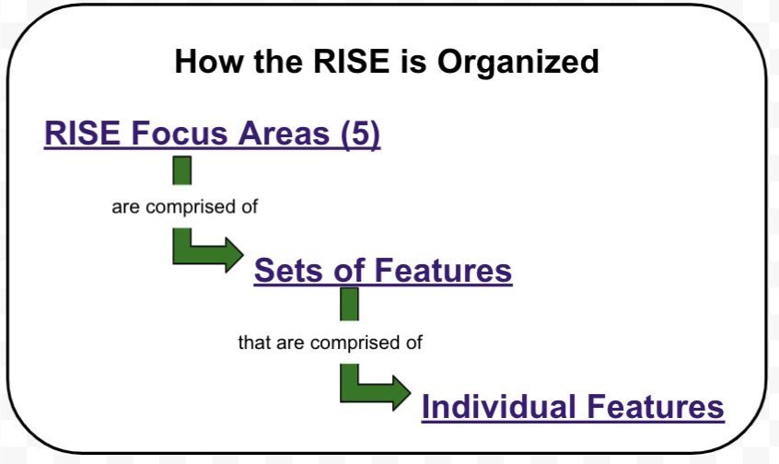

During Part 1 (Focus Area Reflection), the leadership team reviews and considers summary statements (Sets of Features) from each of the five RISE Focus Areas to determine if and how these are currently being implemented in their system. This reflection and discussion will allow the team to create a unique vision for their work in creating inclusive school communities and to prioritize their efforts moving forward. The Focus Area Reflection process supports creating a shared vision of the goals and desired outcomes for the inclusive education initiative and allows the work of the initiative to move forward with clarity of purpose. At the conclusion of the RISE Part 1, the EILT chooses one (possibly two, at a maximum) Focus Areas to reflect upon using the Features Reflection (Part 2). Although the team will work on one Focus Area at a time, all areas will need to be addressed over time in order to create lasting change.

During Part 2 (Features Reflection), the team completes an in-depth reflection on one (or two at most) RISE Focus Areas chosen at the end of Part 1: Focus Area Reflection process. Each Focus Area contains 20-30 Features divided into Sets of Features. Each Set of Features relates to a common theme. The team will rate their system in reference to each Set of Features. During the Features Reflection Process each feature in the Set of Features is read aloud and discussed. The team then describes the extent to which each Set of Features is currently demonstrated in their system. The team then scores their system on each Set of Features in the chosen Focus Area. When all sets are scored, the team then ranks the Sets of Features to create a list of first priorities for implementation. From there, teams engage in an Action Planning and Implementation process which is described in and supported by the TIES Inclusive Education Roadmap.

General Information about Facilitating the RISE

Engaging in a Facilitated Reflection Process

The RISE is a facilitated team self-reflection tool. The facilitation process is essential to creating a collaborative team experience in which all voices are heard, all concerns are discussed, and everyone’s time is respected. This type of process creates clarity and builds buy-in both of which will contribute to positive momentum moving forward.
Team members will likely come to the table with differing points of view about a variety of topics. Using the structured RISE meeting agendas (Appendix A) will allow everyone to share their views without any one person or point of view dominating the discussion.

Although one person can facilitate the RISE process alone, it is much easier to share responsibilities between a small team (2-3) of Facilitators. Anyone who is supportive of inclusive education for all students, including students with significant cognitive disabilities, can facilitate the RISE. All RISE Facilitators should complete the online training module before facilitating the RISE.

RISE Facilitator Responsibilities

Primary Responsibilities
- Leading the team through the RISE process allowing for rich conversation while also keeping the team on task.
- Posing guiding questions (provided for each Focus Area, see Appendix B) when needed, and help the group come to consensus when prioritizing Focus Areas and Sets of Features.

Additional Responsibilities
- Requesting relevant data for the RISE Focus Area Reflection (Part 2) meeting (such as, LRE for state, district and school disaggregated as much as possible, number and percentage of students who do not currently attend their home schools)
- Scheduling the RISE meetings
- Inviting stakeholders to the meeting
- Recording the team’s scores and rankings
- Keeping the team focused and on-task
- Answering questions regarding the RISE process
- Time-keeping

Facilitating the RISE Focus Area Reflection (Part 1)

Before the Focus Area Reflection meeting

- Facilitator Preparation

  - Read the RISE Facilitator’s Guide.
  - Complete the RISE Facilitator Training online module
  - Review the RISE (Part 1): Focus Area Reflection document
  - Enlist the assistance of others for tasks during the meeting, such as welcoming the leadership team, handing out materials, note-taking, and time-keeping.

- Data Gathering- work with administrative offices to acquire relevant data to review at the meeting. This would include current LRE data disaggregated by disability category and other demographics, as desired. Data regarding the number of students with significant disabilities not placed at their home school will also be useful.

- Material Preparation- Materials will vary depending whether the meeting is in-person or virtual. Suggested materials:

In-person | Virtual
- Technology needed to project the RISE on a screen for the team.  - RISE Part 1 PowerPoint with embedded rating scale  - Accessible paper copies of the RISE for those who prefer/request  - RISE Focus Area Reflection Steps-At-A-Glance for the Facilitator (Appendix C)  - Poster paper for brainstorming and “parking lot”  - Name tags or tents  - Colored markers | * Decide on the online virtual platform  * Determine and be familiar with the technology that will be used for rating and ranking. For example, Zoom poll, using the Chat Feature, Mentimeter software, or Kahoot.  * RISE Focus Area Reflection Steps-At-A-Glance for the Facilitator (Appendix C)  * RISE Part 1 PowerPoint with embedded rating scale

Facilitating the RISE Focus Area Reflection (Part 1)

- Welcome team members, conduct team introductions and provide housekeeping information as needed. Information shared will vary depending upon if the meeting is in-person or virtual.

- Provide an overview of the meeting purpose and intended outcomes of the RISE.

- Provide an overview of the RISE Focus Area Reflection (Part 1) process and distribute materials as needed.

- Review the RISE Frame of Reference

- Review and discuss disaggregated LRE system data.

- The facilitator leads the team though the RISE Focus Area Reflection tool
•Read through one Focus Area and the associated description.
•Discuss how this Focus Area supports each Outcome in your system
•Identify examples of where this Focus Area is being demonstrated in the system
•Identify examples of where the demonstration of this Focus Area needs strengthening
•For each Focus Area, rate the degree to which the related policies, practices, and procedures in the team’s system support each Outcome

- Based on the ratings, prioritize the Focus Areas and identify 1-2 for further reflection during the RISE Part 2. Ask the following questions as needed to guide the prioritization process:
- Do any of these Focus Areas seem foundational to the rest of the work?
- Are there current initiatives, programs, or restructurings happening in the (state, district or school) that could or should be paired with this Focus Area?
- How does this Focus Area fit with our current system culture and processes?
- Is there one Focus Area that might be an “easier” win that would increase buy-in for this work?

- Close the RISE Part 1 meeting. Choose a time and place to engage in Part 2 of the RISE, if not already scheduled.

After the Focus Area Reflection meeting

- Ensure that each team member is sent a copy of the completed RISE Focus Area Reflection (Part 1).

- Send calendar invite/reminder to all team members to the RISE Features Reflection (Part 2) meeting.

Facilitating the RISE Features Reflection (Part 2)

The RISE Features Reflection process gives the EILT the opportunity to dig deeper into the policies, practices, and procedures within the 1-2 RISE Focus Areas that were identified in the RISE Focus Area Reflection (Part 1). It is important to start with a “doable” number of priorities. All RISE Focus Areas will eventually need to be addressed over time in order to create equitable and inclusive schools for all students, including those with significant cognitive disabilities.

At the end of the RISE Features Reflection process the team will have a list of system priorities to increase the use of evidence-based best practices for inclusive education. The team will then engage in an Action Planning process using the TIES Inclusive Education Roadmap.

Before the RISE Features Reflection meeting

- Facilitator Preparation

  - Read the RISE Facilitator’s Guide.
  - Review the RISE Facilitator Training online module
  - Review the RISE Features Reflection document

- Material Preparation- Materials will vary depending whether the meeting is in-person or virtual. Note: The facilitator might enlist the assistance of others for tasks during the meeting, such as welcoming the leadership team, handing out materials, note-taking, and time-keeping.
Suggested In-person Materials:

In-person | Virtual
- Technology needed to project the RISE on a screen for the team.  - Accessible paper copies of the RISE for those who prefer/request  - RISE Features Reflection Steps-at-a-Glance for the Facilitator (Appendix D)  - Poster paper for brainstorming and “parking lot”  - Name tags or tents  - Colored markers | * Ideally, the team continues with the same online virtual platform and methods for rating items as they did during the RISE Part 1.  * RISE Features Reflection Steps-at-a-Glance for the Facilitator (Appendix D)  * The

During the RISE Features Reflection Meeting

- Welcome team members, conduct team introductions and provide housekeeping information, as needed. Information shared will vary depending upon if the meeting is in-person or virtual.

- Review the RISE Focus Area/s to be discussed in this meeting, and share the definition of the selected Focus Areas with the team (Refer to p.3)
- Review the RISE Frame of Reference.

- Present and explain the RISE Features Reflection scoring rubric:

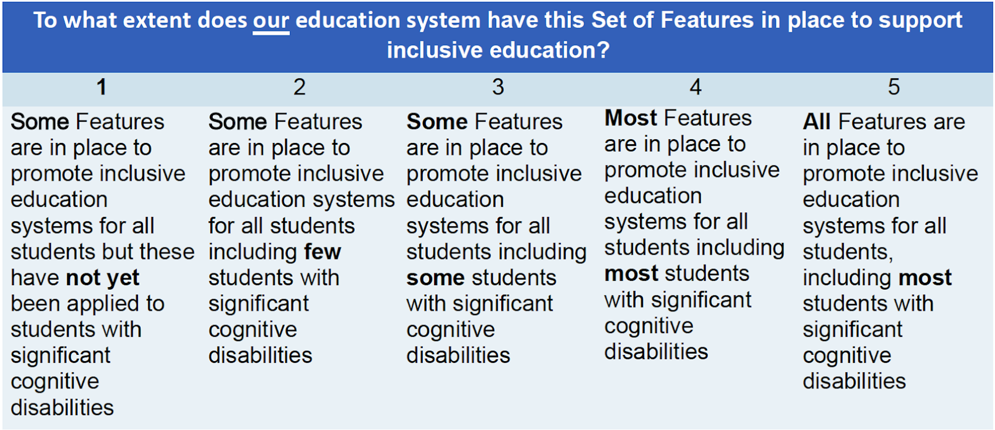

- Discuss each Feature of Inclusive Education in the first Set of Features in the Focus Area.

- Team members take turns reading each of the Features within the Set.
- Discuss what each feature would or does look like in your system.
- Continue until all Features in the Set have been discussed.
- Ask all team members to privately score their system on the current level of implementation of the Set of Features using the Features Reflection scoring rubric.
- Share the scores (using numbered cards, holding up fingers, Zoom poll etc.) and discuss the range of scores, the most frequently chosen score, and the reasons for the team members’ choices.
- After the discussion by the team, re-score the Set of Features and negotiate a consensus score that is acceptable to the entire team.
- Record the score.
- Repeat until all Sets of Features in the Focus Area are scored.

- Review Features Reflection Scoring Summary and build consensus on the
top priorities for initial implementation. While there is no required number of Sets of Features to select as priorities, it is recommended that the chosen sets will lead to the development of an action plan that:
- impacts student outcomes (including those with the most significant cognitive disabilities) across contexts;
- results in increased collaboration, support, and resources for general education, special education, and other teachers to plan and improve instruction for all students in diverse classrooms; and
- builds capacity across all stakeholders.

7. Ask the following questions, as needed, to guide the prioritization process:
- Which of these Sets of Features seem foundational to the rest of the work?
- Are there current initiatives, programs, or restructurings happening in the state, district or school that could or should be paired with a particular Set of Features?
- How does this Set of Features fit with our current system culture and processes?
- Is there one that might be an “easier” win that would increase buy-in for others on this project?

8. Record the priorities.

After the RISE Features Reflection Meeting

- Ensure that each team member is sent a copy of the completed RISE Features Reflection Summary Scoring Sheet and priorities.

- Recruit team members who will create a proposed action plan for each priority Set of Features using the IER for review and finalization by the whole EILT.

Appendix A

Sample RISE Part 1 Agenda with time map:
RISE Part 1: Today’s Agenda

- Review the list of potential stakeholders and add any others you may want to include in future meetings. (3-5 minutes) minutes)

- Read the RISE Frame of Reference and consider it in all conversations and ratings (3-5 minutes)

- Read the TIES Outcomes of building inclusive education systems (1 minute)

- Reflect on each Focus Area: (20 minutes each)
  - Definition
  - Relationship to T-I-E-S Outcomes
  - Identify positive examples of the focus area in your system
  - Identify need areas in you system
  - Rate your system’s current levels of practice

- Rank the Focus Areas to identify 1-2 for RISE Part 2 Reflection (10 minutes)

Appendix B

Possible Focus Area Reflection Questions

Values and Climate
- Which of these values are reflected in our state education system?
- What are some examples of shared responsibility currently evident in our system?
- How can we keep a special focus on students with significant disabilities when they represent only 1-2 % of our school population?
- What are some examples of our cultural and linguistically relevant parent resources?
- What barriers might we come up against when working on this area and how could we address them?

Placement and Settings
- What percentage of our students with “intellectual disability” as the primary or secondary disability category identified on their IEP are included in general education for 80% or more of the school day?
  - Does the percentage vary based on the age of the students?
  - Does the percentage vary based on the geographic location of the students?
  - Does the percentage vary based on the socio-economic status of the students’ neighborhood?
- Are we sure that our district and school personnel understand that taking an alternate assessment or using alternate learning standards does not, in and of itself, indicate the need for a self-contained classroom placement? How do we know?
- Is our team aware of the research describing the unintended negative consequences of placement in separate classrooms for students with SCD?
- What barriers might we come up against when working on this area and how could we address them?

General Education Curriculum Content and Access
- How do we ensure that our students who take the alternate assessment are accessing grade-level general education curriculum with adaptations as needed?
- How many (districts, schools, classrooms) do we think have embraced Universal Design for Learning (UDL)? Do we currently provide ongoing professional development with coaching on UDL?
- Do we currently provide ongoing professional development with coaching on providing access to general education curriculum for students with significant cognitive disabilities?
- What barriers might we come up against when working on this area and how could we address them?

Instructional Strategies
- Are we sure that our messaging about specially designed instruction (SDI) clearly states that students with significant cognitive disabilities can and should receive SDI in general education classes?
- Do we currently provide professional development on the “how tos” of providing SDI to students with disabilities, including those with significant cognitive disabilities in general education settings?
- Do we have data available that can tell us what percentage of teachers responsible for students with significant cognitive disabilities have the most appropriate teaching certificate offered by our state? If not, do we currently offer professional development on evidence-based instructional strategies for this student population?
- What barriers might we come up against when working on this area and how could we address them?

Education Systems

- Are we planning on using or advocating for district use of interim assessments now or in the future? How will we ensure there is an alternate interim assessment available for students with significant cognitive disabilities?
- Do we currently have a system in place to monitor access to alternative and augmentative communication systems for students in need of these systems?
- What opportunities are currently available for cross-department collaboration?
- Do we currently employ any individuals with identified disabilities?
- How does our system live up to the ideal that “low incidence does not mean low priority” when serving students with low incidence disabilities?

Appendix C
RISE Focus Area Reflection (Part 1): Steps-At-A-Glance

- Review the potential stakeholders and add any others to consider during ratings
- Read the TIES Frame of Reference and consider it in all conversations and ratings
- Read the Outcomes to support building inclusive education systems
- Read one Focus Area and associated Sets of Features.
- Discuss how this Focus Area and associated Sets of Features should lead to/support each Outcome. As you discuss, you can note times when your team
  - Identifies examples of where this Focus Area and Sets of Features are being demonstrated in our education system
  - Identifies examples of where the demonstration of this Focus Area and Sets of Features need strengthening
- For each Focus Area and Sets of Features, rate the degree to which the related policies, practices, and procedures in our education system lead to and support each Goal
- Rank the Focus Areas to identify 1-2 for further reflection

Appendix D

RISE Features Reflection (Part 2): Steps-At-A-Glance

- Review the five RISE Focus Areas and read the definition for the Focus Area to be addressed in the meeting.
- Review the RISE Frame of Reference
- Team members take turns reading each of the Features within the first Set of Features.
- Discuss what each feature would or does look like in your system.
- Continue until all Features in the first Set have been discussed.
- Ask all team members to privately score their system on the current level of implementation of the Set of Features using the Features Reflection scoring rubric.
- Share the scores (using numbered cards, holding up fingers, Zoom poll etc.) and discuss the range of scores, the most frequently chosen score, and the reasons for the team members’ choices.
- After the discussion, re-score the Set of Features and negotiate a consensus score that is acceptable to the entire team.
- Record the score.
- Repeat until all Sets of Features in the Focus Area are scored.
- Review Features Reflection Scoring Summary and build consensus on the top priorities for initial implementation.

