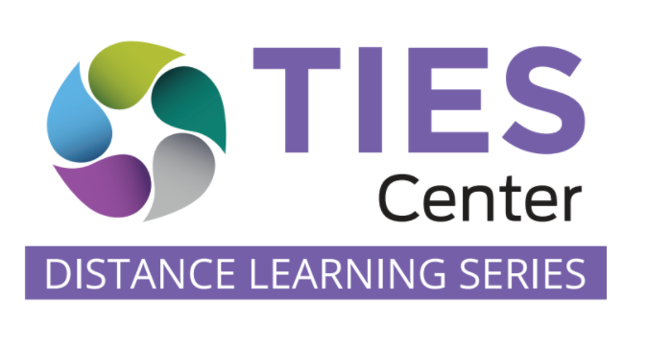
TIES Center 5C Process Guiding Questions

Components
- What is the long-term vision of the family and the student?
- Given this vision, what priority areas should be focused on in each of the learning components to build the student’s knowledge and skills towards the vision?
  - What content standards are addressed at this grade level? Which parts of each standard are the most relevant to this student, at this time?
  - What are the priority routines and transitions to focus upon across environments?
  - What are the social and communication priorities to enhance interactions?
- What are the family’s daily routines, important times of the day, and traditions that would help the instructional team support scheduling and instruction at home?
- Are there any specific areas of concern that the family has already experienced through distance learning that we should proactively think about together?

Collaboration
- How will the team work to maintain a focus on the student experiencing membership, active participation, and learning the general education curriculum across the day?
- What does the family’s typical day look like? What are their traditions and routines?
- Is there a natural time during the day to prioritize each IEP goal?
- If an IEP goal cannot be easily addressed at home, is there a modified goal to focus on in the same learning component that could be substituted?
- Beyond what the school is doing to protect the safety of all students and staff during this time of the pandemic, are there any additional needs that the team needs to consider in terms of safety concerns for the student when instruction is happening at school?

Continuity
- What no-tech, low-tech, or high-tech tools is the teacher offering to all students? Is this the same or different across classes/teachers?
- What are the available no-tech, low-tech, or high-tech tools and strategies that the student usually uses?
- Are there any other no-tech, low-tech, or high-tech tools and strategies that should be proactively introduced to prepare for the possibility of distance learning? (Note: This would include using any schoolwide platform or a supplemental support).
- Are there family members, including siblings, already familiar with the district platforms who can support the student?
- Would family members be able to comfortably use these tools and strategies if they were supported in learning them? What would support look like? By whom, how, and when would that support be provided?

Collect Data
- Which formative and summative assessments related to the general education curriculum will be used to monitor progress for this student?
- Is collecting data at home an option if it can be very straight-forward and built into the daily routines?
- Are there goals that you will collect data on more or less frequently during distance learning?
- How can the data collection be streamlined and fit into the family’s schedule?

Capacity
- What are the student’s overall learning priorities?
- What is the plan for supporting the teaching and learning of IEP goal areas at school and home?
- How will data be collected, by whom, and when?
- What do I need to know to use the no-tech, low-tech, and high-tech instructional tools and strategies (current or that will be strategically initiated) to support student learning?

