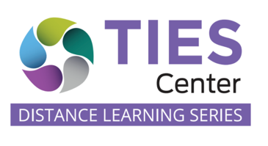

5C Process: Planning Instruction in Inclusive Environments both at School and in Distance Learning

Why?
We are committed to providing meaningful instruction where students with disabilities learn and thrive in inclusive environments with their grade-level peers.
The current reality is hard on all students, schools and families. It has created new barriers for achieving this commitment. This is particularly true for students with significant cognitive disabilities. Meaningfully and realistically planning and aligning instruction between being at school, at home or moving between the two during hybrid learning for these students has been challenging for everyone.
Yet, a student’s learning priorities do not change just because the learning environment changes. The learning priorities are specific to the student, but what instruction looks like in the different inclusive settings to reach these priorities may vary. Determining what, how and where instruction happens needs to be thoughtful so that what is learned is documented and transfers when instruction returns to full-time in person.

What?
The 5C Process guides instructional teams, including family members, through a planning process to identify the priority learning areas; when, where and how instruction related to these priorities will happen at school and home; determining how we will know if the student is learning; and aligning what instruction looks like across environments. Through this collaborative process, teams develop a comprehensive plan for student learning wherever that is currently occurring, in-person in schools and/or during synchronous and asynchronous distance learning. Families help to identify what is reasonable and doable for them to support their child’s learning during the times of synchronous and asynchronous distance learning.

How?
Ideally, the 5C Process is completed in a single session of about one hour (for more complex students or students who are new to a team, planning for two meetings that total 1½ hours may be more realistic). Using the Guided Questions, the team goes through 5Cs (Components, Collaboration, Continuity, Collect Data and Capacity) and collaboratively builds common knowledge about the student and develops the instructional plan. Using the Learning Matrix for School and Learning Matrix for Home, everyone on the team has a common understanding of the implementation of the overall instructional plan.

