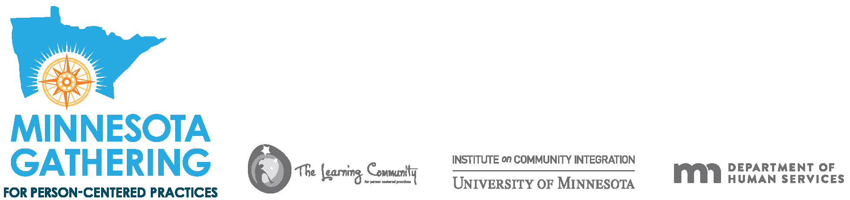
Certificate of Participation for the 2022 Minnesota Gathering for Person-Centered Practices
About the Minnesota Gathering for Person-Centered Practices:
This training serves as an opportunity for everyone who is involved in supporting people with disabilities to continue to grow their understanding of person-centered practices, such as:
- The importance of being listened to and effects of having positive control
- The role of daily rituals and routines
- How to discover what is important to people
- Connecting with community service providers to discuss methods of implementing person centered practices
- The history of person-centered practices
The Minnesota Gathering for Person-Centered Practices offers a variety of learning experiences throughout both days. The Minnesota Gathering for Person Centered Practices is eligible for you to request Continuing Education Units (CEUs) from your certifying body. To obtain CEU credit utilize your registration confirmation email and the Gathering program which you may print on the day of the Gathering.
_____________________________________________________________________

October 25 & 26, 2022
Dates of training:
First and Last Name

