RTC/OM HCBS Outcome Measures

About the Measures

The University of Minnesota’s Research and Training Center on HCBS Outcome Measurement (RTC/OM) followed a multi-phased and iterative development and testing process to develop a set of two-tiered measures related to eight different domains of the National Quality Forum’s (NQF) Framework for Home and Community-Based Services (HCBS). All measures are intended to be used with adult HCBS recipients who experience intellectual/developmental, physical, age-related, or psychiatric disabilities, as well as with people who have traumatic/acquired brain injury. The measures are person-centered and focus on assessment of the extent to which desired levels of outcomes have been achieved by people with disabilities receiving HCBS. RTC/OM measures coincide with individual domains and subdomains of the Revised National Quality Forum Framework (RTC/OM, 2016).

Figure 1. RTC/OM Revised National Quality Forum HCBS Outcome Measurement Framework

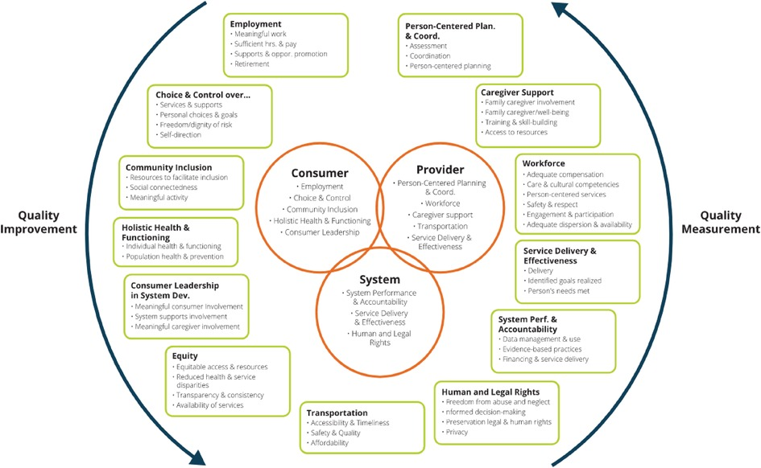

Each of the outcome measures developed by the RTC/OM is modular in format. Measures can therefore be used independently or in conjunction with other measures as part of a structured interview. There are two tiers of items within each measure. The first tier (tier 1) includes global items designed to gain a broad understanding of each measurement domain/subdomain. The second tier (tier 2) includes specific items that are intended to elicit more detailed and actionable information regarding specific domains/subdomains. Tier 2 items can be used to gain more complete information for all or some participant responses to the global items.

It is important to note that a number of HCBS outcome measures are currently available and in use. However, many of these focus primarily on state level compliance with regulations set forth by the Center for Medicaid and Medicare Services (CMS) for programs eligible for funding under Home and Community-Based Services waivers. RTC/OM outcome measures are focused on the provider level and have the capacity to be used longitudinally (at multiple points across a specified time period) in order to assess when change has taken place in the outcomes HCBS recipients are experiencing.

A description of the purpose and structure of each outcome measure is provided below.

Choice and Control (Self-Determination) Measures
The Choice and Control measures developed by the RTC/OM are designed to determine the extent to which the recipients of HCBS make important decisions and exercise control over those aspects of their daily lives and services. Items allow for a determination of whether those areas in which people exercise control are important to them and the degree to which their control is consistent with their desired degree of choice and control.

Three measures of choice and control are provided in this domain. One measure focuses on choice and control over a variety of aspects of personal and daily life. A second measure centers on the choices people have and the control they exercise over the services and supports they receive. The third measure, self-direction is intended for HCBS recipients who utilize a self-directed waiver plan and determines their degree of control over the plan and its implementation. Each measure is designed to determine: (a) the level of personal control a person exercises, (b) the degree to which this is consistent with the level of control they desire to exercise, and (c) the level of importance they assign to having control over each area.

Total Number of Choice and Control Items: 46

Choice Over Personal and Daily Life: 21
Tier 1 Items (Global): 3
Tier 2 Items (Specific): 18

Choice Over Services and Supports Total Items: 20
Tier 1 Items (Global): 5
Tier 2 Items (Specific): 15

Self-Direction: 5

Employment Measures
Employment measures focus on three components or sub-measures related to the experience of people who work, are looking for work, or are retired/beginning to plan for retirement. Beyond tracking type of employment, hours worked, and wages, these measures focus in a wholistic manner on the experiences an individual has while on the job including job-related supports, opportunities for advancement, and relationship with both co-workers and customers.

Measures in this domain focus on the degree to which a person’s current employment experiences are of high quality and meet their personal needs. Measures focus on
Job Experiences, Experiences Seeking Employment, and Retirement. Both unemployed and employed HCBS recipients are administered the Experiences Seeking Employment measure and are asked about their desires related to work and attempts at obtaining a job, along with the barriers they have encountered seeking employment. In addition, for employed HCBS recipients, the Job Experience section measures various aspects of their employment experience. Individuals are briefly asked about their retirement planning including if they are or did plan for their retirement and the extent of their planning.

Total Number of Employment Items: 31

Job Experiences:(14 total items)
Tier 1 Items (Global):3
Tier 2 Items (Specific): 11

Experiences Seeking Employment: (13 total items)
Tier 1 Items (Global):3
Tier 2 Items (Specific): 10

Meaningful Community-Based Activity Measure
The Meaningful Community-based Activity measure includes items related to six general categories of meaningful activities: everyday life tasks, social activities, leisure/relaxing activities, physical exercise, educational, and professional activities. The focus is on determining the degree to which respondents have the opportunity to engage in community activities that they value to the extent that meets their needs and preferences as well as their experiences when taking part in these activities.

For each type of community-based activity category included in this measure, respondents are asked: if the type of activity is meaningful to them; if they take part in this type of activity enough to meet their needs/desires; if they recently enjoyed engaging in this type of activity; and finally, if they receive enough support to take part in activities to the extent to which they desire. Items cover a wide variety of community-based activities.

Total Number of Meaningful Community-Based Activity Items: 29
Tier 1 Items (Global): 3
Tier 2 Items (Specific): 26

Social Connectedness Measure
The Social Connectedness measure assesses the extent to which the social connections that respondents have with those they consider to be family, friends, acquaintances, and other community members meet their affiliation needs. In addition, items measures the quality of these relationships and the degree of reciprocity that exists within them.

The Social Connectedness measure has 15 items assessing participation in the community and relationships with family members, friends, and others. Items address both the person’s connection with the community (i.e., if people in the community are friendly); the extent to which the respondent feels connected to others in their community, the social supports they have available (i.e., emotional, instrumental, informational, companionship) including areas in which social support is received when needed and opportunities to provide it to others (i.e., the reciprocity they experience in their personal lives). In addition, the measure assesses the extent to which services and supports are assisting HCBS recipients in being and staying socially connected.

Total Number of Social Connectedness Items: 15
Tier 1 Items (Global): 3
Tier 2 Items (Specific): 12

Transportation
The Transportation measure is designed to measure the degree that the transportation to which a respondent has access meets their needs and preferences. The measures focuses on the availability of the transportation the person prefers to utilize and most often use, its quality, and the extent to which the individual feels safe when using it.

The focus of the Transportation measure is on the types of transportation a person most often uses, the quality of this transportation, the barriers the respondent faces in using it, and those modes of transportation they desire to use more frequently. In addition, items assess the individual’s judgment as to the affordability of the transportation to which they have access, its accessibility, and the extent to which the transportation support they have available is meeting their needs.

Total Number of Transportation Items: 17
Tier 1 Items (Global): 4
Tier 2 Items (Specific): 13

Person-Centered Planning and Coordination Domain Measures
This suite of Person-Centered Planning and Coordination measures covers multiple aspects of the provision of HCBS in a person-centered manner. It includes measures of Person-Centered Assessment, Person-Centered Planning, Person-Centered Service Delivery and Coordination, and Person-Centered Life Outcomes/Goal Attainment. The focus of the measures is to determine both the degree to which the services and supports a person receives are person-centered in their orientation, the extent to which they take into consideration both the individual’s needs (what is important for the person) and preferences (what is important to the person), and how effectively services are supporting respondents to achieve or make progress toward their personal goals.

This suite of measures assesses a wide variety of aspects associated with the person-centeredness of the services and supports an HCBS recipient is receiving. The Person-Centered Assessment and Planning measures included in the suite, evaluate the extent to which the assessment and planning for the HCBS recipient’s needs is completed in a person-centered manner. The Coordination measure assesses several different aspects of the quality of person-centered service coordination and provision. The Life Outcomes Goal Attainment measure can be used for several purposes. These include identifying a person’s desired life goals, assessing the degree to which the HCBS recipient is making progress toward or has achieved personal goals, the barriers they have encountered along the way and any additional supports they believe are needed to support progress toward goals or goal attainment.

Total Number of Items: 77

Person-Centered Assessment: 12
Tier 1 Items (Global): 2
Tier 2 Items (Specific): 10

Person-Centered Planning: 17
Tier 1 Items (Global):3
Tier 2 Items (Specific): 14

Person-Centered Coordination: 22
Tier 1 Items (Global): 3
Tier 2 Items (Specific):19

Person-Centered Life Outcomes Goal Attainment Measure: 30

Consumer Leadership in System Development Measures
Consumer Leadership in System Development measures focus on two aspects of
the leadership recipients of HCBS services are able to exercise over the system that provides them with services and supports. The first focuses on the extent to which the respondent has been involved in leadership activities associated with HCBS. The second measure centers on the extent to which the system including providers of HCBS provide the accommodations and supports the person needs in order to actively participate in the decision- and policy making related to development, implementation, and evaluation of HCBS.

Consumer Leadership in System Development measures include separate measures that focus on Evidence of Meaningful Consumer Involvement and the degree to which the System Supports Meaningful Consumer Involvement. The Evidence of Meaningful Consumer Involvement measure focuses on the degree to which an HCBS recipient has assumed a leadership role in improving the organization that provides their services and/or the HCBS system as a whole. The System Supports Meaningful Consumer Involvement measure evaluates the extent to which the organization in question is providing opportunities for leadership and supporting the HCBS recipient to be involved in the design and improvement of HCBS.

Total Number of Consumer Leadership in Systems Development Items: 21

Evidence of Meaningful Consumer Involvement:11
Tier 1 Items (Global):5
Tier 2 Items (Specific): 6

System supports meaningful consumer involvement:10
Tier 1 Items (Global):3
Tier 2 Items (Specific):7

Freedom From Abuse and Neglect Measure
The Freedom from Abuse and Neglect measure was developed to assess the extent to which HCBS recipients are free from the experience of abuse and neglect and have access to the resources needed to prevent, and when necessary report, and when needed receive the supports needed to recover from such traumatic experiences as well as their perceptions with respect to safety at home and within their community.

The Freedom from Abuse and Neglect measures include two indicators. The first, Freedom from Abuse and Neglect reflects the respondents person’s actual experiences with respect to abuse and/or neglect with a focus on those that have occurred within the past year and the degree to which they feel safe. The second measure, Abuse and Neglect Education focuses on the extent to which the individual’s support organization has provided training/instruction related to identifying instances of abuse and neglect, reporting these incidents in a safe way, and accessing the services needed to prevent future instances of this outcomes and support recovery.

Total Number Freedom from Abuse and Neglect Items: 26
Tier 1 Items (Global):4
Tier 2 Items (Specific): 22

References
Rehabilitation Research and Training Center on HCBS Outcome Measurement (RTC/OM). Stakeholder Input: Identifying Critical Domains and Subdomains of HCBS Outcomes. (2016). Available from: https://rtcom.umn.edu/phases/phase-1-stakeholder-input

