Technical Report: Results of the RTC/OM Pilot Study Testing of Person-Centered HCBS Outcome Measures

Developed by:

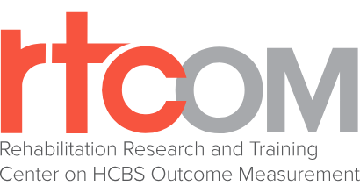

The Rehabilitation and Research Training Center on Home and Community-Based Services Outcome Measurement, Institute on Community Integration, College of Education and Human Development, University of Minnesota.

Brian Abery, Ph.D., Co-Director
Renáta Tichá, Ph.D., Co-Director
Matt Roberts, M.S.
Alec Nyce, M.S.

This publication was supported by federal grant/cooperative agreement #90RT5039 from the National Institute on Disability, Independent Living, and Rehabilitation Research (NIDILRR). For any questions about this document, please email rtcom@umn.edu.

Table of Contents
EXECUTIVE SUMMARY 4
Introduction & Background 6
Measurement in HCBS 6
RTC/OM 7
RTC/OM Measure Development Process 9
Technical Expert Panel 11
Cognitive Testing 12
Importance of Pilot Study 12
Method 14
Sample 14
Demographics 14
Description of Measures 15
Scalable Items 16
Item Types and Psychometric Analysis 16
Skip Logic 16
Tier 1 / Tier 2 Item Analysis 17
Administration Procedure 18
Evidence of Feasibility/Usability 21
Measure Completion Times 21
Interviewer Qualitative Data 21
Non-Response, Understanding, and Examples/Definitions Used 22
Interview Feedback 22
Videoconference vs In-Person 23
Data Analysis Methods 24
Item Analysis 24
Psychometric methods 24
Internal Consistency 24
Test-Retest Correlation 24
Inter-Observer Agreement. 24
Missing Data and Missing Data Procedures 25
Inferential Statistical Methods 25
Results 26
General Descriptive Statistics 26
Response Styles 26
Measure Completion Times 27
Summary of Reliability & Agreement 27
Abuse and Neglect 28
Composite Variables 29
Freedom from Abuse and Neglect 30
Tier1-Tier 2 Analysis 32
Choice and Control 33
Tier 1 – Tier 2 34
Employment 35
Tier 1 – Tier 2 Analysis 35
Summary of Employment measure Revisions 36
Meaningful Activity 37
Tier 1 – Tier 2 Analysis 37
Social Connectedness 38
Tier 1 – Tier 2 Analysis 38
Transportation 38
Descriptive Statistics 39
Tier 1 – Tier 2 Analysis 39
Disability Group Comparisons 40
Emoji-Text Response Scale Comparisons 41
Discussion 42
Limitations 42
Representativeness of Sample 42
Positive Response Bias 43
Tier1- Tier 2 Analysis Limitations 44
Feedback for interviewers/interview from participants 44
Videoconferencing vs In-person 45
Pandemic Impact 45
Future Measure Revisions 45
Conclusions 46
References 48
Appendix 53
Appendix Figure 1a to Figure 1f. Measure completion times (in minutes) for individual participants. 53
Appendix Figure 2. Box-and-whisker plots of participant gender. 56
Appendix Figure 3. Barplots of participant residence location and living arrangement type. 56
Appendix Figure 4. Barplots indicating participants’ type of living situation (columns), their primary source of support (rows), and the residence location (color). 57
Appendix Figure 5. Counts of total scores for Freedom from Abuse and Freedom from Neglect composite scores. 58
Appendix Figure 6. Cross-tabulation of level of Freedom from Abuse (horizontal axis) by level of Freedom from Neglect (column plates). 58
Appendix Figure 7. Histogram of sum scores of reported usage of different transportation types from the “How often…” items. 59
Appendix Figure 8a-8g. The distributions of total scores on each of the RTCOM measures. 60
Agreement Response Scales 64
Abuse and Neglect – Inter-item correlations 65
Appendix Table 1a. Pearson correlations between items of the Abuse and Neglect measure. 65
Choice and Control – Inter-item correlations 66
Appendix Table 2a. Pearson correlations between items of the Choice and Control measure. 66
Job Experience Survey (Employment) – Inter-item correlations 70
Appendix Table 3a. Pearson correlations between items of the Job Experience Survey sub-measure included in the Employment measure. 70
Barriers to Employment (Employment) – Inter-item correlations 72
Appendix Table 3b. Pearson correlations between items of the Barriers to Employment sub-measure included in the Employment measure. 72
Meaningful Activity – Inter-item correlations 73
Appendix Table 4a. Pearson correlations between items of the Meaningful Activity measure. 73
Social Connectedness – Inter-item correlations 76
Appendix Table 5a. Pearson correlations between items of the Social Connectedness measure. 76
Transportation – Inter-item correlations 77
Appendix Table 6a. Pearson correlations between items of the Transportation measure. 77
Appendix Table 1b. Abuse and Neglect item stems and response scales 78
Appendix Table 2b. Choice and Control 80
Appendix Table 3c. Employment 81
Appendix Table 4b. Meaningful Activity 83
Appendix Table 5b. Social Connectedness 84
Appendix Table 6b. Transportation 85
Appendix Table 7. Interview Feedback questions 86

EXECUTIVE SUMMARY
Overview
The Rehabilitation Research and Training Center on Home and Community-Based Services (HCBS) Outcome Measurement (RTC/OM) conducted pilot testing of newly developed measures during the Fall 2019 to Spring 2020 time period. The purpose of the pilot testing was to obtain feasibility/usability and preliminary psychometric data for HCBS outcome measures assessing eight domains/subdomains of the National Quality Forum’s (NQF) HCBS Outcome Measurement Framework.

Study (Target) Population
The target population for this study included adults from the states of Minnesota and Pennsylvania (18 years of age or older) with at least one of the following disability types: Traumatic Brain Injury (TBI), Age-Related Disability (ARD), Serious Mental Health Condition (MH), Intellectual or Developmental Disability (IDD), or Physical Disability (PD). In addition, the person also needed to be receiving HCBS for the disability to be eligible for participation in the study.

Methodology and Sample
Pilot study participants with disabilities were recruited primarily through partnerships with local HCBS providers in Minnesota and Pennsylvania. The measures were administered as part of a structured in-person (n=85) or videoconference (n=22) interview with each participant and responses were collected using the Qualtrics survey platform. A total sample of 107 participants was obtained and the number of participants administered each measure ranged from 100 (Abuse and Neglect) to 105 (Social Connectedness). The demographic makeup of the sample included 72 identifying as White, 18 as Black, 3 as American Indian and 6 as more than one race. Identified gender was 49 Male and 56 Female. The primary disability types of participants included IDD (26), MH (26), PD (25), ARD (17), and TBI (13).Ages of the sample ranged from 22 to 101 years and included members of both suburban/urban (n=76) and rural areas (n=31).

Results
Overall, the data indicated good feasibility and usability of the measures. Average measure completion times ranged from 10.2 minutes (Social Connectedness) to 18.2 minutes (Choice and Control), and in-person administration resulted in faster measure completion times than interviews performed via videoconferencing. Moreover, withdrawal from the study was rare and interviewers and participants indicated positive impressions from the interviews.

Internal Consistency Reliability. Cronbach’s alpha indicated acceptable internal reliability for the majority of measures. Estimates ranged from .62 (Abuse and Neglect) and .94 (Meaningful Activity).

Test-Retest Reliability. Test-retest was estimated for a portion of the sample (n= 28). Of these participants, nine (9) were administered the measures via videoconferencing. The target interval between administrations was 10-14 days. The realized range of days between administrations was 3-28 days, with an average time frame of approximately 13-14 days. Estimates by measure ranged from acceptable (.72; Personal/Daily Choice and Control) to excellent (.99; Job Experiences).

Inter-Observer Agreement. Inter-Observer Agreement was estimated for a portion (n=24) of the participant interviews using the average percent agreement between observers (primary interviewer and observing interviewer). All inter-observer agreement observations were performed in-person. Estimates by measure ranged from .89 (Employment measures) to .98 (Abuse and Neglect and Personal/Daily Choice).

Discussion
Limitations. There are several limitations noted for the pilot study. These included sample limitations such as size, high number of employed participants, and possible underrepresentation of HCBS recipients with more significant disabilities due to informed consent requirements and the need for participants to directly respond to the items in the measures. The study data were also informative regarding areas the measures could be improved and used to make final revisions prior to beginning the national field study.

Conclusions. Overall, it can be concluded that the measures demonstrated good indications of the feasibility/usability of the measures and very good or excellent preliminary psychometric characteristics. Some analyses were limited by the sampling and measure structure and this led to several revisions to the measures and to the process of administering the measures. Further evidence will be gathered during the national field study conducted under the RTC/OM.

Introduction & Background

Measurement in HCBS

Home and Community-Based Services (HCBS) refers to an array of services and supports many people with disabilities receive through the Long-Term Services and Supports (LTSS) program administered by the Centers for Medicare and Medicaid (CMS). Recent estimates indicate that over 2.5 million people with disabilities receive HCBS in the United States (KFF, 2020). Measurement of HCBS outcomes has not kept pace with the developments and expansion of services. Many states, managed care organizations (MCOs), and service providers of varying sizes struggle to adequately measure the quality of the services they provide and the outcomes experienced by service recipients.
High-quality measurement is essential to our understanding of the extent to which HCBS are provided in the intended way and produce the outcomes desired by recipients. The ultimate goal of HCBS is to provide recipients with services that support them to participate in and become engaged with their communities in ways they desire. Regulatory authorities have put increased pressure on providers to design services to meet this goal. The Olmstead legal decision (1999) required states to provide support for people with disabilities in the most inclusive community setting possible. States are also working towards compliance with the HCBS Final Settings Rule (2014) and its requirement for states to provide recipients of HCBS with opportunities to be fully included in the community to the same extent as their peers without disabilities. Measurement is needed to determine whether states and providers are meeting these requirements and recipients are obtaining the outcomes they desire. Moreover, decision makers at all levels of the HCBS system need high-quality measurement tools to provide the information needed to improve services and advance outcomes.
Currently, the quality of HCBS outcome measurement is inadequate and does not meet the needs of HCBS recipients or providers. Many of the measurement tools lack the empirical development and testing to justify their use. In addition, the measurement tools are sometimes used in ways that go beyond their intended purpose. Yet, some states are using the data for program improvement and with other disability populations. Moreover, the majority of measurement in HCBS waivers programs is at the state level with very few programs engaging in measurement at the HCBS provider and individual levels (RTC/OM, 2019).
High-quality, psychometrically-sound measurement is essential to obtaining useful information about the impact HCBS has on its recipients. By psychometrically sound we mean that there is high quality research evidence available to support the argument that the data derived from the HCBS outcome measurement tools in use are both reliable and valid (American Educational Research Association - AERA, American Psychological Association - APA, & National Council on Measurement in Education – NCME; 2014). Without sufficient evidence supporting the reliability and validity of measure outcomes, decisions made by stakeholders such as state and federal medicaid program authorities and organizations who provide HCBS may not be adequately informed. Responsible federal and state agencies cannot make accurate judgements about the degree to which states and provider organizations are in compliance with existing regulations. States cannot make informed decisions about appropriate funding allocations, and areas in need of program development. Provider agencies are left in the dark when choosing in which areas they need to innovate to improve services. At the individual level, HCBS beneficiaries may be left with information that is inaccurate and potentially misleading when it comes to making decisions about which provider(s) or service(s) to select.

RTC/OM

The Rehabilitation Research and Training Center on HCBS Outcome Measurement (RTC/OM) funded by the National Institute on Disability, Independent Living, and Rehabilitation Research (NIDILRR) was tasked with developing person-centered HCBS quality and outcome measures based on the National Quality Forum’s (NQF) HCBS Framework. Using nation-wide participatory planning and decision making (PPDM) process, the RTC/OM validated the importance of the NQF framework domains and subdomains with HCBS recipients, family members, HCBS providers, and HCBS program administrators/policy makers (RTC/OM, 2017). The RTC/OM used data regarding the importance of each domain in conjunction with a gap analysis to prioritize the development of HCBS quality and outcome measures in several different domains/subdomains including:

- Community Inclusion: Meaningful Activity
- Community Inclusion: Social Connectedness
- Community Inclusion: Transportation
- Human and Legal Rights: Freedom from Abuse & Neglect
- Choice and Control: Personal Choices & Goals
- Choice and Control: Choice of Services & Supports
- Choice and Control: Self-Direction
- Employment

The National Quality Forum (NQF), under a contract with the Department of Health and Human Service (HHS), convened an expert panel to develop recommendations for the inclusion and prioritization of elements to address performance measure gaps in HCBS measurement (NQF, 2016). In their sessions, the NQF defined a framework of 11 core elements of quality. The framework highlights what are operationally defined as system factors, service factors, and personal outcomes and lays a foundation for identifying and refining existing measures as well as for prioritizing the development of new measures for domains and subdomains that are not yet being measured. To validate the NQF framework, RTC/OM staff persons led fifty-eight Participatory Planning and Decision Making (PPDM) groups with stakeholders across the country from four primary backgrounds: people with disabilities, family members of people with disabilities, organizations that provide HCBS, and HCBS policymakers and program administrators (RTC/OM, 2016). The PPDM format allowed stakeholders to weigh the importance of potential measurement domains and subdomains and move toward consensus as to which were most important to measure. Figure 1 summarizes the RTC/OM validated framework.

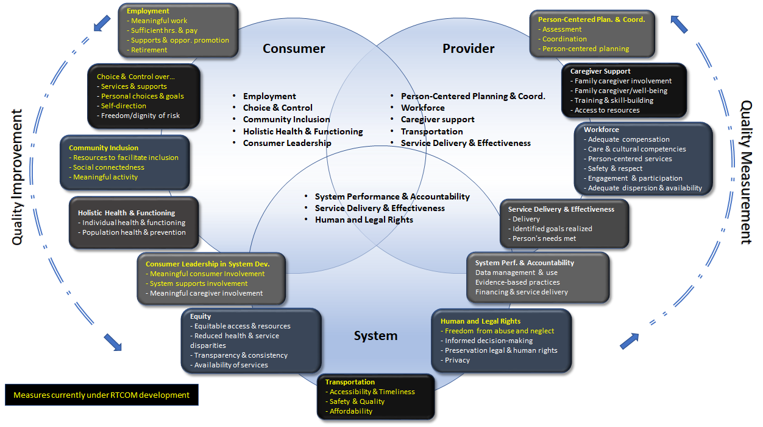

Figure 1. The RTC/OM Validated NQF Framework.

After using the results of stakeholder input to determine the most important areas to measure, a gap analysis was undertaken and input from a national advisory group of HCBS leaders and stakeholders used to finalize the selection of eight outcome areas for measure development. The gap analysis involved a review of over 140 instruments used for HCBS outcome measurement and coding their items against the NQF framework to identify the domains and subdomains in which promising measures were already available and those needing further measure development. An expert panel of members from the RTC/OM national leadership and advisory groups then rated the potential domains and subdomains on feasibility, usability, and importance to guide the selection of the initial concepts for development. Two important criteria for inclusion were: 1) high ratings from stakeholder groups, and 2) person-centeredness (i.e., responded to by the person, based on what is important to him or her). Table 1. includes the measure concepts selected for development and their definitions.

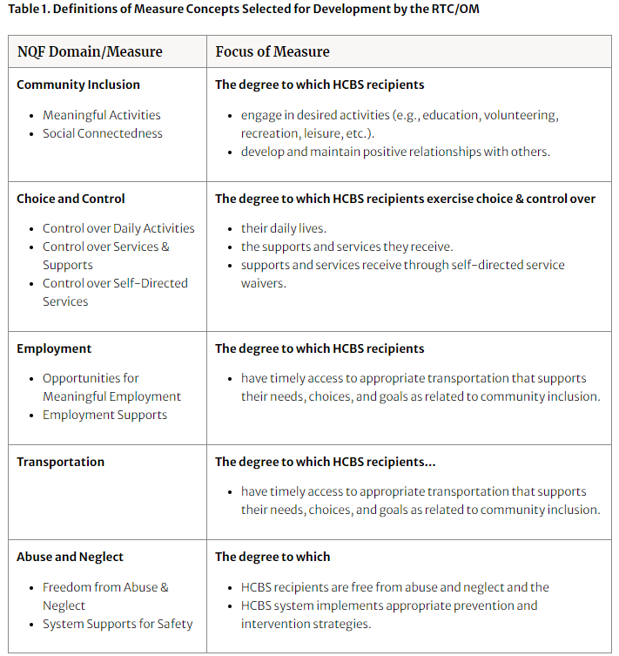

RTC/OM Measure Development Process
Although CMS outlines a comprehensive process for developing, implementing, maintaining, and evaluating measures in their Blueprint for the CMS Measures Management System (2019), they primarily rely on the NQF for independent evaluation and endorsement of measures. The NQF has established a process for evaluating and endorsing measures that involves developers submitting information about a measure related to five key evaluation areas:
- Importance to Measure and Report
- Scientific Acceptability of Measure Properties
- Feasibility
- Usability and Use
- Related and Competing Measures
The NQF uses a standardized review criteria to evaluate the suitability of submitted measures and subsequently makes a recommendation for or against their endorsement. While the NQF endorsement process is an important indicator of the HCBS measure quality, it is important to acknowledge that there are and have been other scientific criteria as laid out by APA that have guided measure development in other fields for many decades (e.g., psychology, education, etc.). For example, specific guidelines for measurement when it is used with people with disabilities are provided by the APA (APA, 2020) and the Standards for Educational and Psychological Testing (AERA, APA, & NCME 2014). Despite these extensive guidelines and standards, the vast majority of instruments in HCBS have not undergone this rigorous development process. As a result, users cannot be confident that their use will lead to the collection of reliable and valid data. In RTC/OM, while we strive to produce measures that will ultimately be endorsed by NQF, we hold ourselves to traditional and universal psychometric standards outlined for quality measure development as laid out by APA, CMS, etc. In the approach undertaken by the RTC/OM, following the identification of measures to develop, extensive literature scans were conducted for each measure concept. These scans had the broad goal of exploring the problem space of each measure concept including, 1) construct definitions (e.g. How is each measure theoretically defined in the literature?), 2) Operational definitions (e.g. What are the concrete domains and indicators used to measure the construct?) 3) Existing instruments that measure the construct (e.g. Are their psychometric characteristics known? Person-centered?). The information collected about each measure concept was summarized in a series of blueprints that guided the next step of item development.

The next step in the measure development process was the drafting of guiding questions. Guiding questions were developed and used to direct the generation of items for each measure concept and to serve as assertions for the intended uses and interpretations of the measure under development. Guiding questions can be conceptualized as arguments that specify the intended inferences and supporting assumptions for the measure. Validity evidence must be provided for each argument presented in each guiding question. Validation for an argument can be thought of as the evaluation of the coherence and completeness of the interpretations and use of the argument and of the plausibility of its inferences and assumptions (Kane, 2013).
They refer to specific inferences related to the construct measured and more specifically their identified domains and subdomains. Before creating new items, items from existing HCBS instruments were reviewed to ensure coverage of those aspects of the construct in question not currently being measured. Based on this review, the RTC/OM team developed items to capture the domains and subdomains identified in the blueprint for each measure concept.

Technical Expert Panel
After draft items were developed for each measure concept, a technical experts panel (TEP) consisting of a variety of stakeholders, including content and measurement experts in each concept area, HCBS program administrators, and people with disabilities and their families, reviewed and rated each item in the six areas summarized in Table 1. For all areas, except response options, reviewers rated the item on a four-point scale. If a reviewer rated an item with a low score, they then completed a follow-up open-ended response item to provide specific feedback related to that item. TEP members were also asked for feedback on the appropriateness of the response options used for each item and given an opportunity to suggest alternative options/scales. TEP ratings and feedback were used to revise and, in some cases, remove or replace items that stakeholders indicated did not adequately measure a concept.

Table 2. Summary of TEP Areas of Input
1) Item Relevance | Is the item relevant to the specific measure concept?
2) Item Importance | Is the item important to measure within the specific measure concept?
3) Item Understandability- Interviewer | Is the item understandable by an interviewer (data collector)?
4) Item Understandability- HCBS Recipient | Is the item understandable by the recipient of HCBS (respondent)?
5) Accuracy | Does the item accurately measure an aspect of the construct?
6) Response Options | Are the response options appropriate for the item?

Cognitive Testing
Cognitive testing (CT) is used to fine-tune items using direct input from the target population. It is considered an essential step for improving item accessibility (Kramer & Schwartz, 2017). CT is designed to obtain direct input to verify that the respondent’s interpretation of an item and the terms within it match the developer’s intent (Ericsson & Simon, 1980; Willis, et al, 1991) and contribute to the validity of the measure (Castillo-Díaz & Padilla 2013). This form of stakeholder involvement was essential to the development of measures to ensure items were interpreted similarly by people from all disability groups and recipients of a variety of HCBS and increase their accessibility for intended interviewees.

The specific RTC/OM interviewing protocol (adapted from Willis, 2005; Beatty & Willis 2007; available upon request) employed a combination of think aloud and open-ended probing to gather in-depth feedback regarding items from each measure concept. The protocol was designed to address the core cognitive components of item responding included in the Cognitive Aspects of Survey Methodology (CASM) model: comprehending the item, retrieving the information needed to answer the item, making a judgement, and reporting a response (Tourangeu, 1984; 2018). This protocol was used with at least five members of each target population (ARD, IDD, TBI, MH, PD) for each measure. First, an item was read to and verbally answered by participants in a think-aloud fashion. The interviewer then asked a series of probing, open-ended questions designed to prompt the participant to provide verbal feedback related to the areas of investigation before proceeding to the next item. Participants were also asked to describe their thoughts related to the measure concept and concept definition, and the use of supplemental pictures during the interview process.

The cognitive testing data were used to make revisions to measure items in an iterative fashion. After a significant amount of data was collected, the data were analyzed, revisions made, and testing resumed using the revised measure concept. Testing identified several item wording improvements related to the item’s measurement intent and, particularly, interpretation of terms (e.g., HCBS-related terminology). Qualitative information was also used to create a glossary of terms and examples to aid interviewers in supporting item comprehension. After all cognitive interviews were completed, final revisions were made to prepare each measure concept for pilot testing.

Importance of Pilot Study
The pilot study was a critical next step in a sequence of measure development activities of the RTC/OM following cognitive testing. Piloting of measures is not only an important step in the process of testing measure feasibility and usability, initial measure validation from a psychometric perspective (Nunnally & Bernstein, 1994) and a requirement for NQF endorsement, but also simply in addressing any remaining measure shortcomings (e.g., non-normal data distribution, ceiling effect, low internal consistency, etc.) based on data. In HCBS, piloting of measures before full testing is especially important, given that people with different types and levels of disabilities are likely to demonstrate different patterns of responses to these measures. In addition, piloting often reveals other issues related to responding to measure items, including response acquiescence, item redundancy, measure fatigue, etc.

Our approach to piloting the newly developed measures was based on the need to investigate preliminary distribution of scores produced in response to items (e.g., normalcy, variability, ceiling effect, etc.) and different types of reliability (i.e., inter-rater, test-retest, and internal consistency). The results of the pilot study provided us with empirical basis for further refinement and subsequent large-scale national field testing of the measures.

Method

Sample
The sample was drawn from five disability populations who receive HCBS services and could pass an informed consent assessment (UBACC; adaptation of Jeste et al., 2007). The five target disability populations for the study were participants with: Physical disabilities, Intellectual or Developmental disabilities, Severe Mental Illness, Traumatic Brain Injury, and/or Age-Related disabilities. The target sample size for the study was N=125, and a total of N=107 participants were recruited for the pilot study. Of the 107 participants, not all completed all the measures. The participants were administered the measures in a randomized order, and some participants took longer to complete individual measures and/or did not agree to finish the remaining measures in a follow-up interview. In addition, the Abuse and Neglect measure was not taken by 2 participants because they did not feel comfortable with the measure content. The final sample sizes for the measures were: Abuse and Neglect (N=100), Choice and Control (N=100), Employment (N=101), Meaningful Activity (N=101), Social Connectedness (N=105), and Transportation (N=102). In addition, 15 other individuals who initially were recruited did not participate in the study. Seven people who contacted the study team did not meet the inclusion criteria; three did not pass the informed consent assessment; two did not wish to consent after learning more about the study; two withdrew after consenting; and, the study team was unable to contact one individual (prior to consent).

Demographics
Participant demographic characteristics are provided in Table 2. A majority of participants were white (n=72). There were fewer participants with an age-related disability (ARD) or a traumatic brain injury (TBI), compared with the three other disability groups. The ARD population was much older than the other four disability groups (see Appendix Figure 1). A minority of participants lived in a rural area (n =31, 29%), and most participants either lived in their own home (alone or with a roommate(s); n =49) or in a home with other people with disabilities who are supported by staff (n =32). Appendix Figure 2 displays a cross-section of participants by both residence location and living situation, with a majority of participants living both in a Non-rural area and in their own home. Rural is defined by the Health Resources & Services Administration as “all population, housing, and territory not included within an urban area,” where “urban” is an area with 50,000 or more people (HRSA, 2020). The primary source of support for participants was from either paid staff (n =51) or unpaid family members (n =26). Appendix Figure 3 displays bar-plots with cross-sections of individuals by their living situation, source of support, and residence location. The figure shows that participants who primarily received support from paid staff typically lived either in their own home, or in a home supported by paid staff. In contrast, participants who received support from paid or unpaid family were much more likely to live with family.
Table 2. Demographic characteristics of study participants.
Age | Minimum | 22
Age | Maximum | 101
Age | Mean | 48.3
Age | Standard Deviation | 17.8
Gender | Male | 49
Gender | Female | 56
Gender | Other/Prefer not to answer | 2
Location | Rural | 31
Location | Non-Rural | 76
Disability | PD | 25
Disability | I/DD | 26
Disability | MH | 26
Disability | TBI | 13
Disability | ARD | 17
Living Situation | With Family | 19
Living Situation | Own Home | 49
Living Situation | Residence with staff support | 32
Living Situation | Other | 5
Living Situation | (No Response) | 2
Race | White | 72
Race | Black/African American | 18
Race | American Indian/Native American | 3
Race | Other race not listed | 4
Race | (More than one race selected) | 6
Race | Don’t know/Refuse | 2
Race | (No response) | 2
Support Source | Paid Staff | 51
Support Source | Paid Family | 9
Support Source | Unpaid Family | 26
Support Source | Unpaid Friends | 7
Support Source | Other | 12
Support Source | (No Response) | 2

Description of Measures

Each measure was conceptualized as having two tiers, containing global and specific questions. Tier 1 (i.e., the global items) consisted of a small number of questions that assessed broad aspects of the construct in question. Tier 2 (i.e., the specific items) provided additional information regarding the factors underlying participant responses on each global outcome. In other words, multiple specific questions in Tier 2 were paired with a global question in Tier 1. These pairings were denoted as item clusters. Items in these clusters were hypothesized to have stronger relationships with each other (quantified by linear correlation) than with items outside these clusters. Broadly, these two-tiered and clustering approaches were utilized to 1) test the validity of the constructs, 2) gather insight with respect to how specific items are related to the broad measure construct, and 3) potentially reduce the length of measures (i.e., fewer items; RTC/OM, 2021).

Scalable Items
The item responses to the RTC/OM measures were predominantly structured to be scalable. Scalable items have a measurement scale that is ordered. Scalable items are required for item statistics, such as correlations and internal consistency. One benefit of having scalable items is that combining item responses (e.g., sum scores) has a meaningful interpretation. For example, the Social Connectedness measure asks participants questions about their degree of connection with friends and/or family, how much they are connected to the community, etc. These items are scalable because the responses can be ordered to indicate more or less social connection. In addition, their scores can be combined (if all ordered in the same direction) to give an overall assessment of a person’s level of social connectedness.

Item Types and Psychometric Analysis
Some measures contain items that are demographic rather than indicators of an underlying construct. For example, the Transportation measure asks participants how much they use different kinds of transportation. These items were not included in reliability analyses because how often a person uses one type of transportation is not consistently related to how often all other types of transportation are used. Participants reporting high use of one type of transportation (e.g., driving a car) would not necessarily be expected to also report high use of other types of transportation (e.g., rides from staff). In other words, using one type of transportation frequently implies other types of transportation are used less often. Therefore, internal consistency reliability analyses of these items would be conceptually flawed.

For some measures, only a subset of items were used for psychometric item analysis. In some cases, non-scalable items were rekeyed (e.g. collapsing categories) or combined to allow for psychometric analysis. The decision to rekey and/or combine items are outlined within each measure section.

Skip Logic
The Employment, Meaningful Activity, and Transportation measures incorporated “skip logic” into their administration protocols. The Employment measure was separated into four sections: an introductory section administered to all participants, and three subdomains taken by participants who were either employed, unemployed/unable to work, or retired. Each participant only responded to one subdomain.

The second tier of the Meaningful Activity measure was structured into sets of five items about a specific topic (e.g. physical activities, social activities). The first question in this five-item set asked if the topic was important to the participant. If the participant indicated the topic was not important to them, then the remaining four items in the set pertaining to that topic were skipped.

The last two questions of the Transportation measure (S13 and S14; see Appendix Table 6b) ask participants how their support helps them with different aspects of transportation. These items are skipped if the participant’s response to the previous item (S12) indicates they do not need support.

Tier 1 / Tier 2 Item Analysis

As previously noted, in order to create measures that are customizable (i.e., independent of each other), easily administered, and potentially added on to existing measures, two tiers of items were created for each measure described above. Preliminary analyses of the two tiers of items within each measure were conducted using data from the pilot study. However, the functionality of the tiered system will be further assessed with data from the national field study to determine for which measures it may be appropriate and for which it is not. This determination will be based on psychometric testing using both classical test theory and item response theory when viable.

Tier 1 includes global items intended to gain a broad understanding of each measure concept. Global items could be used as a brief version of the fuller set of items to gain a general sense of participants’ impressions of the concept. Global items could also be used as a pre-screening test to see for whom probing more deeply may be appropriate. Finally, global items could be used in conjunction with other existing measures to fill in gaps in particular areas of quality-of-service assessment.

Tier 2 includes specific items intended to gain more detailed and, in some cases, actionable information. As mentioned before, specific items could be used to gain more complete information for all or some participant responses to the global items (e.g. what is the most common negative response among those who indicated dissatisfaction or problems with services in the global items?). Specific items could also potentially be added to existing measures with the intention of gaining more detailed information about a particular topic. We will likely recommend that, if resources allow, the full measure should be used to gain the most complete understanding of each measure concept. See the appendix for a list of all tested items; global item numbers are designated with a ‘G’ (e.g. G1) and specific items are designated with a ‘S.’ (e.g. S1).

The two-tiered and clustering approach was evaluated with Pearson product moment (PPM) correlations and internal consistency reliability. The sample sizes (N) for these analyses were the same as the overall measure (or subdomain). The internal consistency results are presented below, with interpretations of the correlational results left to the Discussion. Tables that color-code the PPM correlations by item clusters (i.e. the conceptual pairings of a global [Tier 1] item with a set of specific [Tier 2] questions) can be found in Appendix C, and each cluster is referred to in the text by the title of the item(s) in Tier 1.

Administration Procedure

Approval for this study was obtained by both University of Minnesota (Twin Cities) and Temple University (Philadelphia) Institutional Review Boards (IRBs). All participants either provided consent themselves, or assent alongside the consent of a legally authorized representative when the participant was not their own legal guardian. Prior to each interview, the consent process was reviewed; in addition, participants were periodically reminded in the measure scripting that they could withdraw at any time or pass/refrain from answering any question.

For recruitment, efforts were made to ensure diverse representation within each disability group including: age, gender, disability type and intensity of supports needed or functional level. Organizations that assisted us with recruitment were provided with information relevant to inclusion and exclusion criteria and guided as to how to most efficiently use the information to which they had access to identify potential participants. Potential participants were then be provided with project recruitment brochures by representatives from collaborating organizations and invited to attend an informational session hosted by RTC/OM staff. As a quality-control check, potential participants were asked to self-report whether they were over the age of 18 and a member of one of the disability groups for which measures are being developed before proceeding with the consent process. At no time during this process will these organization share any information about potential participants with RTC/OM personnel.

The measures were administered using a structured, but conversational, interview format. Two modes of administration were tested during the pilot study: in-person (n=85) and videoconferencing (n=22). In-person interviews involved completing the interview with the person in a private space, such as a community meeting room. Videoconference administration used a HIPPA compliant version of the Zoom meeting platform to administer the interview remotely. All interviewers were trained in consent procedures and research ethics, disability etiquette, interviewing procedures for both modes of administration, and in data collection using the Qualtrics Offline App.

The measure protocols were identical between the two modes of administration with the exception of response option cards being displayed by the interviewer by sharing screen in the videoconference interviews and a physical card presented during in-person interviews. Data were collected by trained interviewers using the Qualtrics survey platform. Paper and pencil versions were also available as a backup, but were not used during any interview. The Qualtrics Offline Survey App was primarily used to collect data, and the data were then uploaded to the online server using a secured internet connection. For items with an agreement scale, one of two visual scales was presented as a tool to aid responding. All participants with even-numbered identification (ID) numbers were offered a text-only version of the agreement scale. Participants with odd-numbered IDs were offered the same text agreement scale with the addition of emojis above the text. This procedure was used to test whether an additional emoji scale aided responding for some individuals.

A second interviewer was present during a portion of the interviews to collect data on agreement, fidelity, and etiquette of measure administration. Interrater agreement was assessed by having the second interview input the participant’s answers in a duplicate Qualtrics survey in-tandem with the primary data collector. Interrater agreement was determined by the average percentage of absolute agreement between interviewers for the same participant. A fidelity check was performed by the second interviewer where they answered a set of questions to control, document, ensure that primary data collectors were following scrupulously the interviewing protocol agreed upon (e.g., making the participant feel comfortable before starting the measure administration). Primary interviewers were trained to deliver the different measures , but as experience suggest, interviewers’ ability to follow a given protocol may drift with time, our fidelity check allows us to ensure primary data collectors are consistent in the way they collect data. Finally, the etiquette instrument was developed to provide feedback and ensure documentation of interviewers' respect of etiquette (e.g., do not touch a wheelchair or anything else belonging to the participant without asking permission).

Another aim for the study was to obtain preliminary test-retest reliability estimates to determine how stable the measured constructs were across repeated testing. The intention was to retest the measures with five participants from each of the target disability groups for the study (IDD, MH, ARD, PD, TBI). Each target disability group was represented to ensure the retest sample matched the heterogeneity of the HCBS recipient population. Starting with the initiation of data collection for the study all participants from each disability group were offered the opportunity to meet with the same interviewer approximately 10-14 days following the first interview for a retest of the measures (an additional honorarium provided). Retests continued to be offered to participants in each of the five disability groups until the maximum retests were conducted for the specific disability group (n=5); at which point, retests were no longer offered to new participants in that disability group. Generally, the interview procedures during the retest closely matched the original interview/testing procedures. The intended retest time frame of 10-14 days was chosen based on considerations recommended by Polit (2014). The selected time frame represented a compromise between the minimum amount of time needed to reduce interview burden and rehearsal effects while attempting to minimize the likelihood a participant would experience life changes that produce a true change in responses at the retest time point (Polit, 2014). Moreover, the time frame was similar to those used by developers of other social inclusion and quality of life measures (e.g., Marion-Francis & Davies, 2010; Huxley et al, 2012; Freedman et al., 2014).

Evidence of Feasibility/Usability

Feasibility and usability were tested during the pilot study to determine:
- Issues or concerns with measure administration and scoring
- Acceptability of measures to participants who are interviewed
- Administration time
- Ease of use for interviewers
- Acceptability/ease of use of response options and format
Feedback from both interviewers and participants with disabilities about the interview process will be used to make decisions regarding the need to revise items. Additionally, we will analyze the data from the pilot study to determine relationships between items (i.e., the extent to which they are correlated) and distributions among response options (i.e., skew and kurtosis). Although initial estimates of reliability will be extracted from the study and used to make revisions where appropriate, more extensive determination of both reliability and validity will be established in the subsequent national field study.

Measure Completion Times
Individual completion times (in minutes) for each measure were provided by the Qualtrics survey tool. Qualtrics tracks measure time from when the interviewer opened the survey to when the interviewer closed the survey. For the following analyses, outliers were removed prior to plotting and computing descriptive statistics. These outliers were defined as a measure completion time greater than 60 minutes, or equal to 0 minutes. The number of outliers for each measure ranged from 2 to 5. The values of almost all outliers were either zero or greater than 1000 (one thousand) minutes, indicating administration error (e.g. an interviewer not “closing” the survey after completion).

Interviewer Qualitative Data
Individual interviewers provided notes and feedback about the interviewing process and how participants responded to the content and structure of the measures. The impressions of the interviewers as a whole were generally positive. Minor administrative concerns were noted and used to improve the interview process (e.g., improvements to skip logic). Interviewer notes also included minor feedback on participant understanding of items and suggestions made by participants on ways items could be improved. This qualitative feedback was summarized and taken into consideration following the completion of the study to make item wording revisions prior to the field study.

Non-Response, Understanding, and Examples/Definitions Used
Each item across all measures was followed by three optional items for the interviewer. These optional items were designed to collect information in the following three areas: 1) if the ‘NR’ (No Response) option was selected for the participant, the reason for selecting ‘NR’; 2) an indication of whether the interviewer provided clarifying examples or definitions to the participant; and 3) if the interviewer had concerns about the participant’s understanding of the item. The second and third follow-up questions (noting examples used and understanding concerns) were removed for the field study due to infrequent use. The NR follow-up item remains in the field study form but only displays if NR has been selected by the interviewer; this response selection was rare in the pilot study. An additional set of three items were added to the end of each measure assessing the interviewer’s confidence in the participant’s understanding of items in that measure.

Interview Feedback
Following each interview, participants were given a brief, five-item survey designed to obtain feedback regarding the interview. The items are listed in Appendix Table 7. The first four items were on a four-point Likert scale (“Agreement”), and also included open-ended follow-up questions. The items offered the participants the opportunity to express concerns with the interview process, privacy, and provide suggestions for improving the interview experience. Since this feedback was not gathered anonymously and was collected by the staff member who performed the interview, the results likely contain social desirability responding. In addition, only participants who completed all six measures were given the feedback survey. It is likely that those who had serious concerns about the interview process did not complete all measures.

There were 91 participants who completed the feedback survey. Of these 91 participants, 10 completed an additional survey at retesting, so there were 101 total completed surveys. The results indicated overall high satisfaction with the interview. The average response to each Likert-scale item ranged from 3.37 to 3.70 (on a scale of 1-4, 4 being highest satisfaction with the interview). One participant indicated concerns about privacy, but not to the degree of withdrawing from the study. A female participant expressed anxiety over having two male interviewers. A few participants would have liked to receive additional compensation for the interview.

Videoconference vs In-Person

There have been advances in remote technologies and rapid increases in internet video conferencing accessibility from various devices and platforms (e.g., Zoom, Skype, Face Time) over the past decade. For example, use of non-hospital-based provider to patient telehealth has increased by 1,393% since 2014 (Fair Health, 2019). Using telecommunications as a cost-effective service delivery mechanism and to conduct research has also increased. Telehealth for instance has been used to coach caregivers to implement behavioral interventions in their homes (e.g., Dimian et al., 2018; Simacek et al., 2017), used to improve access and quality of care for older adults (e.g., Quinn et al., 2018), and to address mental health needs has increased (e.g., Myers et al., 2018). Within HCBS, 88% of home care agencies indicated that telehealth and video conferencing specifically improved the quality of services provided to their consumers (Engle, 2009). Moreover, some states with large rural and ‘frontier” regions stress the importance of being able to administer measures using remote technology. The technology has the potential to reduce the resources needed and expand measurement to a wider HCBS recipient population.

The measures were administered using a videoconference mode to a small sample of participants (n=22) during the pilot study to obtain preliminary evidence regarding the feasibility of this mode compared to an in-person mode. There was one interviewer on the research team that did the majority of video-conference interviews. The interviewer notes and log entries did not indicate any major problems encountered using the videoconference mode of administration. Minor technical difficulties were reported for two of the interviews (i.e. slow internet connection, the Zoom application not working on the participant’s device). Despite the occasional minor technical difficulties, data collection was completed for all six measures with each participant administered via this mode. Both the quantitative and qualitative interview feedback data collected with participants indicated a generally positive interview experience that did not differ significantly from participants interviewed using the in-person mode.

Data Analysis Methods

Only data collected during a participant’s first interview were used to compute statistical results, unless otherwise noted (e.g., retest data). Data analyses were performed in the R (version 4.0.0; R Core Team, 2020) statistical programming language.

Item Analysis
Two broad kinds of analyses were performed, depending upon whether or not items were scalable. For items that were scalable, descriptive statistics (e.g., means, standard deviations) were calculated using the R psych package (Revelle, 2020). In addition, Pearson product moment (PPM) correlations, internal consistency reliability, and test-retest correlations, are reported for scalable items. Fewer analysis options were devoted to non-scalable and demographic items. Predominantly, frequency distributions and barplots were used.

Psychometric methods

Internal Consistency
Cronbach’s alpha is a widely used estimate of internal consistency reliability (Crocker & Algina,1986, p. 114). Due to the presence of missing data, Cronbach’s alpha was calculated using the correlation table estimated using full-information maximum likelihood (see below concerning missing data). The sample size used in the calculation of internal consistency reliability was the average number of participants who did not have missing data across all items.

Test-Retest Correlation
Test-retest reliability was assessed at the measure level. Measure scores were sum scores of the scalable items on each measure. The PPM correlation quantified the degree of test-retest reliability, i.e. the coefficient of stability (Crocker & Algina,1986, p. 117).

Inter-Observer Agreement.
A subset of participants were interviewed by two interviewers, a primary and secondary interviewer. Both interviewers marked the participant’s responses for each measure. Inter-observer agreement tabulated the average (%) agreement across all pairs of interviewers and participants.

Missing Data and Missing Data Procedures
There were missing data across all measures. For analysis purposes, missing data were handled in two ways. For univariate descriptive statistics, such as means and standard deviations, missing values were not included, and calculations were performed with only the available data. For correlations and internal consistency reliability calculations, full information maximum likelihood (FIML; see Enders, 2010) was used when calculating inter-item correlations (which were then used when computing internal consistency reliability). The presence of missing data may lead to improper correlation matrices, so correlation smoothing techniques were employed alongside FIML procedures. Correlations are estimated using FIML and correlation smoothing in the R lavaan package (Rosseel, 2012). For descriptive statistics, such as means and standard deviations, missing values were ignored.

Inferential Statistical Methods
Group differences were assessed across all measures. Typically, methods such as the t-test and the Analysis of Variance (ANOVA) are used to perform such tests (Hays, 1981). However, these methods assume that the data are normally-distributed and have equal variability. Distributions of item responses on the piloted measures, and the sum scores on each of the measures, did not meet these assumptions. Due to these assumption violations, nonparametric statistical tests were used instead (Hollander, Wolfe, & Chicken, 2014).

The nonparametric methods used were the Wilcoxon signed rank test (WSRT; Hollander et al., 2014, p. 56) and Kruskal-Wallis ANOVA (Hollander et al., 2014, p. 204). The WSRT is the nonparametric alternative to the paired-sample t-test, and the Kruskal-Wallis ANOVA is akin to traditional ANOVA for multiple-group comparisons.

Results
Pilot study results for each measure are presented. These results include descriptive statistics, inter-item correlations, psychometric results, feasibility and usability results, and further inferential analyses.

General Descriptive Statistics
Appendix Tables 1a, 2a, 3a, 3b, 4a, 5a, and 6a contain inter-item Pearson product moment (PPM) correlations for each measure. The text of each item corresponding to the column and row names of the above tables are provided in Tables 1b, 2b, 3c, 4b, 5b, and 6b, respectively.

Response Styles
Participants tended to respond with an agreement/positive response style. When present with ordered response options (e.g. Strongly Disagree, …, Strongly Agree), participants tended to choose the response that indicated e.g. more social connection, better employment, quality access to transportation, etc. This responding style was consistent across all disability populations, including I/DD. There are multiple possible explanations for this behavior. The responses are likely valid responding for most participants, i.e. most participants are happy with their services.

Another possible response pattern was acquiescent responding, where participants always choose the “highest” option regardless of content. However, this was difficult to assess with our measures since there were very few negatively-worded items. Our limited results indicate that acquiescent responding was unlikely the cause of the response patterns. Research has well documented the tendency for people with IDD to ‘acquiesce to’ or choose agreeing responses to items (Sigelman, et.al., 1983, Heal & Sigelman, 1995; Rapley & Antaki, 1996; Perry & Felce, 2002). Others have also noted a tendency for people with cognitive disabilities to select the last option offered (recency; Stancliffe & Parameter 1999). Moveover, since the interviews were done in-person with an interviewer, the response patterns could have also been due to social desirability. In this case, the participant wants the interviewer to think highly of them and their services, so they give responses that are more favorable than their actual attitudes.

In any case, it is unclear what effect this has on the forthcoming results, specifically how much the PPM correlation, internal consistency reliability, etc. are attenuated due to the decreased response variability.

Measure Completion Times
Appendix Figures 1(a) through 1(f) display individual measure completion times (in minutes) for the Abuse and Neglect, Choice and Control, Employment, Meaningful Activity, Social Connectedness, and Transportation measures, respectively. Both test (T) and retest (R) completion times are provided. Means, standard deviations (SD), and sample sizes (N) for both conditions are given in the figure legends. The average measure completion time for participants in the test condition was shortest for the Employment ($M=10.18, SD = 5.84$) and Social Connectedness ($M=10.19, SD = 7.26$) measures. The measures that took the longest, on average, were Choice and Control ($M=18.19, SD=8.57$) and Transportation ($M=17.40, SD=8.02$). Alongside the Abuse and Neglect ($M=13.65, SD=6.26$) and Meaningful Activity ($M=16.11, SD=7.49$) measures, an “average” participant would take approximately 85 - 90 mintues to complete all six measures, not including breaks between measures.

Measure completion times did not change substantially in the retest condition. One exception was the meaningful Meaningful Activity measure, where time to completion was slightly faster in the retest condition ($M_{R}=13.52, SD_{R}=4.64$).

Measure completion times were also compared across administration modes: in-person (IP) or video-conferencing (VC). These comparisons were made within each measure, and data from both test and retest conditions were combined. Medians ($\tilde{M}$) were used to compare administration modes to highlight specific features of the data. The results for the Abuse and Neglect (${\tilde{M}}_{IP}=11.17, {\tilde{M}}_{VC}=15.95$), Choice and Control (${\tilde{M}}_{IP}=15.42, {\tilde{M}}_{VC}=17.88$), Employment (${\tilde{M}}_{IP}=8.75, {\tilde{M}}_{VC}=9.54$), Meaningful Activity (${\tilde{M}}_{IP}=13.35, {\tilde{M}}_{VC}=14.66$), Social Connectedness (${\tilde{M}}_{IP}=7.47, {\tilde{M}}_{VC}=12.50$), and Transportation (${\tilde{M}}_{IP}=14.35, {\tilde{M}}_{VC}=16.03$) measures suggest in-person interviewing was faster than video-conferencing. However, caution should be used in interpreting these results. A sole interviewer on the RTC/OM team performed a large portion of the VC interviews, and these longer completion times may be a feature of this particular interviewer.

Summary of Reliability & Agreement
Table 3 provides a summary of the internal consistency reliability, test-retest reliability, and inter-observer agreement psychometric results across all measures. The table also includes sample sizes and confidence intervals where appropriate, as well as summary statistics on the time gap between test and retest administrations.

Table 3. Summary of internal consistency reliability, test-retest reliability, and inter-observer agreement
 | Reliability |  | Agreement
Measure | Internal Consistency  Estimate [95% CI]  (Sample size) | Test-retest  Estimate [95% CI]  (Sample size)  Time gap {Range, Mean, SD} | Inter-observer  Agreement  (Sample size)
Abuse and Neglect | All: .62 [.51,.73] (N=100)  Global: .24 [-.01,.48]  No Q1&Q2: .54 [.41,.68] | All: .81 [.62, .91] (N=26)  {R= 7-21, M= 12.6, SD= 3.5} | All: .98 (N=24)
Choice and Control | All: .85 [.80, .89] (N=100)  Global: .58 [.45, .72]  S&S: .77 [.70, .84]  PC&G: .75 [.68, .82] | All: .76 [.54,.88] (N=29)  S&S: .74 [.51, .87]  PC&G: .72 [.48, .86]  {R= 7-21, M= 12.9, SD= 4.1} | All: .94 (N=24)  S&S: .93  PC&G: .98
Employment | JE: .81 [.73, .89] (N=47)  B: .70 [.52, .87] (N=34) | JE: .99 [.94, 1.00] (N=10)  B: .95 [.84, .99] (N=12)  {R= 7-28, M= 12.3, SD= 4.1} | JE: .89 (N=15)  B: .89 (N=10)
Meaningful Activity | All: .94 [.92, .96] (N=101)  Global: .75 [.67,.84] | All: .79 [.59, .90] (N=29)  {R= 7-28, M= 13.3, SD= 4.4} | All: .92 (N=29)
Social Connectedness | All: .88 [.85, .92] (N=105)  Global: .46 [.27, .64] | All: .91 [.81, .96] (N=29)  Global: .68 [.42, .84]  {R= 7-21, M= 13.0, SD= 3.5} | All: .94 (N=27)
Transportation | All: .86 [.82, .90] (N=102)  Global: .75 [.67, .83] | All: .76 [.54, .88] (N=28)  {R= 7-28, M= 13.5, SD= 4.3} | All: .92 (N=28)

Abuse and Neglect
The Abuse and Neglect measure was composed of items with two types of content. Items of the first type asked participants whether or not they had experienced abuse or neglect. Items of the second type probed participants’ perceptions of their (1) knowledge of abuse and neglect (i.e. what it is and how to report it), and (2) feelings of safety around family and friends. Items were constructed to evaluate participants’ freedom from abuse and neglect.

The overall sample size for the Abuse and Neglect measure was N = 100. The inter-item PPM correlations for scalable items on the Abuse and Neglect measure are found in Appendix Table 1a. Items measuring freedom from abuse and neglect had significant leftward skew. Five questions asked participants if they had been neglected, and eight asked if they had been abused. Two composite variables were created by summing participant responses on experiences of neglect and abuse, respectively.

Table 3. contains the psychometric results for the Abuse and Neglect measure. The internal consistency for item responses on the entire Abuse and Neglect measure was alpha = .62 ([.51, .73]), the test-retest reliability for the entire Abuse and Neglect measure was .81 ([.62, .91]; N=26), and the inter-observer agreement for the entire Abuse and Neglect measure was .98 (N=24). The range between test and retest administrations for the measure was 7-21 days, with an average of M=12.6 days (SD=3.5).

There were two introductory items asking participants about their knowledge of abuse and neglect. These questions were asked before and after either concept was defined (four total questions; the same question twice for abuse, and similarly the same question twice for neglect). The responses before and after the definitions are presented are not independent. To resolve this, the average response of each participant to the same question was used, leading to two composite variables. Details are presented below.

The first global item, “You feel safe with the people you spend most of your time with [...]”, was also given to participants at the end of the measure. The same question was included to see if participants changed in their perceptions of their safety after receiving the measure. The Wilcoxon signed rank test (WSRT; Hollander et al., 2014, p. 56) with continuity correction was used to test the null hypothesis of no change. The null hypothesis was not refuted ($V=135.5, p=.090$). There was no evidence for significant change in participants’ feelings of safety after responding to the measure.

Correlation and internal consistency analyses were performed on the four composite variables defined above, alongside the remaining abuse and neglect items.

Composite Variables
The Abuse and Neglect measure included introductory items to capture how well participants understood the concepts of abuse and neglect (see Appendix Tables 1b). One question was asked per concept. Each question was asked twice: once before the concept definition was given (pre-definition), and once after the definition was given (post-definition). The responses to pre- and post-definition items were compared to see if participants changed their responses. The RTC/OM group hypothesized that providing the definition would improve participants’ understanding of the concepts.

Four (4) composite variables were created from the raw data. The first two (2) composite variables were formed from the introductory questions. The second two (2) composite variables were formed from the items that ask about experiences of abuse and neglect.

Introductory Questions
Participants were asked two introductory questions to determine whether or not they would know if they were being abused or neglected. A four-point Likert measurement scale (“Agreement”) was used. Each question (abuse, neglect) was asked first, followed by providing the definition of abuse or neglect, then the same question was asked again. The difference between pre-definition and post-definition scores were The WSRT was performed to test the null hypothesis that the difference between scores pre- and post-definition were equal. The alternative is the two-sided test that they change after reading the definition. The WSRT is the nonparametric equivalent to the paired t-test. The WSRT is more efficient when the data are not normally distributed (as is the case here).

The average difference between pre- and post-definition scores for “You would know if you were being abused” was 0.01 ($V=53$, $p=1.0$). We retain the null hypothesis at the $α=0.05$ level. There is no evidence that participants’ understanding of abuse changed after providing the definition of the concept.

The average difference between pre- and post-definition scores for “You would know if you were being neglected” was -0.11 ($V=32$, $p=0.023$). The null hypothesis was rejected at the $α=0.05$ level. There is evidence that participants’ understanding of the neglect concept changed after the definition was provided. The direction of the change (negative) suggests that participants’ understanding of neglect increased. However, closer examination of the individual responses showed that this increase was for participants who responded “Agree” pre-definition, then “Strongly Agree” post-definition. This suggests providing the definition solidified participants’ conception of the concept, rather than a marked change in their understanding of the neglect concept.

In previous iterations of this document, pre- and post-definition scores were averaged for a single score on either pair of “Abuse” and “Neglect” introductory items. I retain that procedure here, since changes were primarily seen across the “Agree” dimension of the response scale for the “Neglect” item.

Freedom from Abuse and Neglect
Table 4 contains participants’ reported rates of abuse and neglect. 39% of participants experienced at least one form of neglect, and 31% of participants experienced at least one form of abuse. Freedom from abuse and neglect were also broken down by a participant's type of disability, gender, and living situation. Participants with I/DD experience the highest rates of abuse (44%) and neglect (52%). Participants with a TBI experience the lowest rates of abuse (17%) and neglect (17%). Women report higher rates of abuse (36%) compared to men (27%), but both genders report an equal rate of experiences of neglect (40%). For the entire sample, 51% reported freedom from both abuse and neglect, and 21% reported at least one instance of both abuse and neglect. Across the entire sample and all analyzed subgroups, the proportion of individuals who reported freedom from both abuse and neglect was greater than the proportion of individuals who experienced both abuse and neglect.

This led to high skew in item responses, some with no variability. To circumvent this issue, composites of items were created. Two composites were created, the first was total freedom from neglect, the second was total freedom from abuse. Questions AN_S1.1 through AN_S1.5 asked participants if they experienced different forms of neglect, and questions AN_S2.1 through AN_S2.8 asked if participants had experienced abuse.

To create the composite variable, questions AN_S1.1 through AN_S1.5 were summed. If a person did not experience a form of neglect they responded 1, and 0 otherwise. Scores on the freedom from neglect could range from 0 to 5, where 0 reflected experience with all forms of neglect, and 5 represented total freedom from neglect. The same procedure was performed for items AN_S2.1 through AN_S2.8 for experiences of abuse. Composite scores ranged from 0 to 8 with higher scores representing greater freedom from abuse.

It is noted here that lower scores on either composite do not necessarily imply participants experienced a greater number of neglectful or abusive incidents. In other words, it was possible that one neglectful or abusive incident had features captured by several items. While it is more likely that lower scores correspond to more occurrences of abuse or neglect, lower scores could also represent greater severity of one incident of abuse or neglect.

Barplots of response counts for the two composite variables are presented in Appendix Figure 5. While the composites were still highly skewed, there was now greater overall variability among participants. A majority of participants did not report any experience of neglect or abuse (61% and 69%, respectively). Barplots in Appendix Figure 8 display the degree of freedom from abuse by the amount of freedom from neglect.
Table 4. Reported rates of Abuse and Neglect
 |  | N | % Experience  Abuse | % Experience  Neglect |  | % Experience Neither |  | % Experience Both
Type of Disability | ARD | 16 | 25 | 50 |  | 44 |  | 19
Type of Disability | I/DD | 25 | 44 | 52 |  | 40 |  | 36
Type of Disability | MH | 23 | 26 | 35 |  | 52 |  | 13
Type of Disability | PD | 24 | 33 | 33 |  | 58 |  | 25
Type of Disability | TBI | 12 | 17 | 17 |  | 67 |  | 0
Gender | Male | 50 | 27 | 40 |  | 52 |  | 19
Gender | Female | 48 | 36 | 40 |  | 48 |  | 24
Living Situation | Live with Staff | 29 | 34 | 41 |  | 48 |  | 24
Living Situation | Live with Family | 18 | 22 | 17 |  | 72 |  | 11
Living Situation | Live Independently | 46 | 33 | 48 |  | 43 |  | 24
Living Situation | Other | 5 | 40 | 40 |  | 40 |  | 20
Overall |  |  | 31 | 39 |  | 51 |  | 21
Across different living situations, individuals who live with their family report the lowest rates of abuse (22%) and neglect (17%). Those who live independently report the highest rates of neglect (48%).

Tier1-Tier 2 Analysis
The Abuse and Neglect measure had four clusters: G1, G2, G3, and G4- G5. Note that cluster G1 is composed of two items, but each item has the same item stem. The internal consistency analysis results for the four clusters are: G1 (alpha = .71 [.59, .82]), G2 (alpha = .40 [.16, .63]), G3 (alpha = .53 [.37, .69]), and G4-G5 (alpha = .68 [.58, .79]).

The PPM correlations of items within the four clusters of the Abuse and Neglect measure were all positively correlated, suggesting modest convergent validity. (The cluster G1 is a set of two items with the same item repeated twice, so it is not a dependable source of validity.) Clusters G2, G3, and G4 had small to moderate inter-item correlations. However, the internal consistency reliability of the measure was below minimum standards (alpha > .70), with many PPM correlations either nil or negative. Given this, it is difficult to comment on the validity of the cluster concepts. Further testing of the Tier 1-Tier 2 relationship will be conducted following the field study.

Choice and Control
The Choice and Control measure was answered by n=100 participants, and the measure contained three subdomains: Personal Choices & Goals, Supports & Services, and Self-Direction. The two subdomains Personal Choices & Goals and Supports & Services were answered by all participants who completed the measure. In addition, these two subdomains contained sets of items that were organized into a tripartite structure. This structure is discussed in detail below. The subdomain Self-Direction was structured differently than the other two. First, the Self-Direction subdomain was only answered by participants who indicated they were on a self-directed service plan (n=13). In addition, the questions were structured to be more demographic in nature, with response options different than those of items in the other two subdomains. For these reasons, the Self-Direction subdomain was not included in psychometric analyses.

The Personal Choices & Goals and Supports & Services subdomains were structured with tripartite sets of items. This structure was unique to the Choice and Control measure. Each tripartite set contained three items. Each of these three items had the same question stem across all sets. The tripartite sets differed in what specific area of life the questions asked about. As an example, a tripartite set from the Personal Choices & Goals subdomain is presented below. The items asked participants about their personal (daily) life, and were presented to participants as follows (with the response scales and item names included):
Item G1 - Is it important for you… to make decisions about your personal (daily) life? Scale: Yes / No
Item G2 - How often do you get to decide… what you want to do in your personal life? Scale: Never / Sometimes / Most of the time / Always
Item G3 - Do you want to decide more often… what you do in your personal life? Scale: Yes, I want to decide more / No, I decide enough / No, I make more decisions than I want
The three question stems in boldface comprised the tripartite item structure that was the same across all sets (the response scales were also the same). The specific area of life assessed in this example – the participant’s personal (daily) life – was unique to this set. The other sets assessed other areas of the participant’s life, such as how a participant spends their personal money, or who the participant’s staff members are. The full list of the areas of life covered across the two subdomains can be found in Appendix Table 2b.

Items with the question stem Would you like to decide more often… are un-ordered with response options: Yes, I want to decide more / No, I decide enough / No, I make more decisions than I want. These items are not scalable and were not included when computing internal consistency and test-retest reliability. The inter-item PPM correlations between the scalable items on the Choice and Control measure are included in Appendix Table 2a.

The internal consistency for item responses on the Choice and Control measure was alpha = .85 ([.80, .89]; N = 100). The test-retest reliability for the Choice and Control measure was .91 ([.81, .96]; N=29). The inter-observer agreement for the Choice and Control measure was .94 (N=27). The range between test and retest administrations for the measure was 7-21 days, with an average of M=12.9 days (SD=4.1).

The internal consistency reliability (ICR), test-retest reliability (TRR), and inter-observer agreement (IOA) results for the Supports & Services subdomain were, respectively: ICR = .77 [.70, .84], TTR = .74 [.51, .87], and IOA = .93. Likewise, the results for Personal Choices & Goals were: ICR = .75 [.68, .82], TRR = .72 [.48, .86], and IOA = .98.

Tier 1 – Tier 2
To remind the reader, Tier 1 (global) and Tier 2 (specific) items were grouped into item clusters. These clusters were (typically) composed of one global item and several specific items. These item clusters were hypothesized by the research team to have stronger relationships with each other than those outside the cluster. Notably for the Choice and Control measure, these item clusters are a distinct grouping of items separate from the tripartite sets of items discussed above. Tripartite sets were structured around different areas of a participant’s life using the same three questions stems, while item clusters represented specific hypothesized relationships among a theoretically derived group of items.

The Choice and Control measure had four item clusters, labeled by the global item included in each cluster: PC_G1, SS_G1, PC_G2, and SS_G2. The full set of items included in each cluster can be found at the bottom of Appendix Table 2a. The internal consistency results for each cluster were: PC_G1 (alpha = .48 [.32, .63]), SS_G1 (alpha = .61 [.49, .73]), PC_G2 (alpha = .80 [.74, .86]), SS_G2 (alpha = .81 [.74, .87]). These results, alongside the PPM correlations between items on the Choice and Control measure (see Appendix Table 2a) suggest further development of some clusters is needed. Specifically, the clusters PC_G2 and SS_G2 display positive manifold and correlations of moderate magnitude. In contrast, the items within clusters PC_G1 and SS_G1 have several correlations approximately zero. This latter result suggests a lack of convergent validity. Factor analysis with larger samples in the forthcoming national study will better elucidate these relationships and guide cluster refinement in the future. Further testing of the Tier 1-Tier 2 relationship will be conducted following the field study.

Employment
The Employment measure had a distinct structure compared to other measures. It was structured into four sections: an introductory set of items administered to all participants, then three subdomains taken by participants who were either employed, unemployed/unable to work, or retired. Employed participants (n=47) responded to the Job Experience subdomain. Participants who were unemployed or unable to work (n=34) responded to the Barriers to Employment subdomain. Retired participants (n=20) responded to the Retirement subdomain. Employed and unemployed participants responded to a subset of questions in the Retirement domain if they indicated they had plans for retirement. Tier 1 (global) and Tier 2 (specific) items were built into the Job Experience and Barriers to Employment subdomains, where each subdomain had its own set of global and specific items.

Psychometric results were computed only for the Job Experience and Barriers to Employment subdomains. The Retirement subdomain was demographic in nature and not conformable with psychometric analyses. The introductory section given to all participants was included when analyzing both the Job Experience and Barriers to Employment subdomains. The internal consistency for item responses on the Job Experience subdomain was alpha = .81 ([.73, .89]; N = 47). The internal consistency for item responses on the Barriers to Employment subdomain was alpha = .70 ([.52, .87]; N = 34). The test-retest reliability for the Job Experience subdomain was .99 ([.94, .997]; N=10). The test-retest reliability for the Barriers to Employment subdomain was .95 ([.84, .99]; N=12). The inter-observer agreement for the Job Experience subdomain was .89 (N=15). The inter-observer agreement for the Barriers to Employment subdomain was .89 (N=10). Across both subdomains, the range between test and retest administrations was 7-28 days, with an average of M=12.3 days (SD=4.1). For one participant, there were 28 days between administrations because the Employment measure was given during the first round of interviewing at the initial testing occasion, but the second round of interviewing at the retest occasion.

Tier 1 – Tier 2 Analysis
The Employment measure had three item clusters, which were chosen from a subset of items in the Job Experience and Barriers to Employment subdomains. The items included in each cluster can be viewed in Appendix Tables 3a and 3b. Each cluster is labeled by the global item within the cluster. Cluster JE_G1 was composed of a subset of items from the Job Experience subdomain. The remaining two clusters B_G2 and B_G3 were from items in the Barriers to Employment subdomain. The internal consistency results were: JE_G1 (alpha = .81 [.73, .89]), B_G2 (alpha = .45 [.06, .84]), B_G3 (alpha = .60 [.33, .87]). The sample sizes were the same as those in the associated subdomains, since each cluster only contained items in a single subdomain. The PPM correlations between item clusters in the Employment measure subdomains suggests further refinement is needed. The cluster JE_G1 suggests a stable cluster with the exception of item JE_S7, with positive manifold and moderate correlations between items. The two clusters in the Barriers to Employment section, B_G2 and B_G3, show less promising results with several correlations approximately zero. The overall Employment measure will be substantially reworked for the upcoming field study, which will include refinement of the clusters. Further testing of the Tier 1-Tier 2 relationship will be conducted following the field study.

The PPM correlations between item clusters in the Employment measure subdomains suggests further refinement is needed. The cluster JE_G1 suggests a stable cluster with the exception of item JE_S7, with positive manifold and moderate correlations between items. The two clusters in the Barriers to Employment section, B_G2 and B_G3, show less promising results with several correlations approximately zero. The overall Employment measure will be substantially reworked for the upcoming field study, which will include refinement of the clusters. Further testing of the Tier 1-Tier 2 relationship will be conducted following the field study.

Summary of Employment measure Revisions
Following pilot testing, the Employment training and measure protocols were revised to increase efficiency and improve administration for the field study. The pilot results were also used to identify redundant and low-performing items to revise or eliminate prior to field testing. For most items with an agreement scale, they were changed to a frequency scale with response options “Never/Rarely,” “Sometimes,” “Often,” “Almost Always/ Always.” This change was made to increase variability in responding. Pilot test results indicated insufficient variability in responding to the agreement scale. Finally, in order to include more experiences from all participants, we modified the Barriers to Employment measure so it could be answered by all participants. The Barriers to Employment measure was changed to Experiences Seeking Employment. This revised measure is now composed of items designed to be answered by both Employed and Unemployed participants.

Meaningful Activity
The overall sample size for the Meaningful Activity measure was N = 101. Items for the Meaningful Activity measure were developed with an agreement Likert scale, with labels Strongly Disagree, Disagree, Agree, Strongly Agree. The measure was developed with three global questions, and twenty-five (25) specific items organized into sets of five items. Each set of items covered a single topic area, such as social activities or physical activities. The first item in the set asked if the topic area was meaningful to the participant. The four follow-up items gauged the person’s level of participation in, enjoyment of, and support doing, the identified topic area. These latter four questions are asked only if the person agrees, or strongly agrees, with the first item, i.e. that the topic is meaningful to them. If the participant did not find that topic area meaningful, the remaining four items were not answered by the participant.

All items in the Meaningful Activity measure demonstrate leftward skew: participants tended to agree or strongly agree with items on the measure. The inter-item PPM correlations are found in Appendix Table 4a.

The internal consistency for item responses on the Meaningful Activity measure was alpha = .94 ([.92, .96]; N=101). The test-retest reliability for the Meaningful Activity measure was .79 ([.59, .90]; N=29). The inter-observer agreement for the Meaningful Activity measure was .92 (N=29). The range between test and retest administrations for the measure was 7-28 days, with an average of M=13.3 days (SD=4.4). For one participant, there were 28 days between administrations because the Meaningful Activity measure was given during the first round of interviewing at the initial testing occasion, but the second round of interviewing at the retest occasion.

Tier 1 – Tier 2 Analysis
The Meaningful Activity measure had three clusters: G1, G2, and G3. The internal consistency results for these three clusters are: G1 (alpha = .86 [.82, .90]), G2 (alpha = .90 [.87, .94]), G3 (alpha = .91 [.88, .94]). The Meaningful Activity measure demonstrated high internal consistency. With this in mind, the clusters G2 and G3 both demonstrated strong, positive correlations and a high degree of convergent validity. However, the magnitude of inter-item correlations across clusters were of similar magnitudes. This suggests a lack of divergent validity between these clusters. In addition, both convergent and divergent validity were absent for cluster G1: numerous within-cluster correlations were smaller in magnitude than with items outside the cluster. Factor analysis with larger samples are needed to fully explicate these relationships, but results suggest further refinement is needed of the item clusters on the Meaningful Activity measure. Further testing of the Tier 1-Tier 2 relationship will be conducted following the field study.

Social Connectedness
The overall sample size for the Social Connectedness measure was N = 105. There were three global and twelve specific items all on the four-point Likert agreement scale (Strongly Disagree, Disagree, Agree, Strongly Agree). The inter-item PPM correlations can be found in Appendix Table 5a, and the item stems can be found in Appendix Table 5b. Similar to the Meaningful Activity measure, the responses were negatively skewed with participants tending to respond either agree or strongly degree.

The psychometric results are presented in Table 3., and the inter-item PPM correlations are in Appendix Table 5a. The internal consistency for item responses on the Social Connectedness measure was alpha = .88 ([.85, .92]; N = 105). The test-retest reliability for the Social Connectedness measure was .91 ([.81, .96]; N=29). The inter-observer agreement for the Social Connectedness measure was .94 (N=27). The range between test and retest administrations for the measure was 7-21 days, with an average of M=13.0 days (SD=3.5).

Tier 1 – Tier 2 Analysis
The Social Connectedness measure had three clusters: G1, G2, and G3. The internal consistency results for these three clusters are: G1 (alpha = .80 [.73, .86]), G2 (alpha = .67 [.56, .77]), and G3 (alpha = .73 [.65, .82]). The measure demonstrated high internal consistency and near-uniform positive PPM correlations across all items. With this in mind, it follows that all item clusters also demonstrated these same relationships. However, the magnitude of correlations within a cluster were, on average, no larger than correlations across clusters. Currently, the clusters on the Social Connectedness measure do not demonstrate adequate discriminant validity. Further testing of the Tier 1-Tier 2 relationship will be conducted following the field study.

Transportation
The overall sample size for the Transportation measure was N = 102. The measure had a mix of both demographic questions and questions assessing participant attitudes towards their transportation. The attitudinal items assessed participants’ perceptions and preferences about different aspects of transportation, and these items were on a Likert scale with response options None, Rarely, Some of the Time, Most of the Time. All global questions (4), and a majority of specific questions (11), on this measure were attitudinal.

The demographic questions asked participants how often they used different types of transportation. The demographic items were not included in internal consistency and test-retest calculations due to their interdependence. Specifically, there were ten (10) questions corresponding to ten different types of transportation. For each item there were four response options for participants to indicate how often they used a particular kind of transportation: None of the time = 0%, Rarely = Less than 25% / Some of the time = Between 25 and 75% / Most of the time = More than 75%. If respondents provided data that were consistent with the response options, then the sum total of the corresponding percentages across all items would have been roughly 100% for all participants. In other words, participants using certain modes of transportation more would lead to less usage of other modes of transportation. These demographic questions made up a portion of the specific questions (10) and were combined below to assess the feasibility of the percentage weighting scheme of types of transportation.

Responses were given conservative percentages (i.e., low) and then the response percentages were added for each participant across all items. The following are the percentages used:
- None of the time = 0%
- Rarely = 10%
- Some of the time = 50%
- Most of the time = 80%

Appendix Figure 7 is a histogram displaying participants’ total percent usage of all forms of transportation. It can be seen that participants tend to overreport how much they use all types of transportation, collectively. The average reported percent usage across all forms of transportation was 209.8 (SD = 85). A nonparametric hypothesis test using the WSTT was done to test the null hypothesis that, on average, participants’ total transportation use was 100% The alternative hypothesis was that total transportation use was not 100%. The exact WSRT was used because the data are not normally-distributed. The results from the analysis (V = 4948, p < .0001, Md = 210 [95% CI: 190, 225]) agree with the histogram, namely that respondents did not respond to these items as though they were “balancing” across all the items.

Descriptive Statistics
The inter-item PPM correlations for the scalable items on the Transportation measure are provided in Appendix Table 6a. The internal consistency for item responses on the Transportation measure was alpha = .86 ([.82, .90]; N=102). The test-retest reliability for the Transportation measure was .76 ([.54, .88]; N=28). The inter-observer agreement for the Transportation measure was .92 (N=28). The range between test and retest administrations for the measure was 7-28 days, with an average of M=13.5 days (SD=4.3).

Tier 1 – Tier 2 Analysis
The Transportation measure had four Tier 1-Tier 2 clusters: G1, G2a, G3, G4. The internal consistency results for each cluster are: G1 (alpha = .70 [.60, .79]), G2a (alpha = .65 [.54, .76]), G3 (alpha = .47 [.26, .67]), G4 (alpha = .79 [.72, .86]). The PPM correlations between items on the Transportation measure suggest further development of the clusters is needed. Specifically, the magnitude of the correlations between items within a cluster are frequently equivalent or smaller than correlations between items not in the same cluster. This lack of divergent validity will need to be addressed before recommending the clusters as distinct entities. Further testing of the Tier 1-Tier 2 relationship will be conducted following the field study.

Disability Group Comparisons
Participants were asked to identify one primary disability. It is feasible that participants across different disability groups may have different response patterns within each measure. For example, those with physical disabilities may experience greater barriers in using transportation, with lower average scores on the Transportation measure. Thus, for each measure, the average responses of participants in each disability group were compared. The RTC/OM group hypothesized that disability groups did not differ in their responses to each measure.

The response comparisons assessed if disability groups differed on total score distributions across the different measures. Note that, for the Employment subdomains Barriers to Employment and Job Experience Survey, there were a smaller number of participants in the sample who had an Age-Related Disability (ARD) or Traumatic Brain Injury (TBI). Caution is emphasized when comparing the score distributions of the ARD and TBI populations versus other groups. In particular, the results from the statistical tests are likely biased due to the unbalanced (i.e. unequal sample size) design. In addition, no individuals who had an ARD were employed, so comparisons were limited to the four other disability groups.

Total scores were created by summing a participant’s responses to the scalable items on a measure. The nonparametric Kruskal-Wallis ANOVA procedure was used for comparisons. This method was used due to the skewed distributions of total scores within each measure. The null hypothesis is that disability groups do not differ on total score distributions.

Histograms of total scores across five of the measures, and the two Employment measure subdomains, are provided in Appendix Figures 8(a) through 8(g). These figures present score distributions for each of the disability groups within a single (sub)measure. Statistical results with Kruskal-Wallis ANOVA indicate that there were no statistically significant differences between groups on any of the measures or subdomains at the alpha = .05 level:
- Abuse and Neglect (KW Chi^2 = 5.96, df = 4, p = .20)
- Choice and Control (KW Chi^2 = 2.82, df = 4, p = .59)
- Job Experience Survey (KW Chi^2 = 2.66, df = 3, p = .45)
- Barriers to Employment (KW Chi^2 = 6.83, df = 4, p = .15)
- Meaningful Activity (KW Chi^2 = 6.06, df = 4, p = .19)
- Social Connectedness (KW Chi^2 = 6.18, df = 4, p = .19)
- Transportation (KW Chi^2 = 4.64, df = 4, p = .33)

Emoji-Text Response Scale Comparisons
The Employment (Job Experience subdomain), Meaningful Activity, and Social Connectedness measures had an alternative Emoji scale for participants to use. The Emoji scales, in addition to the text of the response options for items, also had smiling or frowning faces that corresponded to the response options (see Appendix). Approximately half of the participants received the normal scale, and the other half the additional Emoji pictures. Two-way ANOVA analyses were performed within each measure to test the null hypothesis that total scores (calculated the same as for disability group comparisons, above) did not differ between response scales, or that there was an interaction effect between response scale and disability group. Results indicated that there were no significant differences when using either the normal or Emoji. there was also no effect of disability type on the effectiveness of Emoji scales, i.e. no statistically-significant interaction between type of disability and scale used.

Discussion
This report describes the development and initial psychometric evidence obtained during the pilot testing of the RTC/OM measures. The study provided preliminary evidence for the feasibility/usability of the measures and initial reliability estimates. Overall, the results demonstrated that the measures were feasible and usable for the intended purpose and have promising psychometric characteristics.

The feasibility/usability of the measures was assessed through, measure completion times, participant interview feedback, the frequency of nonresponses and comprehension assistance, and interviewer qualitative feedback/impressions. The average time to complete a measure was acceptable and averaged from ten (employment) to 18 minutes (transportation). It should be noted that these times include scripting to introduce the study, introductory conversations in each domain, and post-measure completion scripting. Therefore, these times may be somewhat of an overestimate of the completion time; however, efforts were made to further streamline the measure length for the field study. In addition, participant and interviewer quantitative and qualitative feedback during the pilot study indicated that the interviews were a positive experience for most participants. Lastly, nonresponding to items was rare, as was the need for interviewers to provide additional examples and comprehension assistance.

Reliability evidence was also obtained for the measures in three areas: internal consistency (alpha), interobserver agreement, and test-retest (10-14 day interval). Internal consistency reliability estimates were good for all measures with the exception of the Freedom from Abuse and Neglect measure (α=.62). However, this measure includes items that might not necessarily be expected to vary together to form strong internal consistency. Unidimensionality of the measure construct may not be justified when assessing the experience of different types of abuse or neglect. For example, experiencing one form of neglect or abuse might not result in a likelihood of experiencing another type of abuse or neglect; thus, traditional internal consistency may be less applicable for this measure. Whereas, excellent short-term retest reliability and interobserver agreement are highly desirable for this measure. This measure was revised with the intention of improving internal consistency reliability for the field study and will be further evaluated at that time.

Interobserver agreement was high for all measures (>.90). Agreement was lowest on the employment subdomains (.89), likely due to the small sample sizes (Job Experience section n=15, Experiences Seeking Employment section n=10). As noted previously, the measure was revised so that employed and unemployed participants can complete both sections. The greater sample size in the field study calculation for interobserver agreement is likely to increase the agreement level on this measure.

Test-retest reliability ranged from adequate to excellent for all measures. Estimates for test-retest reliability were above .75 and ranged from adequate or excellent on all measures; moreover, estimates were in line with or higher than retest reliability estimates typically found on other measures of community inclusion with similar retest timeframes (e.g., Marion-Francis & Davies, 2010; Huxley et al, 2012; Freedman et al., 2014). The exception to this was the employment measure which had near perfect retest reliability. However, the small sample sizes that responded to the subdomains may bias this value. Finally, the proposed time frame between measure administrations (10-14 days) was found to be feasible, with average measure administration times across all measures being within this time frame. Consequently, the same timeframe will be used in the field study.

The HCBS recipient population is very heterogeneous and includes people with a wide variety of support needs and disability types. Although small in scope, the RTC/OM conscientiously developed the measures for people with a variety of disability types and designed the pilot study to test the measures with all five of the target populations. This strategy is in contrast to the development and use of many HCBS measures which often focused on a single type of disability (e.g. IDD). In reality HCBS are provided to people with a variety of disability types and often recipients have more than one disability. To be relevant across the HCBS spectrum, it is very important to design and test the measures with the goal of using them with people with all types of disabilties and support needs. The preliminary analyses conducted with the pilot data indicated that responses did not differ significantly by disability group. This is a promising finding and will also be further analyzed with data collected in the field study.

Limitations
As noted, the primary intention of this pilot study was to obtain initial feasibility and usability data and preliminary estimates of reliability for the measures. The evidence obtained was very promising in this respect. However, the results of the study suggested revisions to several measures, guided the further development of the measures and procedures for the larger field study. As a small pilot study, there were several limitations to the study that should also be noted when interpreting the findings.

Representativeness of Sample
By design and in practice, the representativeness of the sample was limited. First, the size of the sample was small, as HCBS in the U.S. are provided for over 2.5 million people with wide ranging needs (KFF, 2020). It is possible that the small sample size did not adequately represent this heterogeneous and immense population. In addition, the pilot study sample was limited to participants from the two states Minnesota and Pennsylvania. The population of HCBS recipients in each state and the manner in which HCBS programs are administered varies greatly from state to state. Efforts were made to recruit participants from a variety of HCBS organizations in both states as well as a diverse and regionally representative sample (e.g. rural and urban). However, the small sample size and small number of states may have limited the extent to which the feasibility and usability results and initial psychometric estimates can generalize to the HCBS population as a whole.

Another limitation in the sample was a surprisingly high number of participants being competitively employed. This is partly a result of oversampling from a rural HCBS provider that specialized in providing employment services. All participants recruited through this organization were competitively employed, albeit many were employed at the center location itself as opposed to third-party community locations. Oversampling from this location may have resulted in overrepresentation of the competitively employed population of HCBS recipients; and, more specifically, too many participants who were both competitively employed and from a rural area. This resulted in at least two limitations to the generalizability. The first being a sample that was higher in competitively employed participants than the population of HCBS recipients as a whole. The second being an overrepresentation of the competitively employed rural population.

A final limitation in the representativeness of the sample was the exclusion of HCBS recipients who could not provide informed consent or assent. As noted in the methods section, participants were required to successfully pass the UBACC (Jeste et al., 2007) in order to consent and participate in the study. This involved receiving a score of 75% or higher on the questions designed to assess the person’s ability to provide informed consent. As a result, participants who could not communicate or demonstrate the understanding required to provide informed consent were not able to participate. This limited the sample to those HCBS recipients with less severe communication and cognitive impairments. In the national field study of the measures, versions of the measures designed for a proxy to answer will be tested allowing for responses to be obtained from someone who knows the person well.

Positive Response Bias

Analysis of the data indicated a strong tendency for participants to choose the positive responses (i.e. agree or strongly agree). Response biases associated with self-report have been previously noted in disability populations, most notably for people with IDD (Sigelman, et.al., 1983). Finlay and Lyons (2002) noted that response biases may be linked to the cognitive demand of the items. Two major revisions were made to the measures to reduce the response bias in the measures for the field study. The first major revision was to reduce the number of items using the four-point Likert-type agreement scale (Strongly Disagree, Disagree, Agree, Strongly Agree). Instead, when possible, scales were changed to a frequency scale of ‘Never/Rarely,’ ‘Sometimes,’ ’Often,’ ‘Almost Always/Always.’ This revision was to provide a greater range of responses for participants choosing to agree. Rather than choosing whether they agree or disagree with a response, which many naturally were inclined to agree, the focus of the item was changed to assessing how often a statement is true for the respondent. This change may expand the variability for those participants wishing to agree with an item, while still providing a negative response (never/rarely and sometimes) for those inclined toward disagreement. The other revision to decrease the tendency to respond positively to items was to “raise the bar.” In this case, instead of asking whether someone is experiencing expected or typical levels of a particular outcome, items were revised to focus on whether the person is experiencing their ideal level of the outcome. For example, an item might have asked if someone was able to participate in social activities as much as they need to. For this item, the word need was changed to want to set the item’s threshold for a positive response higher.

Tier1- Tier 2 Analysis Limitations
As previously noted, the design of the measures follows a two-tiered structure. At tier 1, a small number of global items (3-5) measure the construct at a broad/global level. Tier 2 items measure specific aspects of each construct. This design is intended to reduce measurement burden on the measure end users (i.e. HCBS providers, managed care organizations, state and federal HCBS programs). However, some global (tier 1) items were not clearly linked to any of the specific (tier 2) items; and, similarly, some specific items were not clearly linked to any of the global items. This made analysis of the Tier1-Tier 2 relationship more difficult. In addition, a full analysis of the relationship between items within each measure was intentionally delayed until a factor analysis could be conducted with the larger field study sample. The measure development team agreed that there should be specific items that are theoretically related to each global item for the Tier1-Tier 2 measure design to be adequately tested with the field study results. Therefore, prior to the beginning of the field study, measure development teams made revisions to the measures to ensure that each global item had specific items that were at least hypothetically related to it.

Feedback for interviewers/interview from participants
The interview feedback from participants that was collected following completion of the measures was limited in scope and potentially prone to bias. Due to the limited interview time and large number of items being tested, the number of items was limited to the five (with four follow-up items) previously discussed. Significant bias may have also resulted from the same interviewer who conducted the interview being the administrator of the interview feedback survey. However, the intention of the follow-up survey was to determine if there were any major concerns or changes to procedures that were needed to improve the way the interview was administered. The interviewer was not the focus of the items. The parallel versions of the survey (videoconference vs. in-person) were also used to obtain preliminary evidence regarding differences in how participants reacted to a videoconference interview compared to the in-person administration format.

Videoconferencing vs In-person
The sample size of participants in the videoconferencing administration group was low (n=22) compared to the in-person administration group. This makes comparison of the feasibility of the two administrations limited and conclusions about the feasibility of the videoconference approach were preliminary at best.

Pandemic Impact
A final limitation in the study was potential impacts from the COVID-19 pandemic on the data. Restrictions related to the pandemic started midway through data collection for the pilot study. In Pennsylvania, this resulted in 20 participants having data collected during a state-wide stay at home order. This may have changed response patterns for some measures (e.g. Meaningful Activity, Social Connectedness, and Employment) for this group of participants in comparison to the group in which data were collected prior to pandemic-related restrictions. However, the pilot study was not focused on using the measures to assess actual levels of an outcome; the purpose was to determine the feasibility and usability of the measures as well as preliminary estimates of reliability. Further, conclusions about the feasibility and usability of using the measures, and the initial psychometric estimates did not differ based on which environments the data were collected.

Future Measure Revisions
Several opportunities for improvements in the design of the measures were discovered during pilot testing. Consequently, several revisions will be made to the measures prior to beginning the field study.

Employment Measure
The employment measure included skip-logic based on the participant’s employment status. Participants who indicated they were employed only completed the Job Experience section of the measure. Those indicating they were unemployed, only completed the Barriers to Employment section of the measure. For the pilot study, this resulted in a more restrictive sample size and less data for the analysis of these two sections of the measure. Revisions were made to the barriers to employment section of the measure to make the items apply to either employed or unemployed participants when tested in the national field study. This new section, Experience Seeking Employment, is relevant to either group. However, the Job Experiences section continues to be designed solely for participants who are employed at the time of the measure administration.

Choice and Control
Another limitation in the design and development of the Choice and Control measure was discovered during testing. The measure is designed such that a person responds to three items for each area of control in their personal life or services and supports that is assessed. The first item asked whether the specific area is important for them to have control over (e.g. what they do in their free time). The second question asked how often the person is able to make decisions in the area (Never, sometimes, Most of the Time, or Always). The third question asks if they would like to make more decisions in the area (No, I decide enough, No, I decide too much, or Yes, I want to decide more). The data indicated that participants frequently responded in a logically inconsistent way. Across each topic area, 7-28% of participants indicated that they both “always” made decisions in an area while also indicating that they wanted to “decide more” in that same area. This logical inconsistency in responding suggests that there may have been either a misinterpretation of items, or a response bias at work (e.g. social desirability or positive response bias).

Conclusions

The purpose of this pilot study was to evaluate the feasibility, usability, and psychometric properties of the initial measures developed by the RTC/OM. These measures assess eight prioritized domains/subdomains of the NQF HCBS Outcome Framework. Overall, we concluded the measures demonstrated good feasibility and usability qualities, alongside good to excellent preliminary psychometric estimates. These conclusions are based on data in several areas. First, data from interviewer and participant feedback surveys indicated the measures were a positive experience and average measure completion times were acceptable. Second, all three forms of reliability (inter-observer agreement, test-retest, internal consistency) were acceptable and, for some measures, excellent. Lastly, preliminary inter-item correlations suggest promising relationships between items in each measure concept that match the intended structure of the measures. These results guided some revisions to the measures and refinements to the administration process. Although some limitations to the study were noted, they were reasonable considering the small and intentionally preliminary design of the study. We believe the results of the pilot study were invaluable and led to changes that will greatly improve the quality of the measures and results in the national field study.

References

Adair, C. E., Holland, A. C., Patterson, M. L., Mason, K. S., Goering, P. N., Hwang, S. W., & Team, A. H. S. P. (2012). Cognitive Interviewing Methods for Questionnaire Pre-Testing in Homeless Persons with Mental Disorders. Journal of Urban Health, 89(1), 36–52. https://doi.org/10.1007/s11524-011-9632-z
AERA, APA, & NCME. (2014). Standards for Educational and Psychological Testing. American Educational Research Association.
American Psychological Association (APA). (2020). Guidelines for Assessment of and intervention with person with disabilities. Retrieved from https://www.apa.org/pi/disability/resources/assessment-disabilities
Beatty, P. C., & Willis, G. B. (2007). The Practice of Cognitive Interviewing. The Public Opinion Quarterly. Oxford University Press American Association for Public Opinion Research. https://doi.org/10.2307/4500375

Castillo-Díaz, M., & Padilla, J.-L. (2013). How Cognitive Interviewing can Provide Validity Evidence of the Response Processes to Scale Items. Social Indicators Research, 114(3), 963–975. https://doi.org/10.1007/s11205-012-0184-8

Centers for Medicare and Medicaid Services (CMS). (2019). Blueprint for the CMS Measures Management System Version 15.0 September 2019. Retrieved from https://www.cms.gov/Medicare/Quality-Initiatives-Patient-Assessment-Instruments/MMS/Downloads/Blueprint.pdf

Coombs, T., Nicholas, A., & Pirkis, J. (2013). A review of social inclusion measures. Australian & New Zealand Journal of Psychiatry, 47(10), 906-919.

Dimian, A. F., Elmquist, M., Reichle, J., & Simacek, J. (2018). Teaching communicative responses with a speech-generating device via telehealth coaching. Advances in Neurodevelopmental Disorders, 2(1), 86-99.

Engle, W. (2009). The approaching telehealth revolution in home care. Telemedicine And Telehealth. http://tie.telemed.org/articles/article.asp?path=articles&article=telehealthRevolution_wengle_tie09.xml

Ericsson, K. A., & Simon, H. A. (1980). Verbal Reports as Data. Psychological Review, 87(3). Retrieved from http://psycnet.apa.org/fulltext/1980-24435-001.pdf

Fair Health. (2019). A multilayered analysis of telehealth: How this emerging venue of care is affecting the healthcare landscape. https://s3.amazonaws.com/media2.fairhealth.org/whitepaper/asset/A%20Multilayered%20Analysis%20of%20Telehealth%20-%20A%20FAIR%20Health%20White%20Paper.pdf

Finlay, W., & Lyons, E. (2002). Acquiescence in interviews with people who have mental retardation. Mental Retardation, 40(1), 14-29.

Freedman, V. A., Agree, E. M., Cornman, J. C., Spillman, B. C., & Kasper, J. D. (2014). Reliability and validity of self-care and mobility accommodations measures in the National Health and Aging Trends Study. The Gerontologist, 54(6), 944–951. https://doi.org/10.1093/geront/gnt104

Hays, W. L. (1981). Statistics (3rd ed.). New York, NY: Holt Rinehart Winston.

Heal, L. W., & Sigelman, C. K. (1995). Response biases in interviews of individuals with limited mental ability. Journal of Intellectual Disability Research, 39(4), 331–340. https://doi.org/10.1111/j.1365-2788.1995.tb00525.x

Health Resources and Services Administration (HRSA) (2020). Defining rural population [website]. Retrieved from, https://www.hrsa.gov/rural-health/about-us/definition/index.html

Hollander, M., Wolfe, D. A., & Chicken, E. (2014). Nonparametric statistical methods (3rd ed.). Hoboken, NJ: John Wiley & Sons, Inc.

Huxley, P., Evans, S., Madge, S., Webber, M., Burchardt, T., McDaid, D., & Knapp, M. (2012). Development of a social inclusion index to capture subjective and objective life domains (phase II): psychometric development study. Health Technology Assessment, 16(1), 1-248.

Jeste, D. V., Palmer, B. W., Appelbaum, P. S., Golshan, S., Glorioso, D., Dunn, L. B., ... & Kraemer, H. C. (2007). A new brief instrument for assessing decisional capacity for clinical research. Archives of general psychiatry, 64(8), 966-974.

Kaiser Family Foundation. (2020). Medicaid home and community-based services enrollment and spending (February 2020 Issue Brief). Retrieved from http://files.kff.org/attachment/Issue-Brief-Medicaid-Home-and-Community-Based-Services-Enrollment-and-Spending

Kramer, J., & Schwartz, A. (2017). Reducing barriers to patient-reported outcome measures for people with cognitive impairments. Archives of Physical Medicine and Rehabilitation, 98(8), 1705-1715.

Marino‐Francis, F., & Worrall‐Davies, A. (2010). Development and validation of a social inclusion questionnaire to evaluate the impact of attending a modernised mental health day service. Mental Health Review Journal.

Myers, R. E., Karazsia, B. T., Kim, E., Jackman, M. M., McPherson, C. L., & Singh, N. N. (2018). A telehealth parent-mediated mindfulness-based health wellness intervention for adolescents and young adults with intellectual and developmental disabilities. Advances in Neurodevelopmental Disorders, 2(3), 241-252.

National Quality Forum. (2016). Quality in Home and Services to Support Community Living: Addressing Gaps in Performance Measurement. Washington, DC. Retrieved from http://www.qualityforum.org/Publications/2016/09/Quality_in_Home_and_Community-Based_Services_to_Support_Community_Living__Addressing_Gaps_in_Performance_Measurement.aspx

Nunnally, J. C. and Bernstein, I. A. (1994). Psychometric theory (3). New York, NY: McGraw-Hill, Inc.

Perry, J., & Felce, D. (2002). Subjective and objective quality of life assessment: Responsiveness, response bias, and resident: Proxy concordance. Mental Retardation, 40(6), 445. Retrieved from http://login.ezproxy.lib.umn.edu/login?url=https://search-proquest-com.ezp2.lib.umn.edu/docview/1293496796?accountid=14586

Polit, D. F. (2014). Getting serious about test–retest reliability: a critique of retest research and some recommendations. Quality of Life Research, 23(6), 1713-1720.

Quinn, W. V., O’Brien, E., & Springan, G. (2018). Using telehealth to improve home-based care for older adults and family caregivers. AARP Public Policy Institute, Washington, DC.

Rapley, M., & Antaki, C. (1996). A Conversation Analysis of the ‘Acquiescence’ of People with Learning Disabilities. Journal of Community & Applied Social Psychology, 6(3), 207–227. https://doi.org/10.1002/(SICI)1099-1298(199608)6:3<207::AID-CASP370>3.0.CO;2-T

Sigelman, C. K., Schoenrock, C. J., Budd, E. C.,Winer, J. L., SpanheI, C. L., Martin, P. W., Hromas, S., & Bensberg, G. J. (1983). Communicating with mentally retarded persons: Asking questions and getting answers. Lubbock, TX: Texas Tech University, Research and Training Center in Mental Retardation

Simacek, J., Dimian, A. F., & McComas, J. J. (2017). Communication intervention for young children with severe neurodevelopmental disabilities via telehealth. Journal of autism and developmental disorders, 47(3), 744-767.

Stancliffe, R. J. & Parmenter, T. R. (1999) The Choice Questionnaire: A scale to assess choices exercised by adults with intellectual disability, Journal of Intellectual and Developmental Disability, 24:2, 107-132, DOI: 10.1080/13668259900033911

R Core Team (2020). R: A language and environment for statistical computing. R Foundation for Statistical Computing, Vienna, Austria. URL https://www.R-project.org/.

Rehabilitation Research and Training Center on Outcome Measurement. (RTC/OM). (2016). Stakeholder Input: Identifying Critical Domains and Subdomains of HCBS Outcomes. Retrieved from https://rtcom.umn.edu/phases/phase-1-stakeholder-input

Research and Training Center on HCBS Outcome Measurement (RTC/OM). (2019). State HCBS Assessment Tools. [Online database]. https://rtcom.umn.edu/database/state-hcbs-assessment-tools

Research and Training Center on HCBS Outcome Measurement (RTC/OM) (2021). RTC/OM Measure Development Blueprint [Unpublished Manuscript].

Revelle, W. (2020) psych: Procedures for Personality and Psychological Research, Northwestern University, Evanston, Illinois, USA,https://CRAN.R-project.org/package=psych Version = 2.1.3.

Rehabilitation Research and Training Center on Outcome Measurement. (RTC/OM). (2016). “Phase 1: Identifying critical domains and subdomains of HCBS outcomes” [website]. Retrieved from https://rtcom.umn.edu/phases/phase-1-stakeholder-input

Rosseel, Y. (2012). lavaan: An R Package for Structural Equation Modeling. Journal of Statistical Software, 48(2), 1-36. URL https://www.jstatsoft.org/v48/i02/.

Tourangeau, R. (1984), “Cognitive science and survey methods”, in Jabine, T., Straf, M.L., Tanur, J.M. and Tourangeau, R. (Eds), Cognitive Aspects of Survey Design: Building a Bridge Between Disciplines, National Academy Press, Washington, DC, pp. 73-100.

Tourangeau, R. (2018). The survey response process from a cognitive viewpoint. Quality Assurance in Education, 26(2), 169–181. https://doi.org/10.1108/QAE-06-2017-0034

Willis, G. B., Royston, P., & Bercini, D. (1991). The use of verbal report methods in the development and testing of survey questionnaires. Applied Cognitive Psychology, 5(3), 251–267. https://doi.org/10.1002/acp.2350050307

Willis, G. B. (2005). Cognitive interviewing : a tool for improving questionnaire design. Sage Publications.

Appendix

Appendix Figure 1a to Figure 1f. Measure completion times (in minutes) for individual participants.
The means, standard deviations (SDs), and sample sizes (N) for test (T) and retest (R; in red) conditions are given in the upper- and lower-right legends, respectively.
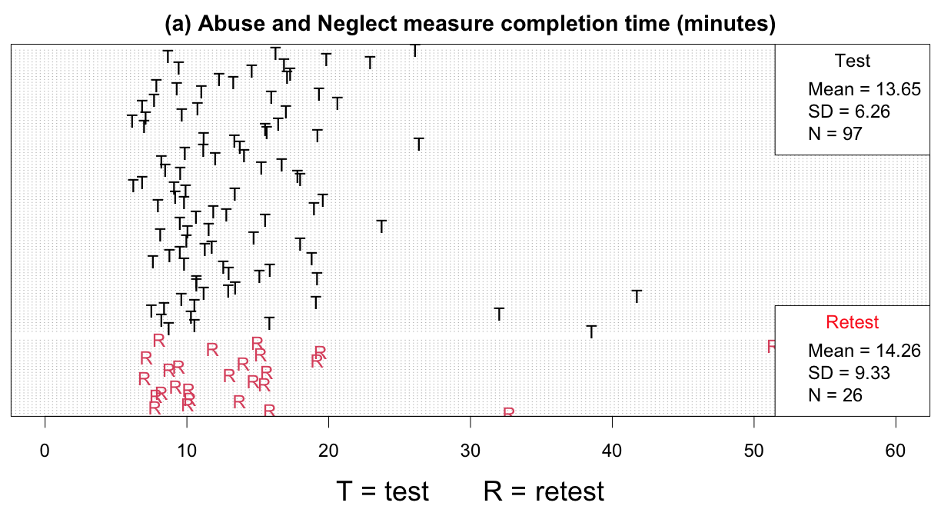
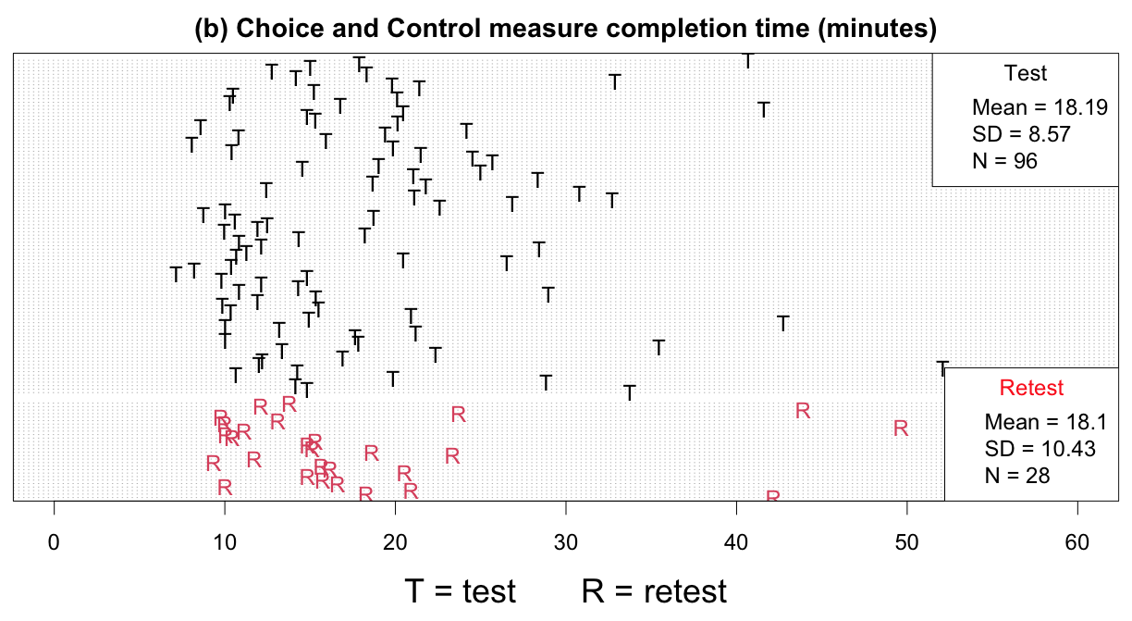

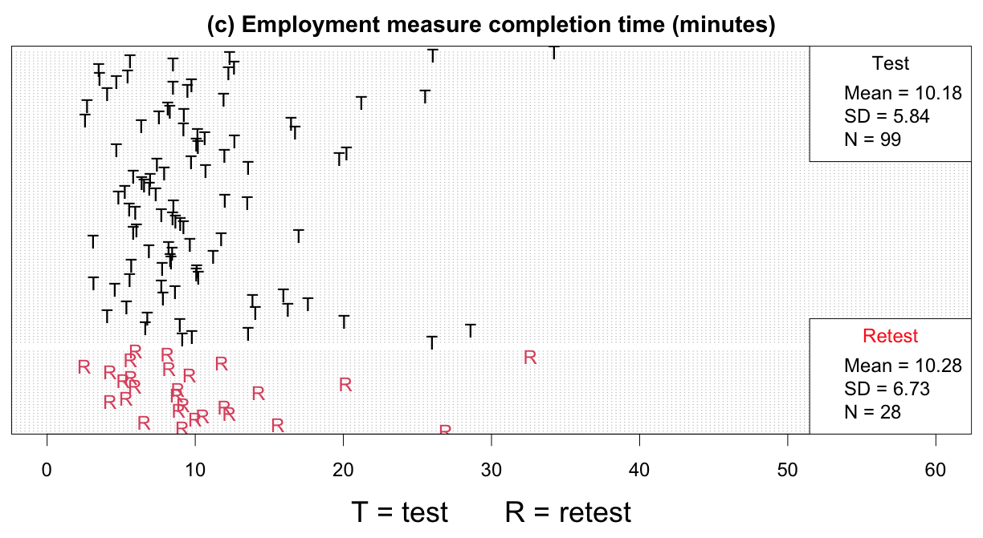
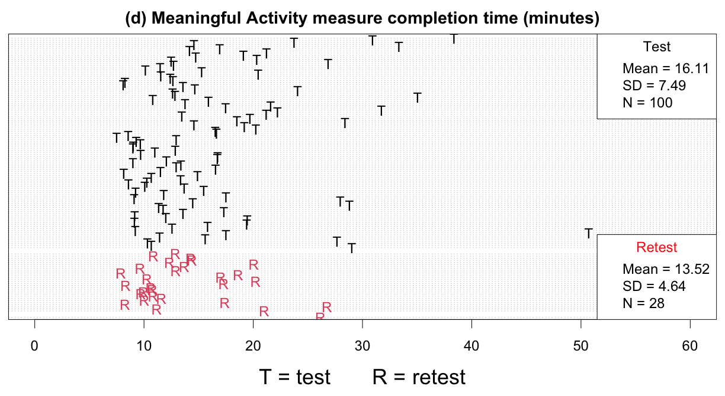
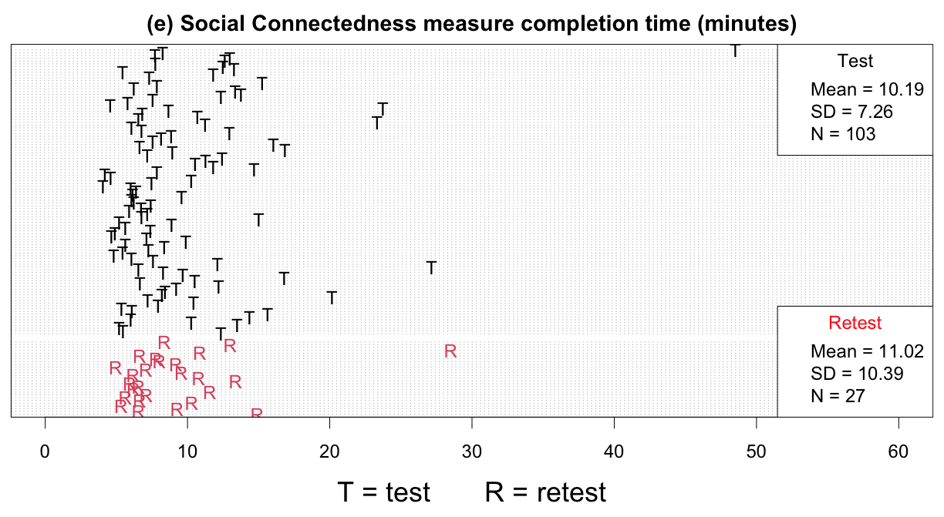
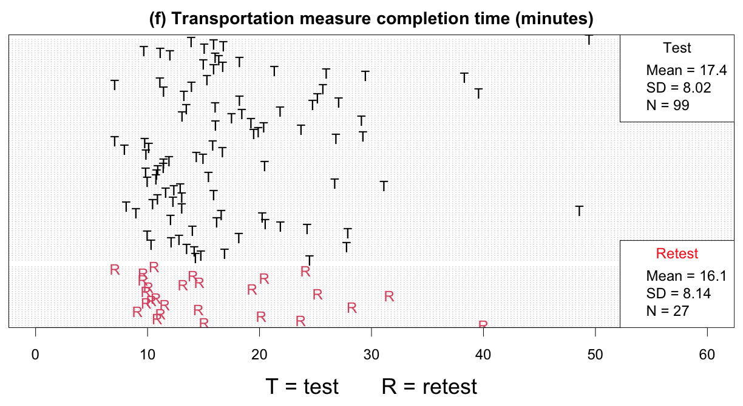
Note. Figures (a)-(f) correspond to the entire Abuse and Neglect, Choice and Control, Employment, Meaningful Activity, Social Connectedness, and Transportation measures, respectively.

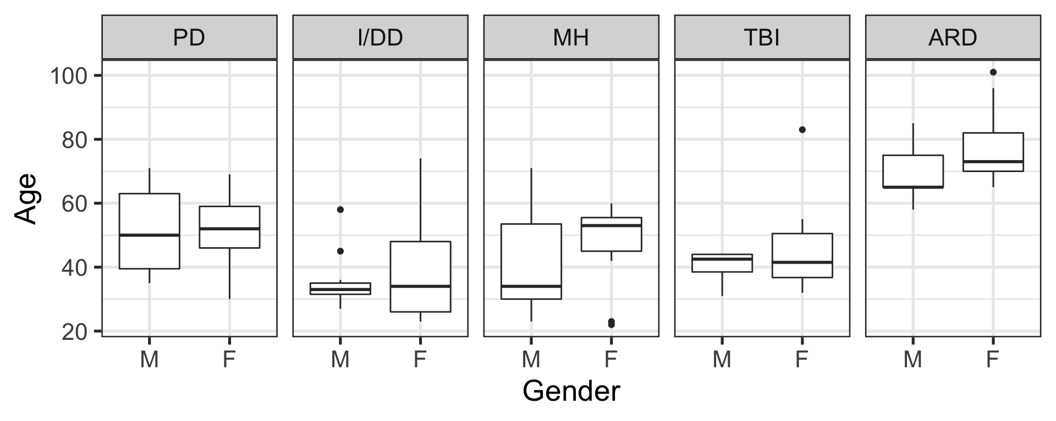
Appendix Figure 2. Box-and-whisker plots of participant gender.

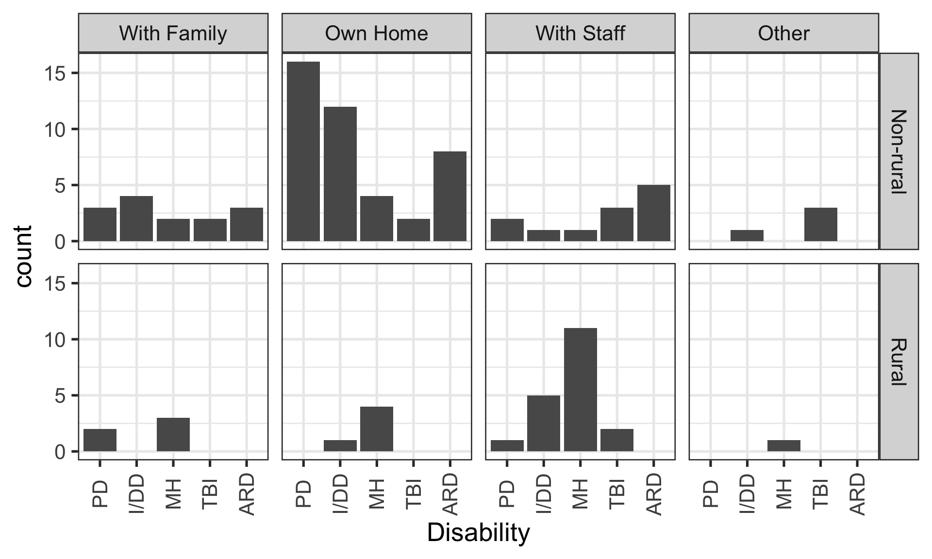
Appendix Figure 3. Barplots of participant residence location and living arrangement type.

Appendix Figure 4. Barplots indicating participants’ type of living situation (columns), their primary source of support (rows), and the residence location (color).
Note that most participants lived in their own home.

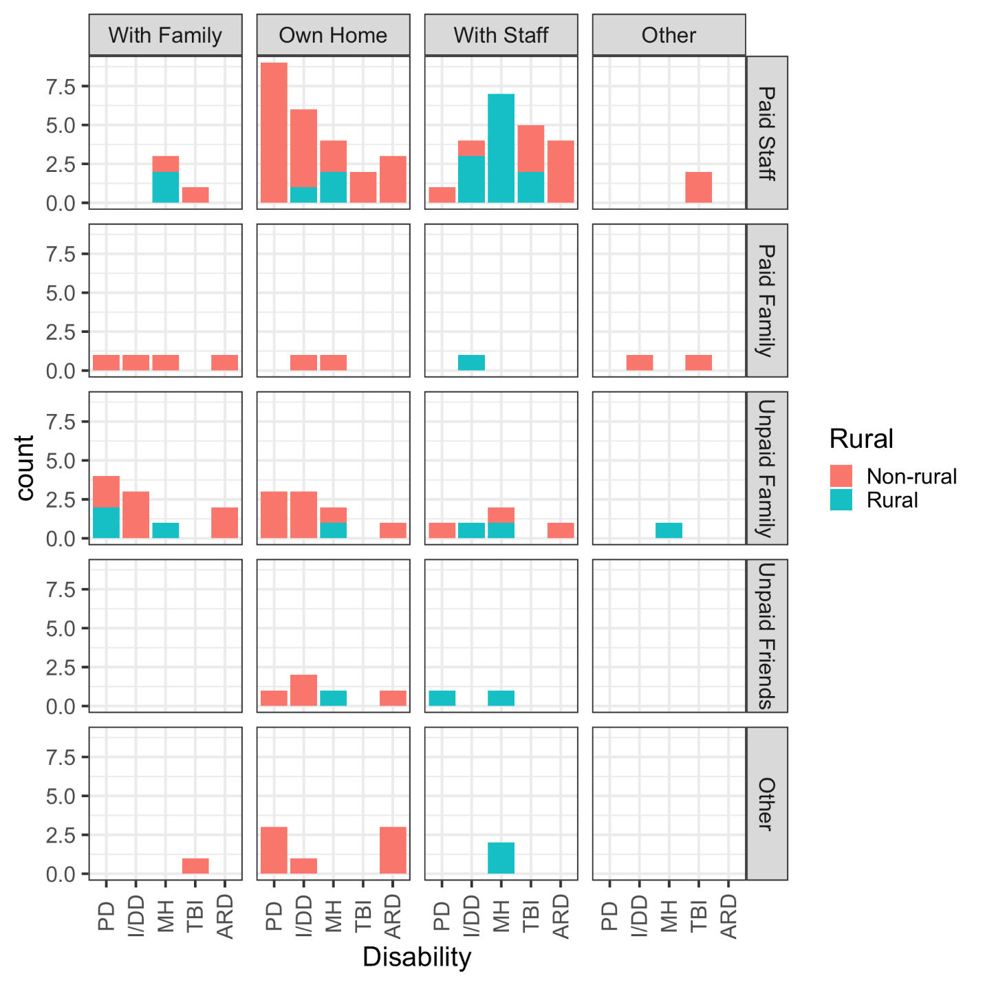

Appendix Figure 5. Counts of total scores for Freedom from Abuse and Freedom from Neglect composite scores.
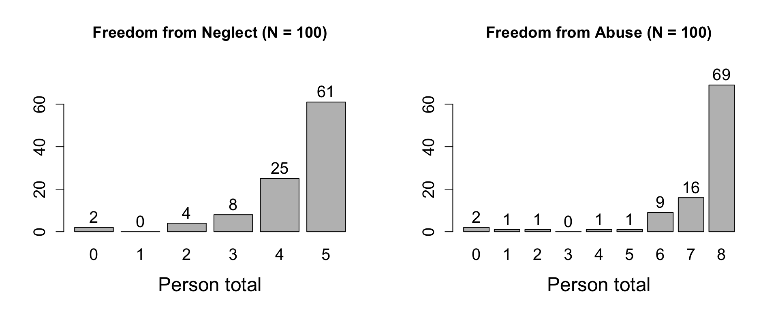
Note: Higher scores indicate fewer cases of abuse or neglect, with the maximum score in either being no cases of either abuse or neglect.

Appendix Figure 6. Cross-tabulation of level of Freedom from Abuse (horizontal axis) by level of Freedom from Neglect (column plates).
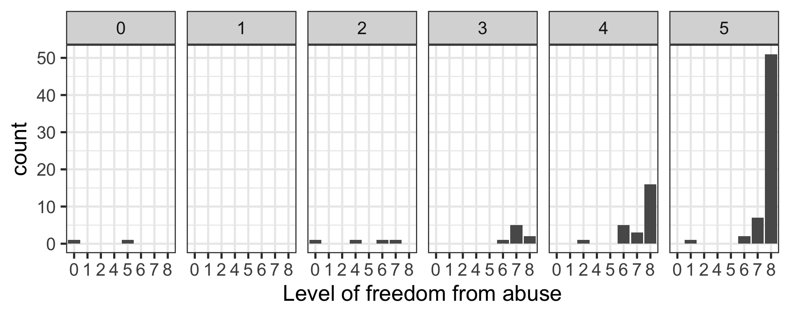

Appendix Figure 7. Histogram of sum scores of reported usage of different transportation types from the “How often…” items.
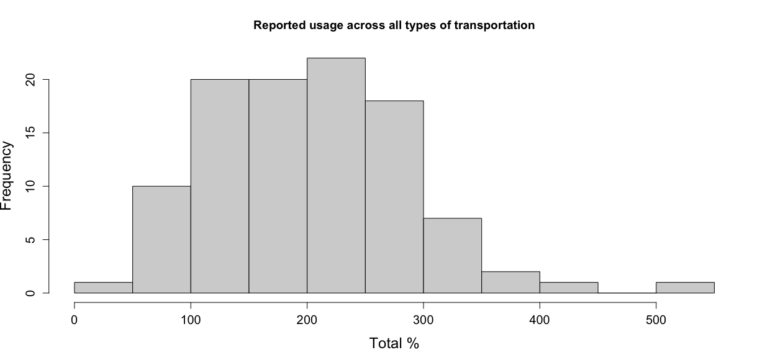

Appendix Figure 8a-8g. The distributions of total scores on each of the RTCOM measures.

(a)
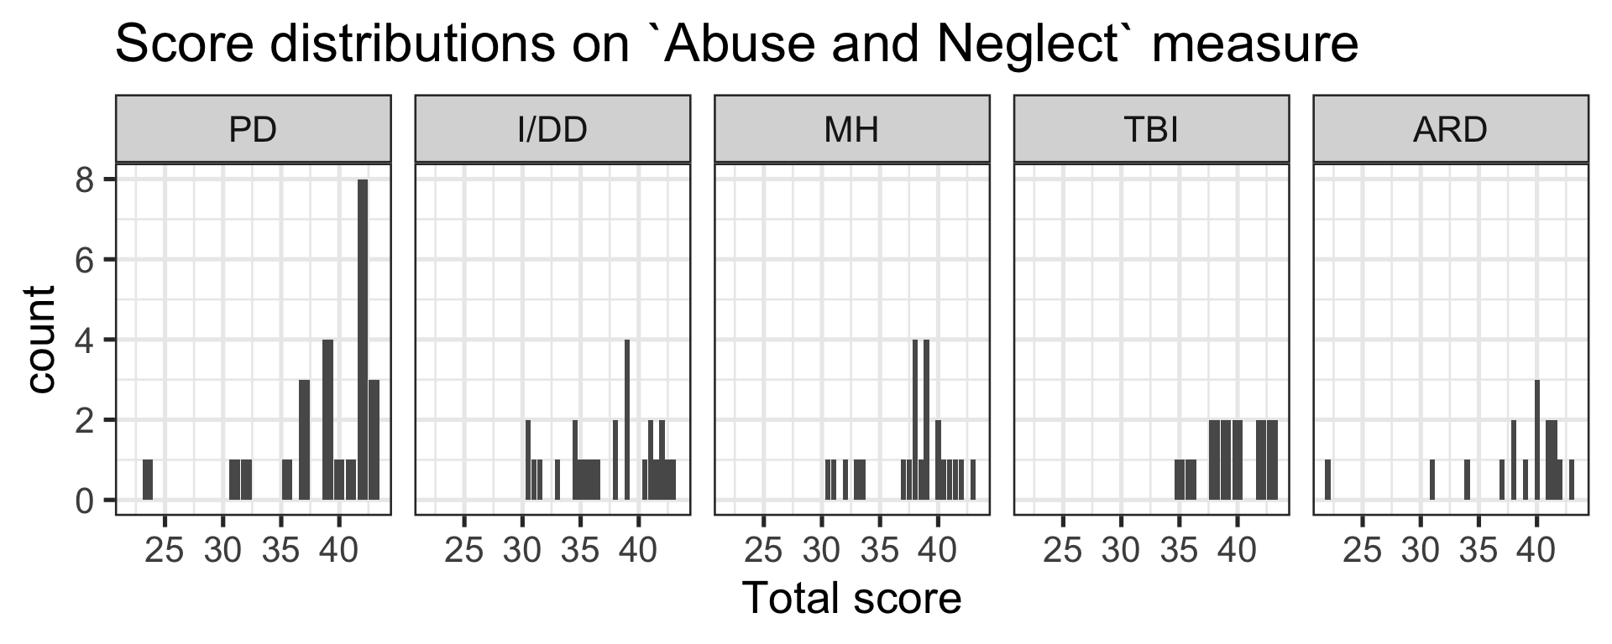
(b)
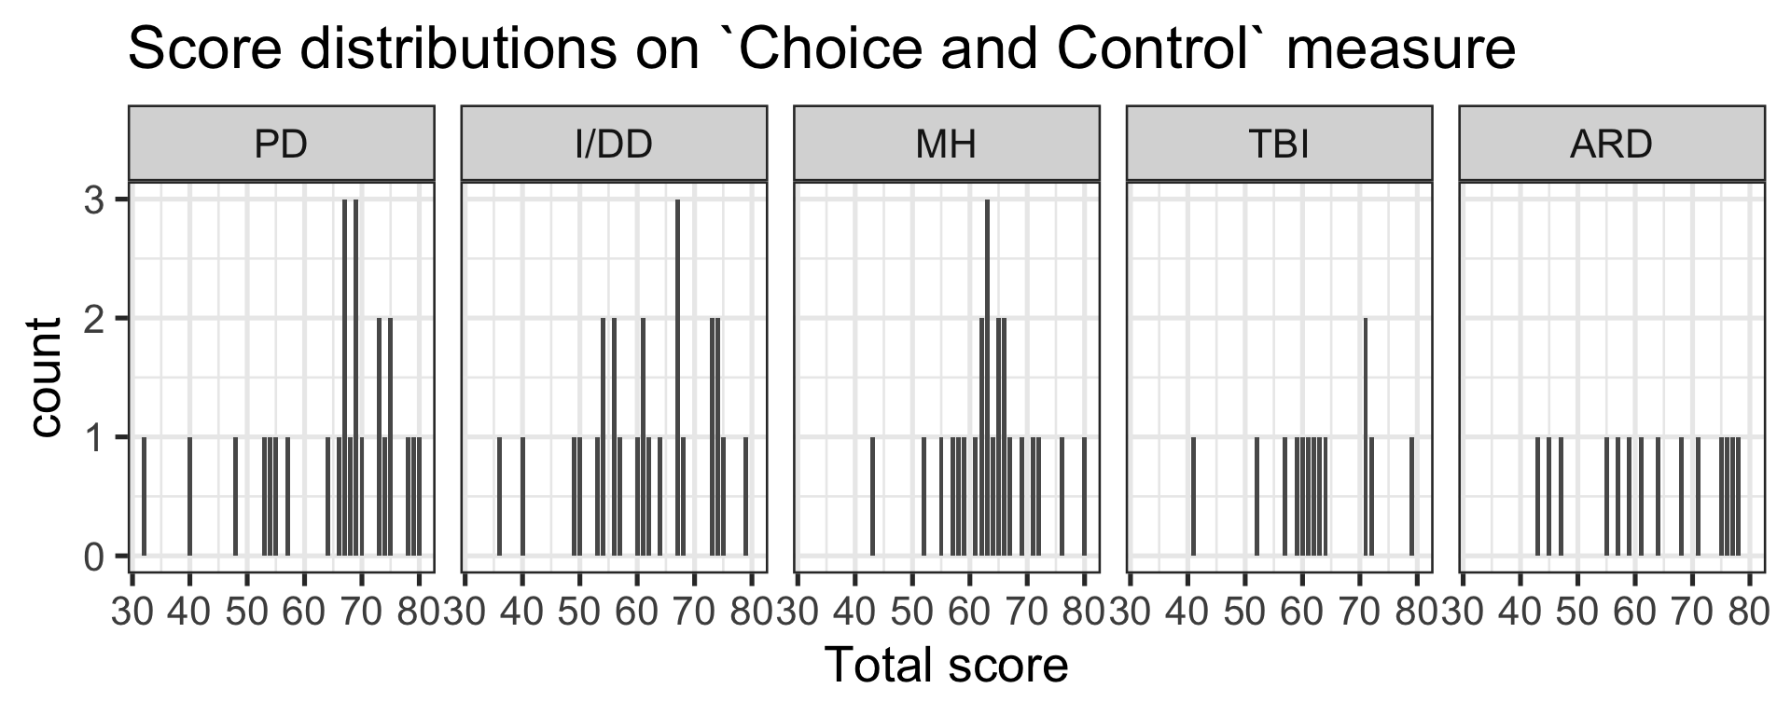

(c)

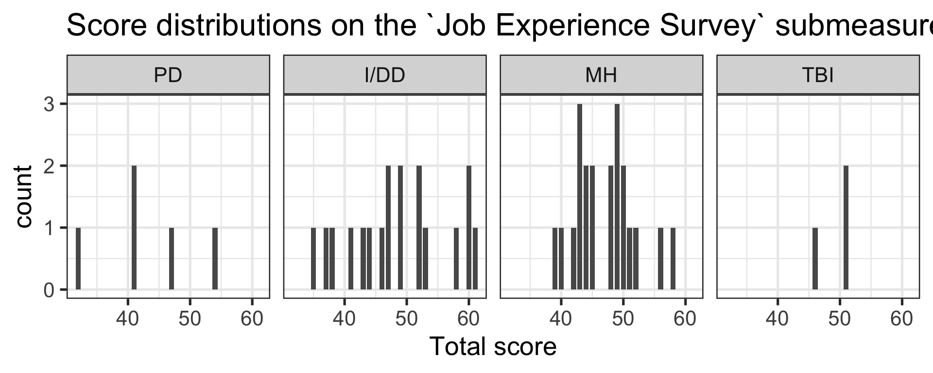
(d)
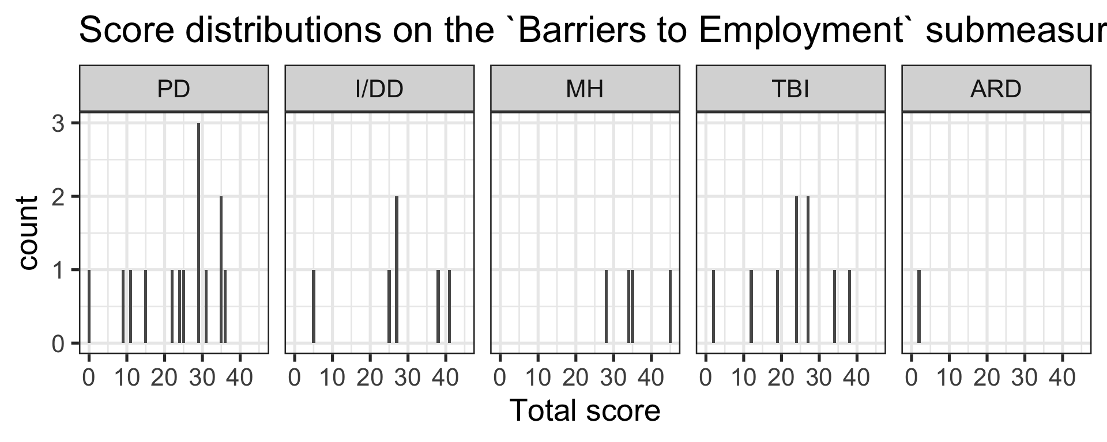

(e)
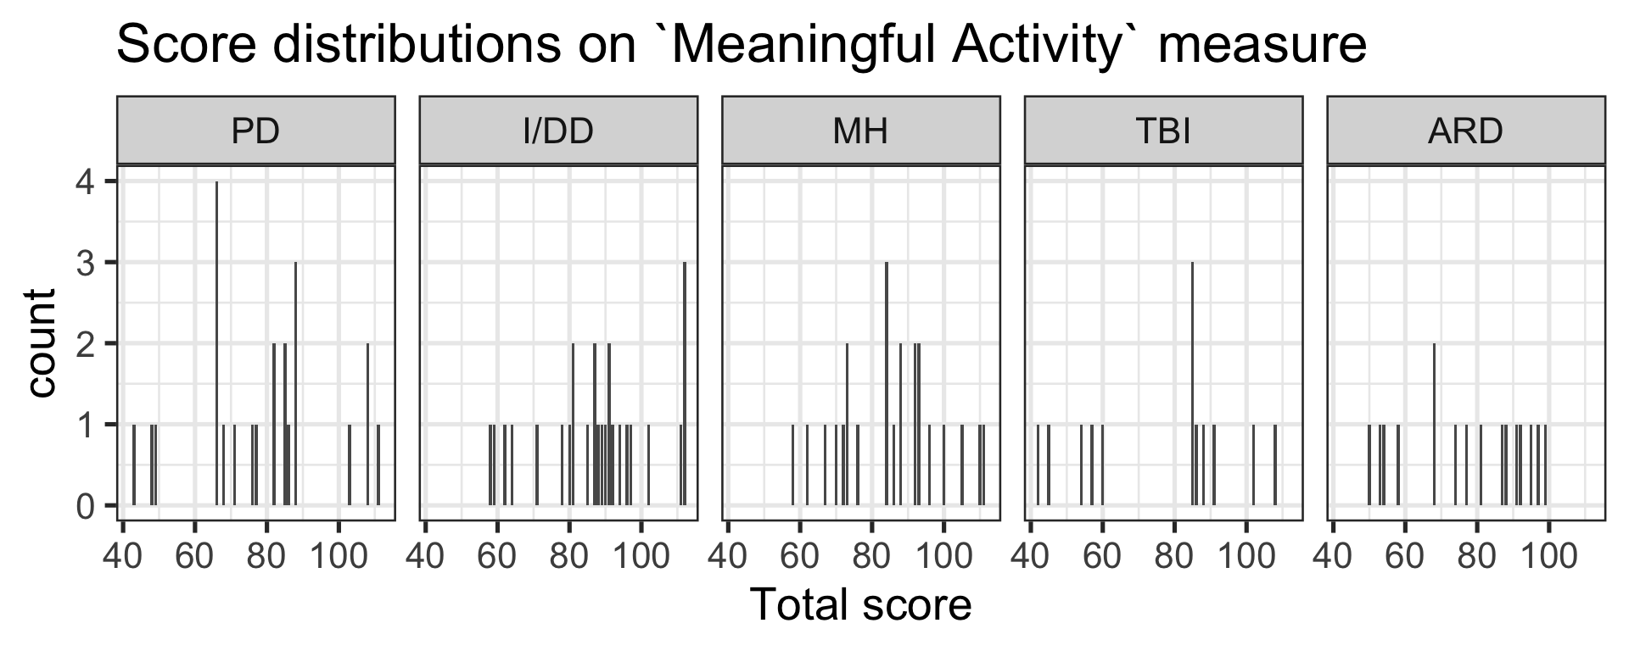
(f)
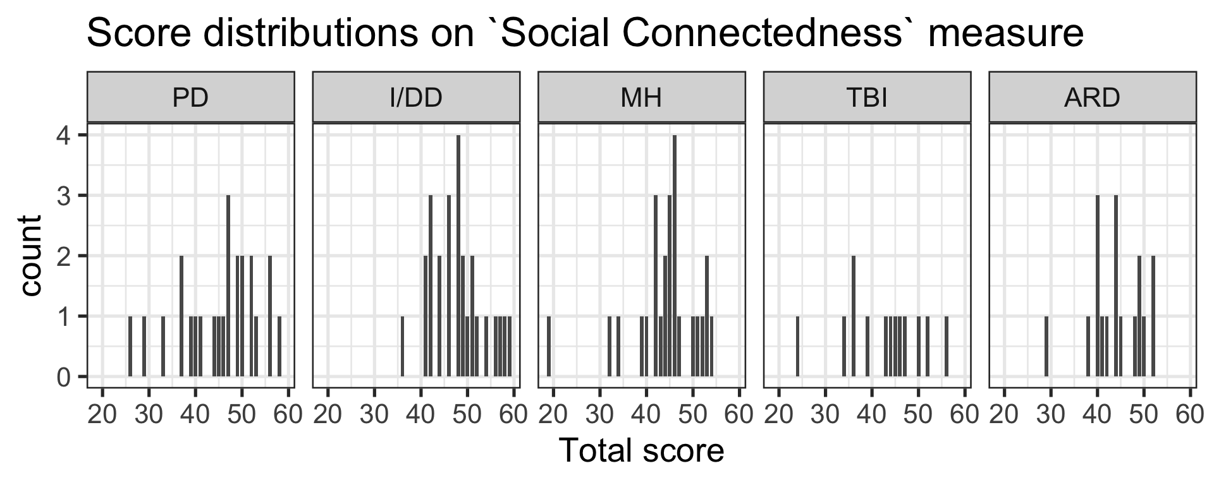
(g)
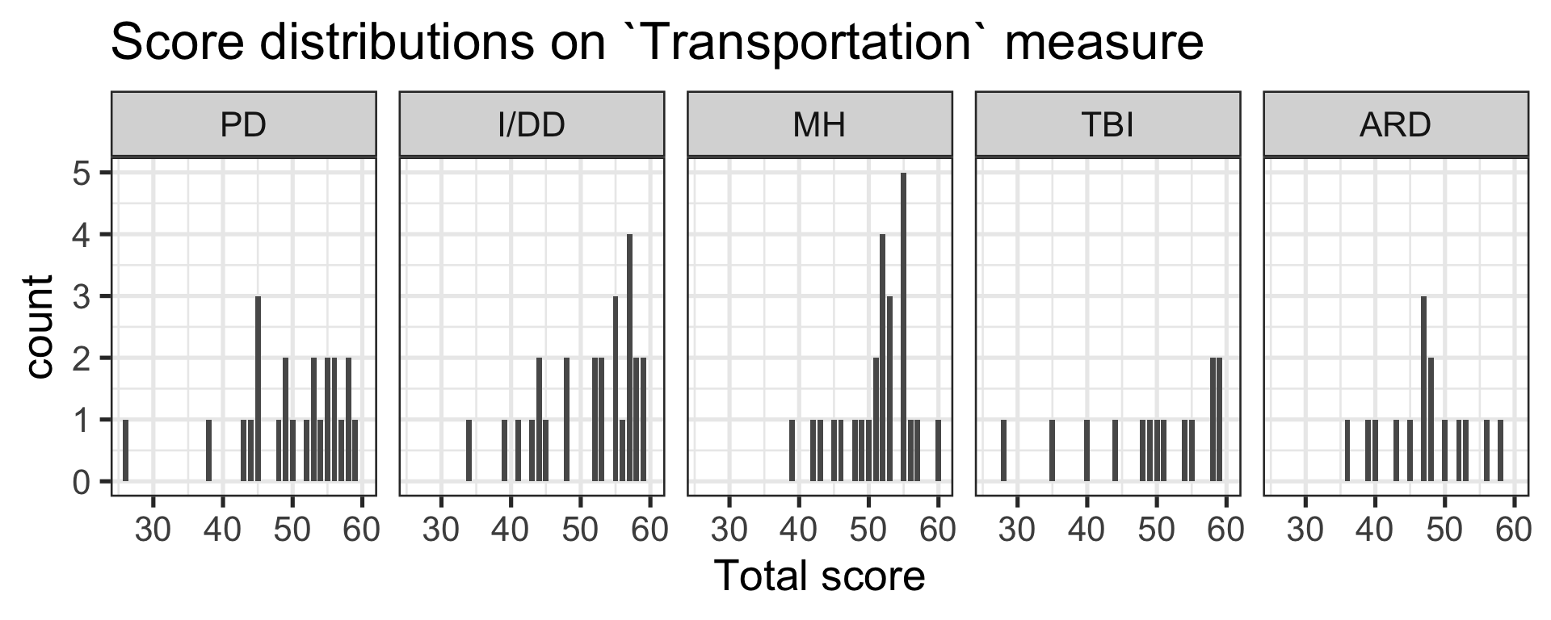

Agreement Response Scales

Text Only Response Scale:

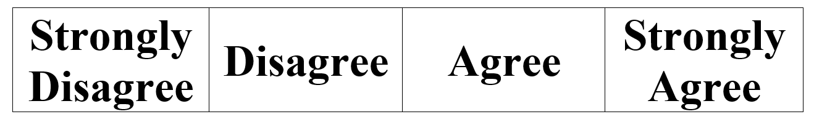

Emoji Response Scale:

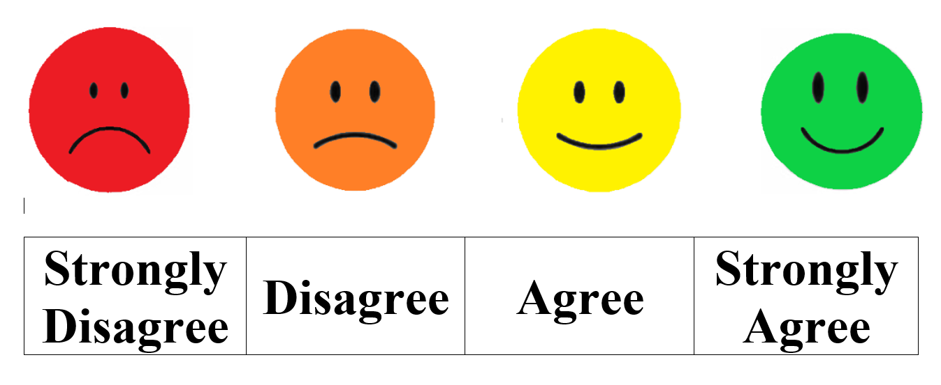

Abuse and Neglect – Inter-item correlations
Tier 1 Global items | Tier 2 Specific Items
G1 | S6
G2 | S2.1 - S2.8
G3 | S1.1 - S1.5, S3
G4, G5 | S4, S5

Appendix Table 1a. Pearson correlations between items of the Abuse and Neglect measure.
 | Q1 | Q2 | G1 | G2 | G3 | G4 | G5 | S1 | S2 | S3 | S4 | S5 | S6
Q1 | 1
Q2 | .60 | 1
G1 | .30 | .37 | 1
G2 | .15 | .10 | .26 | 1
G3 | .21 | .08 | .05 | .20 | 1
G4 | .11 | .06 | .00 | -.20 | .01 | 1
G5 | .02 | -.08 | -.03 | -.19 | -.01 | .49 | 1
S1 | .08 | .08 | .09 | .20 | .38 | -.06 | -.01 | 1
S2 | .12 | .00 | -.03 | .25 | .23 | -.10 | -.13 | .56 | 1
S3 | .24 | .13 | .00 | -.01 | .29 | .00 | -.12 | .15 | .25 | 1
S4 | -.01 | .06 | -.08 | -.06 | .09 | .20 | .22 | -.04 | .07 | .16 | 1
S5 | -.02 | -.07 | -.02 | -.14 | -.09 | .43 | .54 | -.05 | .00 | .06 | .22 | 1
S6 | .43 | .49 | .55 | .24 | .12 | -.01 | -.08 | .13 | .22 | .14 | .00 | .02 | 1
Note. See Appendix Table 1b for the item stems and response scales. Shaded areas correspond to items combined into Tier 1 (global) and Tier 2 (specific) sets. Items ‘Q1’ and ‘Q2’ are a combination of introductory items Q1a and Q1b, and Q2a and Q2b, for the Abuse and Neglect measure, respectively. Item ‘S1’ is a sum score of “freedom from neglect” items, and item ‘S2’ is a sum score of “freedom from abuse” items (see Appendix Table 1b).

Choice and Control – Inter-item correlations

Appendix Table 2a. Pearson correlations between items of the Choice and Control measure.
 | PC_G1 | PC_G2 | SS_G1 | SS_G2 | SS G4 | PC_S1a | PC_S1b | PC_S2a | PC_S2b | PC_S3a | PC_S3b | PC_S4a | PC_S4b | PC_S5a | PC_S5b | PC_S6a | PC_S6b | SS_S1a | SS_S1b | SS_S2a | SS_S2b | SS_S3a | SS_S3b | SS_S4a | SS_S4b | SS_S5a | SS_S5b
PC_G1 | 1
PC_G2 | .10 | 1
SS_G1 | .58 | .06 | 1
SS_G2 | .13 | .57 | .00 | 1
SS_G4 | .04 | .22 | .19 | .29 | 1
PC_S1a | -.03 | .08 | -.01 | .08 | -.09 | 1
PC_S1b | .11 | .44 | .07 | .47 | .11 | .09 | 1
PC_S2a | -.03 | .11 | -.02 | .19 | .18 | -.01 | .03 | 1
PC_S2b | .32 | .33 | .31 | .26 | .09 | -.11 | .24 | .17 | 1
PC_S3a | .20 | .03 | .40 | -.09 | .16 | -.04 | .29 | -.05 | .19 | 1
PC_S3b | -.14 | .43 | -.08 | .36 | .28 | .08 | .38 | .02 | .35 | .14 | 1
PC_S4a | -.05 | .04 | -.03 | .20 | .17 | .29 | .23 | .47 | -.10 | -.07 | .14 | 1
PC_S4b | .12 | .33 | .11 | .44 | .25 | .15 | .44 | .12 | .14 | .17 | .42 | .33 | 1
PC_S5a | .31 | .02 | .58 | .06 | .04 | -.03 | -.05 | -.03 | .24 | .20 | -.06 | -.05 | .05 | 1
PC_S5b | .22 | .38 | .17 | .37 | .09 | .06 | .35 | -.07 | .33 | .21 | .39 | .00 | .41 | .29 | 1
PC_S6a | .26 | .14 | .24 | .15 | .16 | .14 | .15 | .09 | .12 | .13 | .23 | .26 | .22 | .43 | .28 | 1
PC_S6b | .07 | .29 | .28 | .33 | .20 | .05 | .29 | .07 | .44 | .20 | .41 | .00 | .30 | .34 | .64 | .34 | 1
SS_S1a | .06 | .25 | -.05 | .01 | .06 | .11 | -.02 | -.09 | -.03 | -.02 | .20 | -.02 | .03 | .21 | .37 | .40 | .17 | 1
SS_S1b | .17 | .42 | .13 | .43 | .21 | -.01 | .20 | .12 | .32 | .09 | .27 | .07 | .27 | .22 | .38 | .28 | .34 | .54 | 1
SS_S2a | .14 | .25 | -.04 | .22 | .04 | -.05 | -.04 | .14 | .26 | .05 | .13 | -.10 | .00 | .14 | .22 | .35 | .15 | .42 | .34 | 1
SS_S2b | .15 | .38 | -.01 | .54 | .32 | -.01 | .28 | .04 | .27 | .01 | .41 | .06 | .40 | .04 | .37 | .22 | .36 | .34 | .58 | .38 | 1
SS_S3a |  | -.01 | .00 | -.08 | .11 | -.01 | -.02 | -.02 | -.02 | .29 | .18 | .29 | .25 | -.02 | .15 | .16 | .06 | .11 | .12 | .20 | .20 | 1
SS_S3b | .09 | .26 | .00 | .52 | .11 | -.08 | .21 | .02 | .38 | -.03 | .37 | -.03 | .32 | .09 | .32 | .04 | .33 | .12 | .51 | .16 | .64 | .18 | 1
SS_S4a | .27 | .07 | .26 | -.18 | -.11 | .19 | -.17 | .12 | .06 | .25 | -.10 | .04 | .05 | .08 | .04 | .03 | .02 | .12 | .06 | .16 | -.03 | .39 | -.04 | 1
SS_S4b | .19 | .26 | .16 | .35 | .27 | .11 | .16 | -.08 | .32 | .00 | .14 | -.11 | .27 | .12 | .28 | .08 | .23 | .16 | .32 | .02 | .22 | -.13 | .20 | .22 | 1
SS_S5a | -.03 | .10 | -.03 | .14 | .12 | -.02 | .06 | -.05 | .04 | .10 | .36 | .09 | .21 | -.05 | .16 | .34 | .20 | .46 | .30 | .30 | .28 | .56 | .18 | .24 | -.04 | 1
SS_S5b | .00 | .24 | -.10 | .29 | -.06 | .07 | .23 | .06 | .13 | .00 | .29 | .13 | .26 | .11 | .49 | .33 | .32 | .47 | .55 | .28 | .38 | .28 | .44 | .12 | .19 | .45 | 1
Note. See Appendix Table 2b for the item stems and response scales. Shaded areas correspond to items combined into Tier 1 (global) and Tier 2 (specific) sets.

Tier 1 Global items | Tier 2 Specific Items
PC_G1 | PC_S1a, PC_S2a, PC_S3a, PC_S4a, PC_S5a, PC_S6a
SS_G1 | SS_S1a, SS_S2a, SS_S3a, SS_S4a, SS_S5a
PC_G2 | PC_S1b, PC_S2b, PC_S3b, PC_S4b, PC_S5b, PC_S6b
SS_G2 | SS_S1b, SS_S2b, SS_S3b, SS_S4b, SS_S5b

Job Experience Survey (Employment) – Inter-item correlations

Appendix Table 3a. Pearson correlations between items of the Job Experience Survey sub-measure included in the Employment measure.
Tier 1 Global items | Tier 2 Specific Items
JE_G1 | JE_S4, JE_S5, JE_S6, JE_S7, JE_S8, JE_S9, JE_S10, JE_S11, JE_S12
JE_G2
JE_G3

 | JS3 | JE_G1 | JE_G2 | JE_G3 | JE_S1 | JE_S3 | JE_S4 | JE_S5 | JE_S6 | JE_S7 | JE_S8 | JE_S9 | JE_S10 | JE_S11 | JE_S12 | JE_S13
JS3 | 1
JE_G1 | .28 | 1
JE_G2 | .32 | .10 | 1
JE_G3 | .41 | .14 | .55 | 1
JE_S1 | .10 | -.02 | -.17 | .01 | 1
JE_S3 | .07 | -.04 | .25 | .09 | .04 | 1
JE_S4 | .39 | .29 | .19 | .34 | .15 | .12 | 1
JE_S5 | .38 | .34 | .04 | .09 | .15 | .28 | .38 | 1
JE_S6 | .37 | .35 | .07 | .20 | .21 | .01 | .37 | .42 | 1
JE_S7 | .10 | .08 | -.11 | -.04 | -.08 | .25 | .11 | .24 | .24 | 1
JE_S8 | .55 | .29 | .10 | .45 | .02 | -.06 | .36 | .25 | .34 | .19 | 1
JE_S9 | .24 | .50 | -.07 | .19 | .14 | .04 | .41 | .23 | .49 | .13 | .37 | 1
JE_S10 | .55 | .49 | .05 | .29 | .17 | -.12 | .38 | .26 | .44 | .02 | .28 | .43 | 1
JE_S11 | .51 | .42 | .04 | .12 | .02 | .08 | .37 | .44 | .46 | -.05 | .27 | .49 | .59 | 1
JE_S12 | .33 | .27 | .21 | .39 | -.06 | -.16 | .32 | .11 | .42 | .00 | .44 | .27 | .49 | .44 | 1
JE_S13 | .26 | .20 | -.25 | -.08 | .21 | .19 | .16 | .27 | .13 | .05 | .23 | .16 | .22 | .16 | .05 | 1
Note. See Appendix Table 3c for the item stems and response scales. Shaded areas correspond to item clusters constructed from Tier 1 (global) and Tier 2 (specific) items.

Barriers to Employment (Employment) – Inter-item correlations

Appendix Table 3b. Pearson correlations between items of the Barriers to Employment sub-measure included in the Employment measure.
Tier 1 Global items | Tier 2 Specific Items
B_G1
B_G2 | B_S6, B_S7
B_G3 | B_S2, B_S3, B_S4, B_S5

 | JS2 | JS3 | B_G1 | B_G2 | B_G3 | B_S1 | B_S2 | B_S3 | B_S4 | B_S5 | B_S6 | B_S7 | B_S8 | B_S9
JS2 | 1
JS3 | .09 | 1
B_G1 | -.14 | -.04 | 1
B_G2 | .03 | .45 | .10 | 1
B_G3 | .03 | .41 | .33 | .32 | 1
B_S1 | .26 | .04 | -.38 | .20 | -.10 | 1
B_S2 | -.13 | -.03 | .18 | -.25 | .61 | -.02 | 1
B_S3 | .14 | .22 | .13 | .02 | .32 | .34 | .46 | 1
B_S4 | -.02 | .15 | .05 | -.37 | .16 | -.15 | .03 | .08 | 1
B_S5 | .25 | .52 | .03 | .00 | .18 | -.25 | -.21 | .00 | .48 | 1
B_S6 | .26 | .07 | .36 | .16 | .28 | .27 | .04 | .40 | -.33 | -.17 | 1
B_S7 | .18 | .10 | .15 | .33 | .36 | .36 | -.09 | .25 | .26 | .21 | .18 | 1
B_S8 | .18 | .23 | .31 | .57 | .25 | .21 | -.27 | .20 | -.29 | .04 | .51 | .50 | 1
B_S9 | .42 | .14 | -.23 | -.03 | .14 | .06 | -.12 | .19 | .08 | .54 | .08 | .52 | .33 | 1
Note. See Appendix Table 3c for the item stems and response scales. Shaded areas correspond to items combined into Tier 1 (global) and Tier 2 (specific) sets.

Meaningful Activity – Inter-item correlations

Appendix Table 4a. Pearson correlations between items of the Meaningful Activity measure.

 | G1 | G2 | G3 | S1 | S2 | S3 | S4 | S5 | S6 | S7 | S8 | S9 | S10 | S11 | S12 | S13 | S14 | S15 | S16 | S17 | S18 | S19 | S20 | S21 | S22 | S23 | S24 | S25
G1 | 1
G2 | .44 | 1
G3 | .48 | .59 | 1
S1 | .29 | .11 | .22 | 1
S2 | .40 | .48 | .50 | .19 | 1
S3 | .51 | .38 | .59 | .27 | .51 | 1
S4 | .31 | .70 | .72 | .13 | .63 | .47 | 1
S5 | .35 | .47 | .48 | .25 | .64 | .45 | .66 | 1
S6 | .28 | -.07 | .08 | .11 | .11 | .13 | -.01 | .06 | 1
S7 | .14 | .39 | .34 | .26 | .36 | .36 | .29 | .32 | .24 | 1
S8 | .27 | .11 | .19 | .38 | .11 | .32 | .03 | .29 | .21 | .38 | 1
S9 | .26 | .49 | .50 | .22 | .31 | .41 | .51 | .40 | .11 | .42 | .30 | 1
S10 | .36 | .54 | .63 | .39 | .47 | .47 | .58 | .59 | .09 | .50 | .48 | .70 | 1
S11 | .05 | .03 | .04 | .30 | .11 | .17 | .09 | .05 | .25 | .32 | .25 | .15 | .09 | 1
S12 | .16 | .38 | .28 | .37 | .41 | .19 | .38 | .38 | .06 | .56 | .26 | .31 | .44 | .24 | 1
S13 | .32 | .41 | .27 | .21 | .36 | .25 | .26 | .32 | .30 | .47 | .31 | .21 | .42 | .25 | .67 | 1
S14 | .24 | .44 | .38 | .21 | .42 | .30 | .53 | .30 | .09 | .30 | .14 | .63 | .43 | .15 | .49 | .41 | 1
S15 | .26 | .45 | .60 | .43 | .40 | .26 | .59 | .54 | .08 | .39 | .34 | .48 | .68 | .26 | .67 | .52 | .60 | 1
S16 | .11 | .02 | .11 | .22 | .13 | .13 | .17 | .18 | .22 | .06 | .04 | .00 | .21 | .19 | .15 | .23 | -.02 | .12 | 1
S17 | .32 | .40 | .47 | .18 | .48 | .49 | .48 | .51 | .02 | .31 | .22 | .37 | .53 | .19 | .37 | .31 | .32 | .38 | .27 | 1
S18 | .36 | .35 | .47 | .32 | .31 | .50 | .36 | .39 | .12 | .25 | .29 | .21 | .43 | .26 | .23 | .27 | .16 | .41 | .46 | .60 | 1
S19 | .34 | .66 | .73 | .34 | .54 | .49 | .77 | .65 | -.04 | .32 | .24 | .60 | .73 | .12 | .42 | .40 | .59 | .72 | .21 | .63 | .61 | 1
S20 | .29 | .54 | .65 | .25 | .62 | .32 | .75 | .64 | .02 | .34 | .28 | .46 | .67 | .06 | .41 | .40 | .51 | .69 | .29 | .46 | .39 | .73 | 1
S21 | .08 | .11 | .15 | .24 | .24 | .21 | .15 | .23 | .27 | .21 | .06 | .04 | .14 | .25 | .15 | .15 | .12 | .19 | .12 | .17 | .21 | .15 | .06 | 1
S22 | .37 | .33 | .33 | .36 | .49 | .43 | .51 | .41 | .27 | .38 | .24 | .27 | .45 | .30 | .38 | .43 | .37 | .34 | .39 | .59 | .39 | .46 | .51 | .31 | 1
S23 | .37 | .32 | .37 | .22 | .45 | .49 | .36 | .18 | .16 | .13 | .14 | .19 | .27 | .29 | .19 | .22 | .33 | .21 | .20 | .43 | .47 | .45 | .35 | .34 | .53 | 1
S24 | .31 | .63 | .65 | .19 | .62 | .60 | .81 | .53 | .06 | .40 | .17 | .56 | .62 | .13 | .44 | .30 | .52 | .55 | .17 | .44 | .40 | .77 | .75 | .16 | .46 | .57 | 1
S25 | .28 | .45 | .67 | .23 | .54 | .30 | .65 | .49 | .21 | .43 | .19 | .34 | .63 | .13 | .58 | .51 | .49 | .75 | .21 | .37 | .29 | .62 | .64 | .21 | .45 | .22 | .60 | 1
Note. See Appendix Table 4b for the item stems and response scales. Shaded areas correspond to items combined into Tier 1 (global) and Tier 2 (specific) sets.

Tier 1 Global items | Tier 2 Specific Items
G1 | S1, S2, S3, S6, S7, S8, S11, S12, S13, S16, S17, S18, S21, S22, S23
G2 | S4, S9, S14, S19, S24
G3 | S5, S10, S15, S20, S25

Social Connectedness – Inter-item correlations

Appendix Table 5a. Pearson correlations between items of the Social Connectedness measure.
Tier 1 Global items | Tier 2 Specific Items
G1 | S1, S4, S8, S12
G2 | S3, S5, S6
G3 | S2, S7, S9, S10, S11

 | G1 | G2 | G3 | S1 | S2 | S3 | S4 | S5 | S6 | S7 | S8 | S9 | S10 | S11 | S12
G1 | 1
G2 | .22 | 1
G3 | .24 | .19 | 1
S1 | .49 | .30 | .24 | 1
S2 | .31 | .17 | .19 | .45 | 1
S3 | .20 | .22 | .39 | .33 | .39 | 1
S4 | .48 | .33 | .19 | .53 | .46 | .55 | 1
S5 | .40 | .26 | .05 | .51 | .53 | .40 | .58 | 1
S6 | .25 | .31 | -.07 | .22 | .32 | .26 | .49 | .55 | 1
S7 | .46 | .26 | .23 | .26 | .32 | .35 | .44 | .31 | .39 | 1
S8 | .30 | .01 | .04 | .14 | .15 | .21 | .31 | .38 | .59 | .35 | 1
S9 | .31 | .17 | .19 | .41 | .32 | .43 | .36 | .59 | .32 | .39 | .19 | 1
S10 | .44 | .09 | .11 | .28 | .31 | .32 | .34 | .44 | .37 | .48 | .35 | .42 | 1
S11 | .41 | .09 | .18 | .24 | .12 | .31 | .45 | .41 | .43 | .50 | .42 | .44 | .54 | 1
S12 | .70 | .31 | .16 | .51 | .26 | .30 | .57 | .45 | .41 | .39 | .35 | .37 | .35 | .39 | 1
Note. See Appendix Table 5b for the item stems and response scales. Shaded areas correspond to items combined into Tier 1 (global) and Tier 2 (specific) sets.

Transportation – Inter-item correlations

Appendix Table 6a. Pearson correlations between items of the Transportation measure.
Tier 1 Global items | Tier 2 Specific Items
G1 | S4, S5, S7
G2a | S6, S8, S12, S13, S14
G3 | S10
G4 | S9, S11

 | G1 | G2a | G3 | G4 | S4 | S5 | S6 | S7 | S8 | S9 | S10 | S11 | S12 | S13 | S14
G1 | 1
G2a | .49 | 1
G3 | .39 | .36 | 1
G4 | .39 | .47 | .50 | 1
S4 | .37 | .44 | .45 | .41 | 1
S5 | .41 | .50 | .15 | .33 | .27 | 1
S6 | .01 | .00 | .08 | -.09 | .09 | .01 | 1
S7 | .39 | .49 | .45 | .57 | .42 | .34 | .04 | 1
S8 | .21 | .42 | .23 | .34 | .37 | .12 | -.01 | .37 | 1
S9 | .00 | .24 | .31 | .63 | .28 | .05 | -.04 | .27 | .23 | 1
S10 | .18 | .11 | .30 | .26 | .21 | .15 | .01 | .28 | .27 | .12 | 1
S11 | .06 | .32 | .55 | .49 | .22 | -.03 | -.01 | .33 | .23 | .54 | .34 | 1
S12 | .39 | .51 | .60 | .46 | .42 | .17 | .05 | .51 | .31 | .28 | .32 | .40 | 1
S13 | .33 | .31 | .40 | .41 | .33 | .35 | -.18 | .36 | .17 | .23 | .13 | .23 | .41 | 1
S14 | .27 | .41 | .52 | .51 | .47 | .33 | -.02 | .51 | .09 | .32 | .20 | .29 | .45 | .58 | 1
Note. See Appendix Table 6b for the item stems and response scales. Shaded areas correspond to items combined into Tier 1 (global) and Tier 2 (specific) sets.

Appendix Table 1b. Abuse and Neglect item stems and response scales

 | Item Stem | Response Scale
Q1a / Q1b | You would know if you were being abused. | Agreement
Q2a / Q2b | You would know if you were being neglected. | Agreement
G1 | You feel safe with the people you spend most of your time with; think about your friends, family members, coworkers, or people you live with. | Agreement
G2 | Has anyone done anything to hurt you or take advantage of you? | Yes/No
G3 | Have your caregivers/staff neglected or ignored your needs? | Yes/No
G4 | If you or someone else were being abused or neglected, would you know how to report it? | Yes/No
G5 | Do you know who to talk to if you or someone else needed help reporting abuse or neglect. | Yes/No
S1.1 | Have your caregivers/staff: Refused to help you, even when you asked them to? | Yes/No
S1.2 | Have your caregivers/staff: Not responded when you were upset? | Yes/No
S1.3 | Have your caregivers/staff: Not taken care of your needs even though they were aware of them? | Yes/No
S1.4 | Have your caregivers/staff: Not helped you when you stopped doing things you normally did yourself? | Yes/No
S1.5 | Have your caregivers/staff: Frequently ignored you when you talked to them? | Yes/No
S2.1 | Has anyone you live with and/or caregivers/staff: Physically hurt you? | Yes/No
S2.2 | Has anyone you live with and/or caregivers/staff: Taken/used your money or possessions (e.g. phone, TV) without your permission? | Yes/No
S2.3 | Has anyone you live with and/or caregivers/staff: Made you do things you didn’t want to do? | Yes/No
S2.4 | Has anyone you live with and/or caregivers/staff: Prevented you from having contact with important people in your life? | Yes/No
S2.5 | Has anyone you live with and/or caregivers/staff: Done things that scare/threaten you? | Yes/No
S2.6 | Has anyone you live with and/or caregivers/staff: Taken away equipment that helps you to do the things you need to do? | Yes/No
S2.7 | Has anyone you live with and/or caregivers/staff: Belittled/demeaned/blamed you? | Yes/No
S2.8 | Has anyone you live with and/or caregivers/staff: Forced you to have a sexual experience you did not want? | Yes/No
S3 | Do you receive enough support from your caregivers/staff so that you can take care of your needs? | Yes/No
S4 | Have your service providers/caregivers/staff taught you what abuse and neglect are? | Yes/No
S5 | Have your service providers/caregivers/staff taught you what abuse and neglect are? | Yes/No
S6 | You feel safe with the people you spend most of your time with; think about your friends, family members, coworkers, or people you live with. | Agreement

Appendix Table 2b. Choice and Control
 | Item stem | Response Scale
PC_G1 | Is it important for you to make decisions about your personal (daily) life? | Yes/No
PC_G2 | How often do you get to decide what you want to do in your personal life? | Frequency
SS_G1 | Is it important for you to make decisions about your services and supports? | Yes/No
SS_G2 | How often do you decide what services you want? | Frequency
SS_G4 | Are you encouraged to make decisions about your services? | Yes/No
PC_S1a | Is it important for you to decide what you do in your free time? | Yes/No
PC_S1b | How often do you decide what you do in your free time? | Frequency
PC_S2a | Is it important for you to decide how you spend your personal money? | Yes/No
PC_S2b | How often do you decide how you spend your personal money? | Frequency
PC_S3a | Is it important for you to decide your daily routine? | Yes/No
PC_S3b | How often do you decide what your daily routine is? | Frequency
PC_S4a | Is it important for you to decide what you get to do with friends and family? | Yes/No
PC_S4b | How often do you decide what you get to do with friends and family? | Frequency
PC_S5a | Is it important for you to decide what food you eat? | Yes/No
PC_S5b | How often do you decide what food you eat? | Frequency
PC_S6a | Is it important for you to decide when you get to eat? | Yes/No
PC_S6b | How often do you decide when you get to eat? | Frequency
SS_S1a | Is it important for you to decide who your staff members are? | Yes/No
SS_S1b | How often do you decide who your staff members are? | Frequency
SS_S2a | Is it important for you to decide what your staff does for you? | Yes/No
SS_S2b | How often do you decide what your staff does for you? | Frequency
SS_S3a | Is it important for you to decide what goals are set during planning meetings? | Yes/No
SS_S3b | How often do you decide what goals are set during planning meetings? | Frequency
SS_S4a | Is it important for you to decide how your budget for services is spent? | Yes/No
SS_S4b | How often do you decide how your budget for services is spent? | Frequency
SS_S5a | Is it important for you to decide who you live with? | Yes/No
SS_S5b | How often do you decide who you live with, including whether or not you live alone? | Frequency

Appendix Table 3c. Employment
 | Item stem | Response Scale
JS2 | [if employed] Would you like to continue to work for pay? [if unemployed] Would you like to work for pay? | Yes/No
JS3 | You feel encouraged to seek employment by your staff. | Agreement
JE_G1 | You are happy with your current job. | Agreement
JE_G2 | Your staff helped you get paid work. | Agreement
JE_G3 | Your staff help you keep working. | Agreement
JE_S1 | How long have you worked without long interruptions (time off) at a job or between jobs? | Less than 3 months / 3-6 months / 1-3 years / More than 3 years
JE_S3 | Most of the people you work with have a disability. | Agreement
JE_S4 | You work the number of hours you want to work. | Agreement
JE_S5 | Your pay from work covers all your bills. | Agreement
JE_S6 | You are happy with the benefits you receive from your job. | Agreement
JE_S7 | You have chances for advancement or promotion at your job. | Agreement
JE_S8 | You get to learn new skills at your job. | Agreement
JE_S9 | People think you do a good job. | Agreement
JE_S10 | You feel accepted by your coworkers. | Agreement
JE_S11 | You know how to do your job. | Agreement
JE_S12 | You have the accommodations you need to succeed at your job. | Agreement
JE_S13 | Do you have a plan for what you will do when you retire/choose to no longer work? | Yes/No
B_G1 | You had bad experiences looking for paid work in the past. | Agreement
B_G2 | To keep a job, you would need more supports than you currently have. | Agreement
B_G3 | You could find a job if you want one. | Agreement
B_S1 | Are you currently looking for a job that pays you? | Yes/No
B_S2 | Did you give up looking because you could not find a job? | Yes/No
B_S3 | You have opportunities to get a job that pays you. | Agreement
B_S4 | [if strongly agree or agree to B_S3] You have opportunities to work at the type of paid jobs you would like. | Agreement
B_S5 | You have had the training/education you need to find a paid job. | Agreement
B_S6 | In the past, you got the support you needed to keep working. | Agreement
B_S7 | You would be able to get to work on time if you had a job. | Agreement
B_S8 | You would lose important services if you were paid for work. | Agreement
B_S9 | Too much of the money you earn would be used to pay for your staff. | Agreement

Appendix Table 4b. Meaningful Activity
 | Item stem | Response Scale
G1 | You participate in activities that are meaningful to you. | Agreement
G2 | You get enough support to participate in activities that are meaningful to you. | Agreement
G3 | You are encouraged to participate in activities that are meaningful to you. | Agreement
S1 | Social activities are meaningful to you. | Agreement
S2 | You participate in social activities as much as you need to. | Agreement
S3 | Recently, you have enjoyed doing social activities. | Agreement
S4 | You get enough help to do social activities. | Agreement
S5 | The support you get encourages you to do social activities as independently as you can. | Agreement
S6 | Educational/professional activities are meaningful to you. | Agreement
S7 | You participate in educational/professional activities as much as you need to. | Agreement
S8 | Recently, you have enjoyed doing educational/professional activities. | Agreement
S9 | You get enough help to do educational/professional activities. | Agreement
S10 | The support you get encourages you to do educational/professional activities as independently as you can. | Agreement
S11 | Activities that involve physical exercise are meaningful to you. | Agreement
S12 | You participate in activities that involve physical exercise as much as you need to. | Agreement
S13 | Recently, you have enjoyed doing activities that involve physical exercise. | Agreement
S14 | You get enough help to do activities that involve physical exercise. | Agreement
S15 | The support you get encourages you to do activities that involve physical exercise as independently as you can. | Agreement
S16 | Fun-relaxing activities are meaningful to you. | Agreement
S17 | You participate in fun-relaxing activities as much as you need to. | Agreement
S18 | Recently, you have enjoyed doing fun-relaxing activities. | Agreement
S19 | You get enough help to do fun-relaxing activities. | Agreement
S20 | The support you get encourages you to do fun-relaxing activities as independently as you can. | Agreement
S21 | Everyday life tasks are meaningful to you. | Agreement
S22 | You participate in everyday life tasks as much as you need to. | Agreement
S23 | Recently, you have enjoyed doing everyday life tasks. | Agreement
S24 | You get enough help to do everyday life tasks. | Agreement
S25 | The support you get encourages you to do everyday life tasks as independently as you can. | Agreement

Appendix Table 5b. Social Connectedness
 | Item stem | Response Scale
G1 | You feel you are part of your community. | Agreement
G2 | You often feel lonely. | Agreement
G3 | You would like more support to keep in contact with people who are important to you. | Agreement
S1 | People in your community are friendly to you. | Agreement
S2 | You have people to go to when you need information about something. | Agreement
S3 | You have people to go to when you need a favor. | Agreement
S4 | You have people in your life who help you feel better. | Agreement
S5 | You have people you can talk to. | Agreement
S6 | You have close friends who are not your family members or a staff. | Agreement
S7 | You spend time with friends when you want to. | Agreement
S8 | You have friends who come to you when they need help. | Agreement
S9 | You keep in contact with your family members as much as you want to. | Agreement
S10 | You have the help you need to meet people you might want to be friends with. | Agreement
S11 | You have the help you need to meet with people who are important to you? | Agreement
S12 | You feel you are part of your community. | Agreement

Appendix Table 6b. Transportation
 | Item stem | Response Scale
G1 | You have the transportation to get to where you need to go. | Frequency
G2a | You receive the supports you need to use transportation. | Frequency
G3 | The transportation you use fits your schedule. | Frequency
G4 | You are satisfied/happy with the quality of the transportation you use. | Frequency
S4 | You have the transportation you need to get to necessary activities. | Frequency
S5 | You have the transportation you need for your leisure and/or social activities. | Frequency
S6 | You use transportation on your own. | Frequency
S7 | You have access to transportation that meets your individual needs. | Frequency
S8 | You can afford the transportation you need to get where you want to go. | Frequency
S9 | You feel safe when using transportation. | Frequency
S10 | You have to change your schedule based on when transportation is available. | Frequency
S11 | [Skip this item if ‘driving my own vehicle’ or ‘getting rides from friends or family’ is primary transportation] Transportation operators and employees treat you with respect. | Frequency
S12 | You get the support you need to use transportation. | Agreement
S13 | The support you receive gives you useful information about transportation. | Frequency
S14 | The support you receive helps you use your choice of transportation. | Frequency

Appendix Table 7. Interview Feedback questions
 | Item stem | Response Scale
In-person interview feedback items
1 | It was easy for you to take part in the interview. | Agreement
1a | [Ask if Disagree or Strongly Disagree to item 1] What made it hard? | N/A
2 | The support you were provided helped you complete the interview. | Agreement
2a | What support would make it easier to complete an interview like this? | N/A
3 | You are concerned about the privacy of the things we discussed during the interview. | Agreement
3a | [Ask if Agree or Strongly Agree to item 3] What concerns do you have? | N/A
4 | You were comfortable talking about the topics discussed during the interview(s). | Agreement
4a | [Ask if Disagree or Strongly Disagree to item 4] What made it uncomfortable? | N/A
5 | What would make the interviews a better experience for you? | N/A
Video-Conferencing Interview Feedback Items
1 | It was easy for you to take part in the video-interview. | Agreement
1a | [Ask if Disagree or Strongly Disagree to item 1] What made it hard? | N/A
2 | The support you were provided helped you complete the video-interview. | Agreement
2a | What support would make it easier to complete a video-interview? | N/A
3 | You are concerned about the privacy of the things we discussed during the video-interview. | Agreement
3a | [Ask if Agree or Strongly Agree to item 3] What concerns do you have? | N/A
4 | You were comfortable talking about the topics discussed during the video-interview. | Agreement
4a | [Ask if Disagree or Strongly Disagree to item 4] What made it uncomfortable? | N/A
5 | What would make the video-interview a better experience for you? | N/A

